Jury Profiles
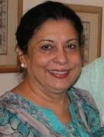
SHAHNAZ HASAN
Your past experiences: An educator by profession, I spent many years teaching young children in Karachi and Islamabad, which is why a project like Design for Change holds such promise in my eyes. Having traveled extensively and lived abroad as well as in Pakistan, I have worked extensively with creative young minds and been part of social initiatives alongside. Engaging innovative ideas to improve others' lives has always formed the core of my experiences as I believe the scope and potential for social change is unlimited.

What you do now: I am a full time volunteer engaged in the development and running of livelihood projects for women from low-income areas of Karachi. I am also an active grandmother of six individualistic girls and boys which obviously keeps me on my toes as well!

If you were a child today, what would you have designed a solution to: The irresponsibility and lack of respect shown by people when they unthinkingly litter and pollute their own surroundings.


ABBAS HUSAIN

Your past experiences: I taught English Literature in Karachi University for 11 years, and throughout my academic life have kept "a foot in the classroom": be it Jaffar Public or Mama Parsi Girls School, or teaching courses at Greenwich University or Indus Valley School or KU's Department of Visual Studies. I have tried to remain connected with the youth of the country to see their aspirations and sources of joy and despair.

What you do now: I have three hubs of concern - Teacher training under Teachers' Development Centre; Corporate (soft-skills) training under TRAINING SOLUTIONS, and (some) connection with spirituality under the regular banner of Muslim Study Group, where I discuss interpretations of the Holy Quran, the interface with modernity and everyday spirituality in today's urban life.

At present, I am Director, Teachers' Development Centre. I am a teacher trainer and have reached 35,000 teachers so far across the country in every possible schooling context. I am also Visiting Faculty at the Department of English, University of Karachi.

If you were a child today, what would you have designed a solution to: I love to see minds unfold. I would design something by which creativity would be fostered in the hours children spent at school

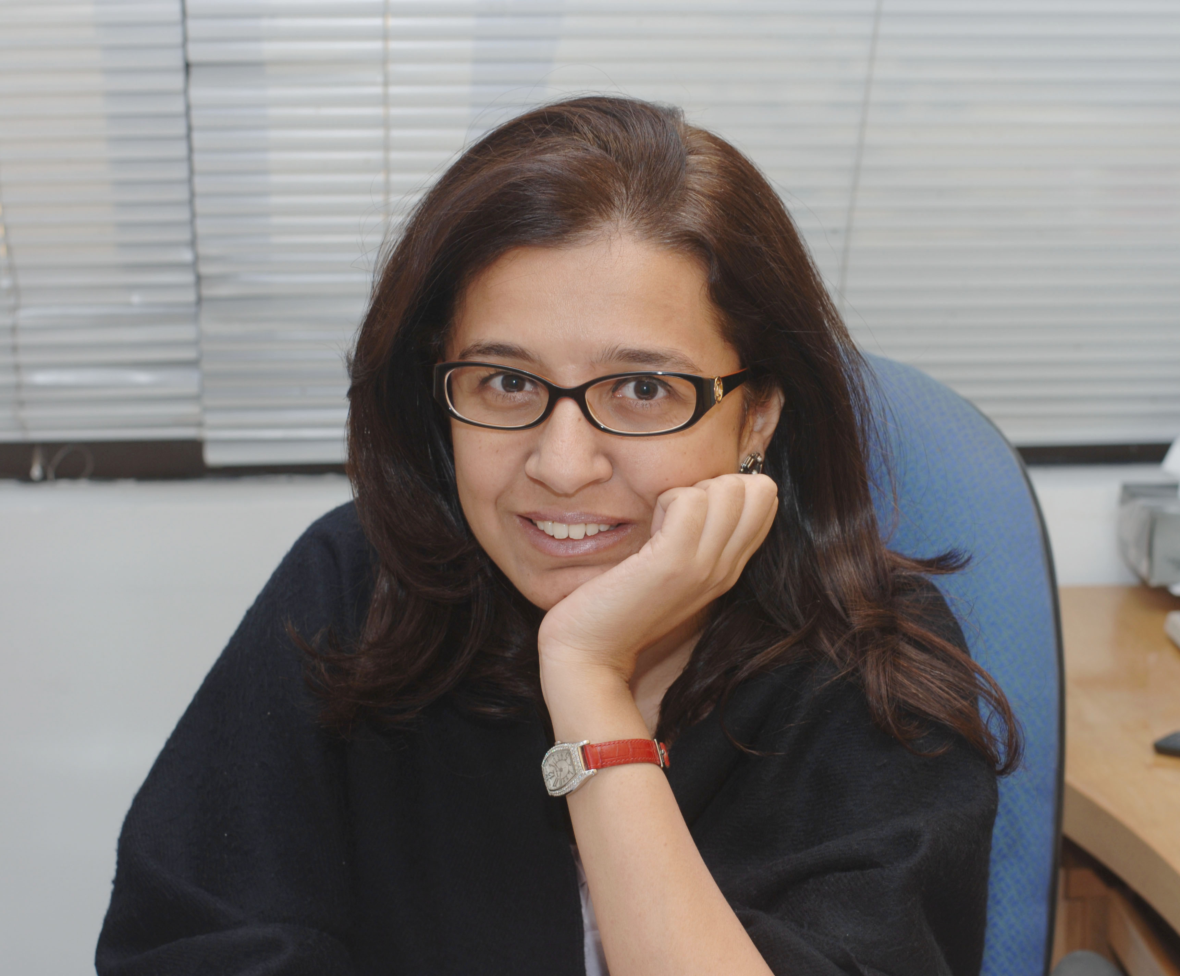
FARAHNAZ HAIDER SHAIKH

Your past experiences: Born and bred in Karachi, I started off as a trainee copywriter at Lintas in 1991 and decided this world of mad deadlines, confusing briefs and light bulb moments was my oyster. Having worked at Creative Unit, the now-defunct Blazon Grey and Spectrum Communications, I joined Asiatic in 2000, and was Executive Creative Director at JWT till March 2010 where I was responsible for all creative output on brands like Unilever, Pepsi, Mobilink Jazz and HBL to name a few. I have also been visiting faculty at the IVSAA and at SZABIST where I taught copywriting and have dabbled in radio broadcast as the host of a live show a couple of years ago.

What you do now: Currently, I am a free lance brand-building and advertising consultant who occasionally dabbles in voice overs for commercials. I am also helping the UKS Foundation compile a report on Media Literacy in Pakistan,

If you were a child today, what would you have designed a solution to: I would make it easy and cheap for every household to conserve solar power so people wouldn't be bothered by the heat and humidity ever again.

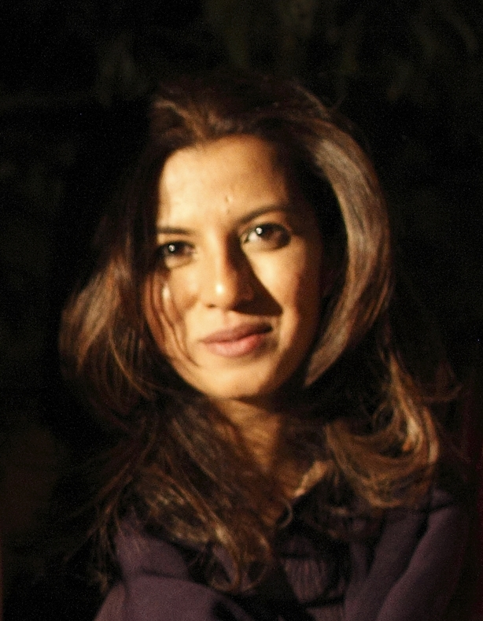
SAIMA ZAIDI

Your past experiences: I studied at the National College of Arts, Lahore and the Pratt Institute, New York. I recently edited and designed a book, 'Mazaar, Bazaar: Design and Visual Culture in Pakistan' published by the Oxford University Press, Karachi, in collaboration with the Prince Claus Fund Library, Amsterdam.

What you do now: A communication designer by profession, I've been teaching history of design and typography in Karachi at the Indus Valley School of Art and Architecture and the Department of Visual Studies, University of Karachi. If you were a child today, what would you have designed a solution to: I would have made school fun!

