Confession of a Husband
“I am an indirect beneficiary of your program,” confessed Antwi, husband of Akosua. “And I will be forever grateful!” This was the happy confession Self Help staff heard from Antwi when visiting Worapong, Ghana last December.

Antwi’s wife, Akosua, is on her third micro-credit loan from Self Help. She sells kose, a popular kind of doughnut prepared from cowpea and usually eaten in the morning with porridge. Akosua reports the loans have helped her start-up and expand her cocoa farm and pay for improvements to her food vending business. “The loans have indirectly helped my entire family,” says Akosua.

Akosua invested some of her micro-credit loan profits in her husband’s firewood business. According to Antwi, the couple is anticipating a profit this year. The funds helped buy a chainsaw which, in turn, allows Antwi to cut more wood, enabling him to produce and sell more lumber. “We will be able to build a new house for our family this year,” says Antwi.

Antwi is so appreciative of Self Help’s micro-credit loan program that he has occasionally made the 20 mile trek to Kumasi to make the loan payment for his wife.

Worapong is a small farming community located outside of Kumasi. Except for the elementary and Jr. High schools, the village is very primitive with no electricity or running water.

Being able to produce and sell firewood and kose in the village benefits the entire community.

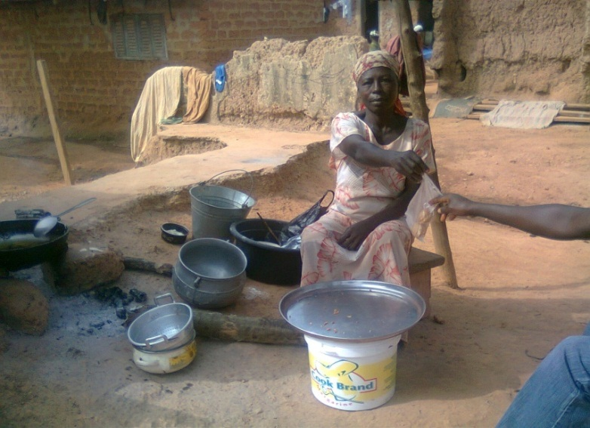
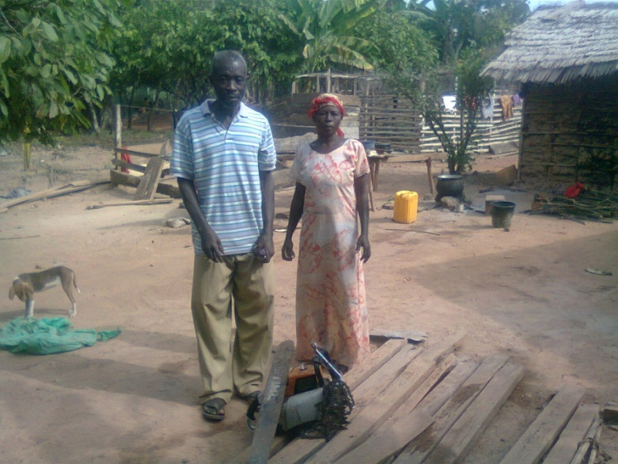
Antwi (45), Akosua (55) by their Akosua finishes selling kose.
chainsaw equipment

