Akosua Sends Her Son to School
Akosua Pokua, a busy, 42-year-old mother of three boys and one girl, is very appreciative of Self-Help International’s micro credit loans.
Akosua and her family live in Nkawie, a small farming town in Ghana. In 2009 Akousa used her first microcredit loan to purchase sheep to start a small trading business. SHI reports her loan repayment record is so consistent she has continued to take out SHI micro credit loans each year since.
Akosua’s eldest son has decided he wants to attend a Teacher Training College, a school requiring a steep tuition. Proceeds from her small business enabled Akosua to build a 3-room home for her family. Now that extra money is needed for her son, she is able to rent out one of her rooms. Happily Akousa reports that rent from the room, combined with her savings, is enough to send her son to college. “We are able to feed the family and send my son to school. I am very appreciative of Self-Help’s support.”
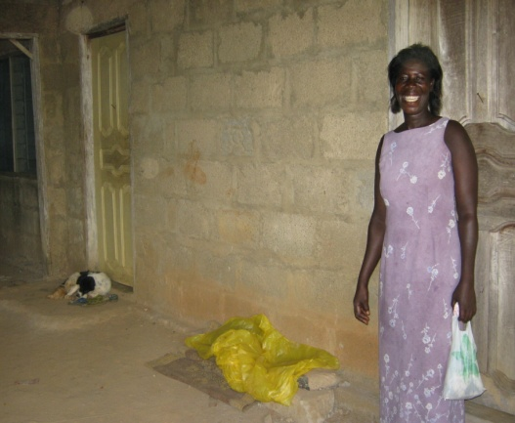
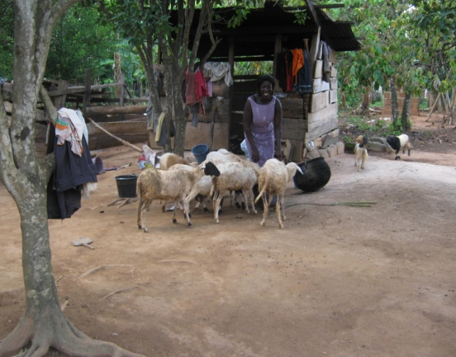

Akosua with her sheep Akosua in the room she is renting

