
The Himalayan Children’s Foundation
Gorkhana
Kathmandu
Nepal

Drinking Water Project for The Kailash Hostel and surrounding Village Community

Water, water, everywhere,
Nor any drop to drink.
Samuel Taylor Coleridge (1772-1834)

Required funding: approximately US$ 11,000

The Kailash Hostel is currently home to 89 desperately poor children from the remote mountain districts of Nepal . The Himalayan Children’s Foundation undertakes to provide a quality education to the Children until they have passed their school leaving certificate (16 years). The construction of the hostel was completed in December 2007 and funding came from sponsors and well wishers of the foundation.

The current water supply for the hostel comes from a 300 feet bore-well but the water had been found to be very turbid and contains unacceptably high levels of ammonia and iron. Currently this is being controlled by the use of a filtration system but is far from ideal. Unfortunately mains-supply water is not available.

An alternative water source has been identified approximately 1.5 kilometers away at the foot of the Shivapuri Hills. The water comes from an underground spring and even without treatment is palatable.

The water source is also currently supplying the nearby village of Nayapati but the water tank and supply pipes and are in a poor condition and in need of repair.

In the village are also six communal water-supply outlets that are in need of repair.

Proposal

It is proposed to repair and increase the capacity of the village water header supply tank and also install a one kilometer 1-inch pipe from an existing storage tank.

The six communal outlets will also be repaired.

Benefits

Approximately 500 people from the village will benefit as well as 89+ children from the Kailash Hostel and around 50+ children from the nearby Pegasus Hostel.
Required Work and cost

The approximate cost is US$ 10,000 – see below approximate budget. Some of the costs may be reduced subject to the involvement and labor provided by the local community

 |  | Sn. |  |  |  |  |  |  |  | Amount
 |  | A |  | Estimation of Collection Tank |  |  |  |  |  | 108,155.75
 |  | B. |  | Existing collection Tank repair |  |  |  |  |  | 55,880.00
 |  | C |  | Estimation of Tap & Sanitary Accessories |  |  |  |  |  | 587,625.00
 |  |  |  |  |  | Total cost |  |  |  | 751,660.75
 |  |  |  |  |  |  |  | US$ |  | 9,890.27

A detailed breakdown of the above is available on request.
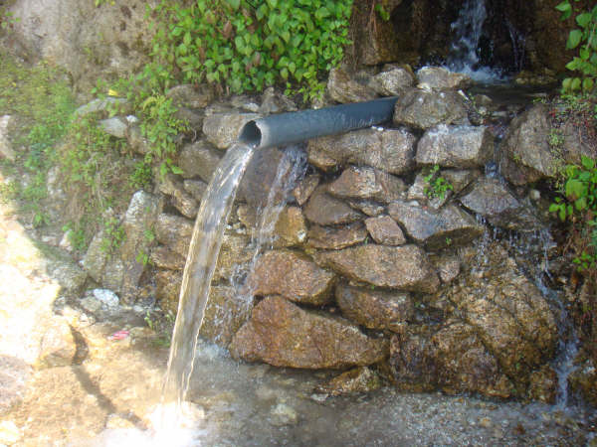
Plenty of water but not a drop to spare !

The existing water tank which is in need of repair and expansion.

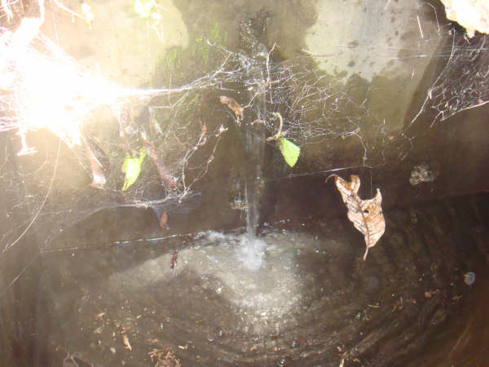
Communal water outlets in need of repair.

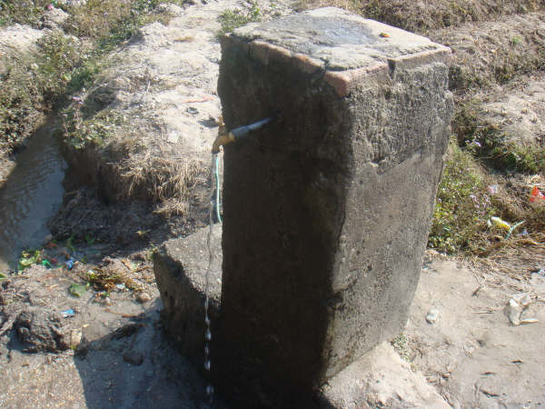

The Kailash Hostel – home to 89 children.

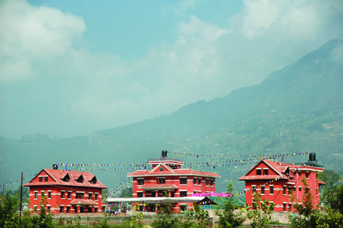

The surrounding village area and the Shivapuri Hills in the background where the water supply will come from.

