CDI-Ecuador: Bridging the Information Technology Gap for Indigenous Women

Our methodology integrates digital education with civic education, using learning and technology as tools for social change and civic empowerment. We believe it is important to know how to use the technology and software, but it is also important to know how to manage and disseminate information. This sort of access and training will provide the tools and knowledge for these women to make a real and lasting change in their lives and communities.

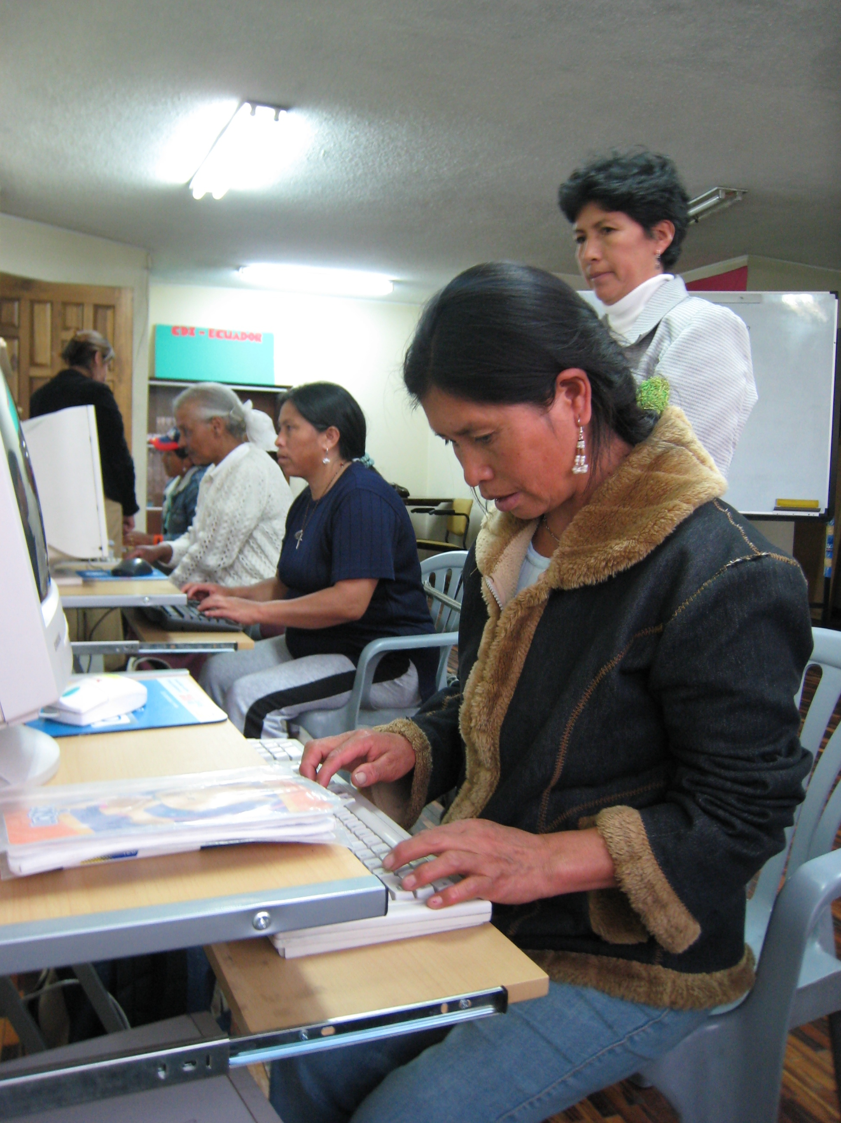
“At the beginning they are “followed” by their children because their husbands don’t believe they are taking computer courses. Later, some of them simply won't come back to the second or third day of class, because they have been humiliated, mistreated by their husbands, even their children because now they know more than them. But the majority like Mariana Quispe, will finish the course, learning something precious like self- esteem and the conviction that she can really achieve her personal goals” El Universo Journal (03/2008)

Ecuador and CDI
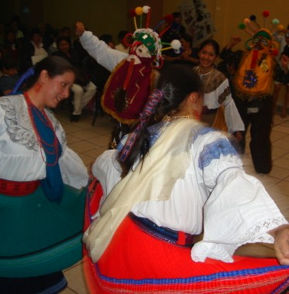
Ecuador is a country that is rich in ethnic and bio diversity, boasting numerous indigenous groups and communities living across the country from the coast to the Amazon. Unfortunately, today, 62% of Ecuador's population of more than 14.5 million is considered poor, with almost 40% of the population subsisting below the poverty line. According to World Bank, “Poverty and inequality remains one of Ecuador's main development challenges. Addressing this will require faster, labor-intensive growth, inclusion of the poor (especially women) in the development process, and more effective targeting of social services.”
Digital exclusion is also a major problem in Ecuador, a country with some of the lowest connectivity and internet accessibility rates in all of Latin America with only 6 out of 100 Ecuadorians owning a computer, and only 5 out of a 100 are able to access the internet. Additionally, internet rates are extremely expensive, at costs up to three times greater than in Argentina, Peru, or Chile.
Ecuador's indigenous population suffers disproportionately from problems of economic, social, and digital inclusion. 40% of the country's population is indigenous, and 80% of the rural and mostly indigenous population lives in absolute poverty. The situation is even worse for women, where only about one third of all women in Ecuador finish school and only 5% of that group are considered indigenous in ethnicity.
A great majority of the Ecuador’s women have no access to ICTs or to any type of modern communication system. For the last 4 years CDI has worked to increase technology access to several community organizations that work with indigenous women. Since know-how is equally as important as access, CDI citizenship and entrepreneurial programs for women concentrate on training and developing skills specialized to the specific needs and demands of these women to empower them in the long run.

Project Goals and Objectives:
The objective of the project is to improve the quality of life and economic opportunities for indigenous women who have been traditionally excluded from these resources by providing access to technology and entrepreneurial skill training. The project will be delivered in Quito, Cayambe and Otavalo, in the Andean Region of the country where many different ethnic groups migrate to in order to find better economic opportunities. We already have computer and IT centers at these locations, and we will be providing them with reliable internet connections.
The goals of the project are to:
- Implement and provide internet access to three CDI centers that frequently serve indigenous women.
- Train indigenous women, their families and their communities, on how to use internet safely.
- Train indigenous women to successfully start and run a microbusiness using IT and computer technology as a resource tool. The training will be offered through a three month civic and IT course where women will learn technology skills and then use them to identify and creatively solve common problems in their communities. Additionally, we will offer a one month entrepreneurial course which will cover basic accounting, project management, marketing and pricing skills.
- Identify and support five microbusiness projects created and run by women in these communities through start-up seed funding ranging from $200 to $300 dollars.
- Teach local leaders on how to improve and support microenterprises lead by the women in their communities.
- Involve the community and make them part of the educational process and social projects created by the program students.
- Effectively disseminate and communicate the impact and stories that will result from the efforts and work of these women throughout the CDI network to share know-how and techniques.

Project Needs

BUDGET IN US DOLLARS (Ecuador local currency) | Unit | Unit cost | Sub total | Outside sources of funding
Women training for women
Basic technology and citizenship curse per person (for a period of three months) | 50 | $ 140.00 | $ 7,000.00
Special entrepreneurial and micro business curse per person (1 month) | 25 | $ 50.00 | $ 1,250.00
Methodology development to trained women in microbusiness skills | 1 | 3000 | $ 3,000.00 | $ 3,000.00 | Provided by Kellog Foundation project (linkeados)
How to use internet securely (3 general workshops) for women and open to the community | 3 | $ 150.00 | $ 450.00
Materials + manuals | 50 | $ 20.00 | $ 1,000.00 | $ 1,000.00 | Provided by Kellog Foundation project (linkeados)
Microcredit for selected project
Start up investment for 5 projects | 5 | $ 250.00 | $ 1,250.00 | $ 300.00 | Local Bank partner (Banco Bolivariano)
Skill development for local leaders
Two general workshops on how to train and follow up micro business project developed by women from indigenous groups | 2 | $ 400.00 | $ 800.00
Infrastructure (Technology)
Internet connection for each center (yearly price) | 3 | $ 950.00 | $ 2,850.00
Pack of 7 computers + printer | 3 | $ 1,000.00 | $ 3,000.00 | $ 3,000.00 | Provided by CDI partners
Computer upgrades and equipments | 3 | $ 350.00 | $ 1,050.00
CDI follow up and coordination
Project manager (income per month) | 12 | $ 300.00 | $ 3,600.00 | $ 3,600.00 | Provided by CDI Ecuador
CDI Monitoring Costs |  |  | $ 2,870.00
TOTAL: |  |  | $ 24520.00 | $ 7,300.00
TOTAL STILL TO BE RAISED |  |  | $17220.00

About CDI in Ecuador
CDI-Ecuador is a non-governmental organization who is part of the network of the international NGO, the Center for Digital Inclusion (CDI) based in Rio De Janeiro, Brazil. For just over 3 years our offices in Ecuador have empowered disadvantaged groups to use Information & Communication Technologies (ICTs) as tools to exercise their full capacities as citizens and tackle the issues that affect their communities. CDI-Ecuador Community Centers are technology and learning centers in impoverished communities. Each CDI Community Center is a partnership with an existing leading grassroots organization, and we have 41 community centers located in poor and underserved area across the country.
About CDI
CDI’s mission is to use information and communication technologies as tools to promote community and youth development and foster the social inclusion of the economically and or socially disadvantaged. Our innovative model has been replicated throughout Brazil and internationally. Today, CDI is an extensive network of 753 schools in eight countries in Latin America; Argentina, Brazil, Chile, Colombia, Peru, Ecuador, Mexico, and Uruguay and with development offices in the US and the UK. CDI schools are primarily located in slums or favelas which are low-income communities, but they are also present in indigenous villages, institutions that assist special needs individuals (mentally or physically disabled), and juvenile and adult detention facilities.

