
Help Home Industry in Make Shoes and Slippers
By Andi Asriadi

The global financial crisis that swept the world also has an impact on the industry, such as handicrafts industry in making shoes and slippers. Before the global financial crisis engulfing the world of business, handicraft making shoes and slippers are very advanced and have a lot of labor. But after the global financial crisis engulfing the world of business, craft business making shoes and slippers are bankrupt and lay off more than 100 employees, and until now these efforts have only just 5 employees. Until now these efforts have not received assistance from both the government and ngo or private.
Your help will be very valuable for the continuation of this effort

After published on GlobalGiving 5 month ago this project still not receive donation from donors.

Mr. Ary Sunandar said that this program will help us for continuation our work, so that wo hope to the donor could helping us for continuation our work.
We expect the GlobalGiving donors to provide assistance so that this program can be implemented.

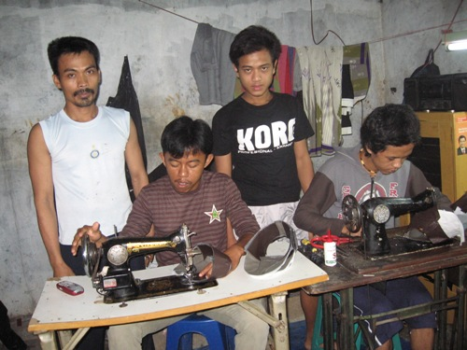  Ary sunandar and his labor | 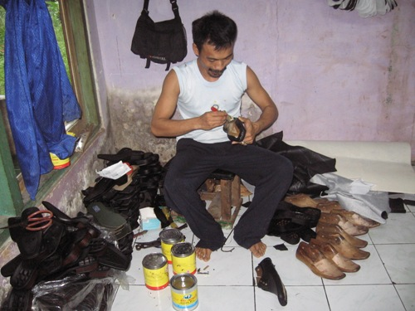  Ary sunandar in make shoes and slippers

