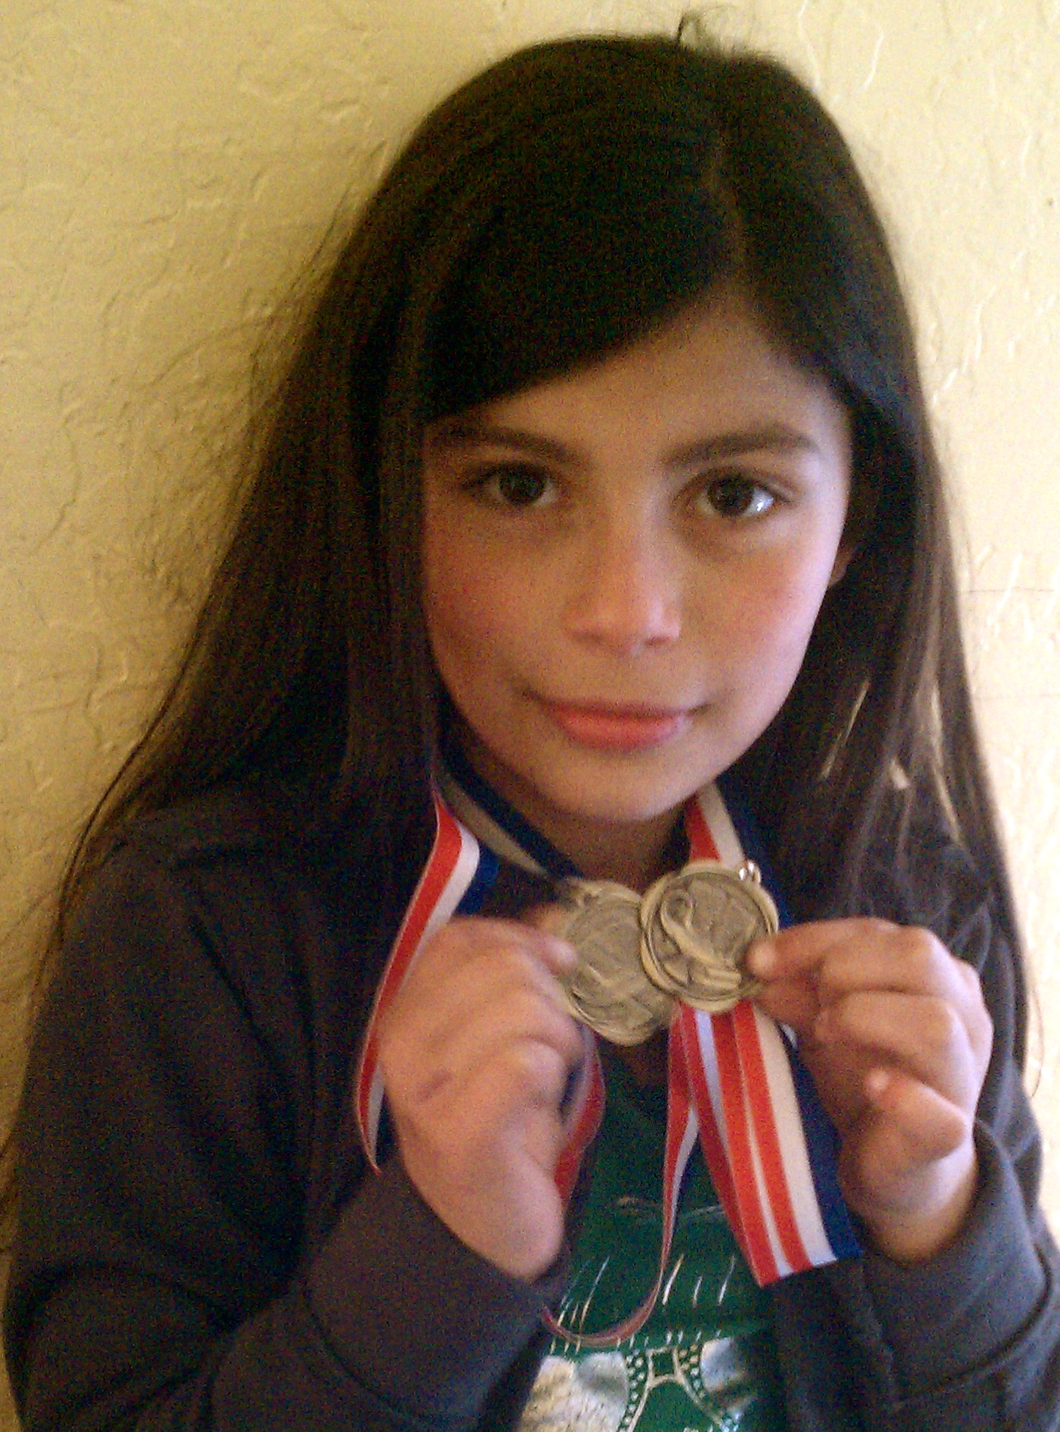
Dear GlobalGiving Friends,

We are excited to share with you our latest accomplishments! Girls To Women was recently named a Top-Rated Women's Nonprofit at GreatNonprofits.org. Please visit Great Nonprofits to read and/or write a review on Girls To Women.

Our after-school program continues to be an on-going success; please read below for the latest news. Thank you for your continued support and interest!

All the best,
G2W Staff

***************************
Joanna, a 3rd grade participant, holding the medals she received for her high achievement on the Benchmark Tests.
The after-school program continues to have a high focus on homework completion as was requested by both the girls and their parents. The girls are focused on achieving and maintaining high academic grades, and they continue to create a safe environment of learning where girls support one another during homework time. Joanna, a 3rd grade participant, was recently named Student of the Month at her school and received two medals for her high performance on the Benchmark Tests.

Admittance to College Prep School
We are proud to say that two of our participants were recently admitted to our neighbor college-prep school, Eastside College Preparatory School. One participant will be entering as a freshman and the other as a 6th grader. We are excited that they are well on their way to preparing to attend four-year colleges! Their achievement is one that the entire Girls To Women community celebrates. When the girls announced their admittance, the other girls and staff celebrated with high-fives, hugs and a room full of smiles!

New Activities
Although we continue to have a high focus on homework completion, we still offer hands-on activities since the majority of our participants (especially the younger girls in grades K-5th) are able to finish homework during the allotted one-hour for homework.

After homework is completed, we continue to provide activities such as Cooking and Gardening, outdoor group games, and Circle Time. We recently began new activities like Yearbook, Photography and a more focused Circle Time.
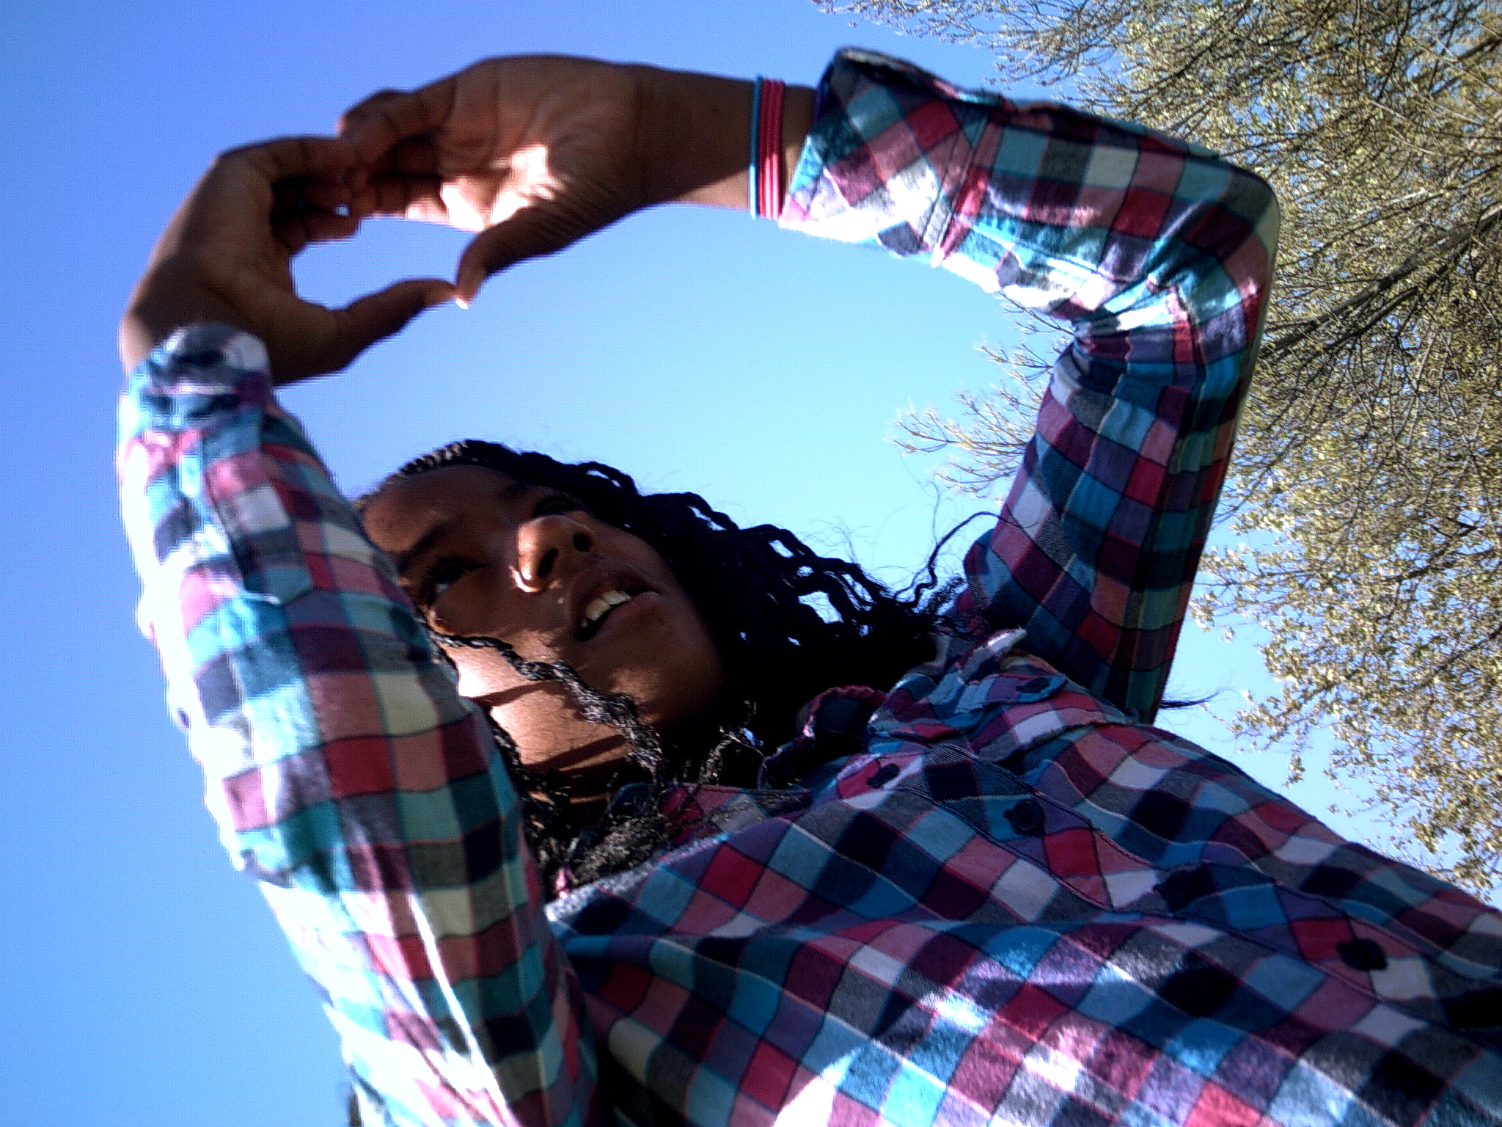
Yearbook/Photography: This activity proved to be a success last year so we have brought it back for a second time. The girls discuss what they want in their yearbook; create and design their own pages that allow them to explore and display their individuality; learn the basics of digital photography; and are hands-on by taking photographs for the activities and candid pages. The girls will receive their Girls To Women yearbooks at the End of Year Celebration to enjoy.
Photograph was taken by a Girls To Women participant during a hands-on photography exercise.
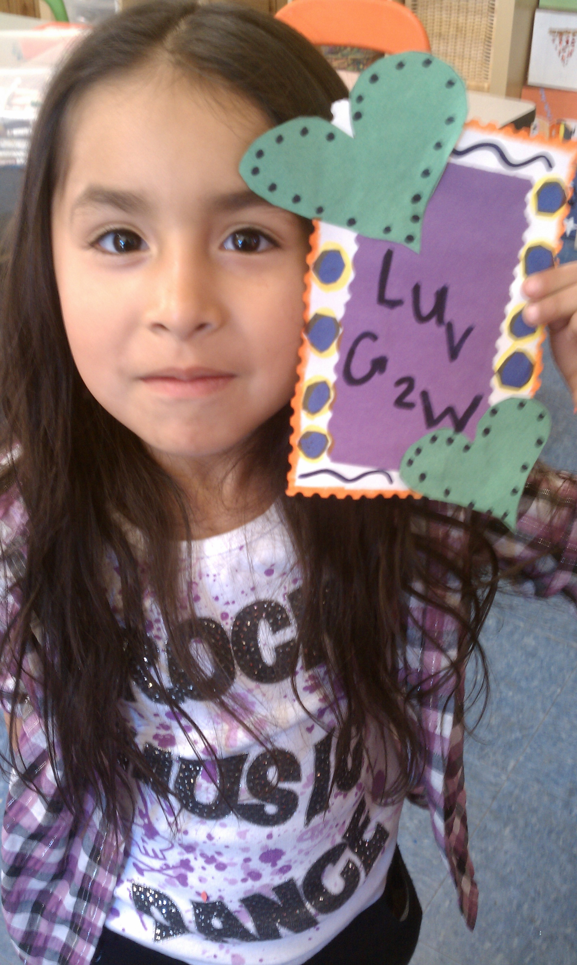
Focused Circle Time: Circle Time continues to take place on Wednesdays for half an hour and it continues to be a space for staff, volunteers and participants to share their highlights of the day or week. Girls with birthdays are also given a few minutes of “spotlight” during which girls sing Happy Birthday and express their appreciation for the birthday girl. The newest addition to Circle Time is that staff is taking turns leading Circle Time and focusing on topics/issues that they feel are important for the girls to discuss. For example, last week the topic was “Friendship”. The girls were asked to list characteristics of a good friend and why those characteristics are important. The girls then discussed the following: what happens when my friend does not have those characteristics? Do I have those characteristics? How can I be a better friend? In pairs, the girls and staff took turns making scenarios portraying each of the characteristics and acting them out for one another. At the end, the girls went around the circle and out-loud chose which characteristic they would focus on for the week in order to be a good and better friend. Circle talks like these will continue and we hope to have to some of our “older” girls lead or choose the topic for Circle Time.

Participant Breakdown
We are currently serving 16 girls in grades K through 8th. 25% are African American, 68% are Hispanic American and 6% are Other. Each girl attends program at least 3 times a week with the exception of participants who are involved in other after-school activities like soccer, basketball and language classes (such as Chinese and French).
At the end of the day the girls are given free time during which they can choose their own activities. Here, Cristina chose to do an art project and made it about g2W!
***************************
Thank you!

