Nourish International recruits, trains and supports college students in designing and implementing high-impact community-based development projects. Working through chapters of Nourish on their campuses, college students gain invaluable skills in entrepreneurship, leadership, community-based economic development and sustainability. Nourish needs funding to sustain its work founding chapters and training their leaders until the revenue stream from campus ventures can support the organization.

Documented need for the Project

In communities throughout the world, billions of people are afflicted by global poverty: 1.1 billion people lack access to clean water, 1 billion live on less than a dollar a day and more than 840 million are malnourished. Economist and Special Advisor to the United Nations, Jeffrey Sachs, estimates that 8 million people die annually because they are too poor to stay alive.

Despite the scope of this problem, traditional top-down approaches to aid have proved ineffective at stimulating economic growth of developing communities. As Nobel Prize laureate Muhammad Yunus explains, developing communities have opportunities to dramatically improve their quality of life but lack the necessary resources.

Meanwhile, in the United States, college students are rich in resources, interested in cross-cultural work and passionate about creating social change, but often lack a platform for action. By providing students with training, support and infrastructure, Nourish International bridges the gap between developing communities and American college students. Through our work, developing communities receive resources to fund high-impact community development projects and college students receive cross-cultural entrepreneurship and community developing experience.

Nourish International is funded through an earned-income model. As our Chapters earn money through businesses on their campus, 25% of their profits (approximately 15% of revenues) are used to fund operational expenses. Nourish needs funding in order to scale this model more quickly and efficiently.

Project Methodology

During the school year, Nourish Chapters raise money through student-run small businesses called Ventures. Some examples of Ventures include Hunger Lunch, a weekly meal of rice beans and cornbread, Pancakes for Poverty, a late night breakfast and Global Music Jam, an international-themed dance party. Through Ventures, Nourish Chapters raise money, recruit students to be involved with their Chapter and raise awareness about global poverty. The most successful Chapter earns approximately $20,000 a year through on-campus Ventures.

The money they raise is invested in community development projects, which are selected by students based upon their feasibility, sustainability and the strength of the local community partner. Community partners are chosen based on their track record in the community and their ability to demonstrate local support for their work. Over the summer, Nourish teams travel abroad to work alongside the community members in the implementation of the project. Past projects have included issues as diverse as improving food security, access to clean water and the economic development. Past partners include Ashoka Fellows Community Enterprise Solutions and Palmamix.

The Nourish National Office is responsible for training, supporting and scaling this movement. At the Nourish Summer Institute, Chapter Leaders receive training from experts in Social Entrepreneurship, Leadership Development and Global Development, share best practices with each other and work with Nourish staff to prepare for the upcoming year. Throughout the year, Chapter Leaders receive professional support from Nourish staff, including weekly phone calls, strategic and financial advice as they expand their Chapters. To scale the movement, the National Office manages the Chapter Founders program, a competitive application and interview process for students who want to seed Nourish Chapters on their campus. This past year, 65 students from more than 25 Universities finished applications (and paid a $40 application fee) for the opportunity to start Nourish Chapters on their campus.

To provide for the continued funding of our work, Nourish Chapters invest 25% of their profits (approximately 15% of revenues) in the National Office. In 2008, dues funded about 1% of our organizational budget. In 2009, they are expected to fund more than 5%.

Since its foundation in 2003, Nourish has grown from one to 20 Chapters and sent more than $100,000 and 85 students to implement projects in 14 communities in the process. This summer, Nourish will send more than $40,000 and 50 students to implement projects in 11 communities abroad.

Evaluation of Success

Nourish has specific profit goals for its chapters and a detailed model of sustainable on-campus businesses. To be financially sustainable, the model requires 39 chapters producing an average of $4,920 a year (net profit per Chapter). The revenue supports the organization and community-based development projects which students participate in.

Nourish also assesses it’s performance through the tracking of several key success metrics. These metrics are published in our annual report.

Table 1: Key Success Metrics and Feedback Mechanisms.

Performance area | Metric | Feedback Mechanism
Engaging students | Chapter Membership | Tracked by Chapter Leaders.
Engaging students | Students on Projects | Tracked through project registration.
Engaging students | Chapter Profitability | Tracked through National Office.
Empowering communities | Money Sent Abroad | Tracked through National Office.
Empowering communities | Number of Constituents Affected | Reported through post-project surveys.
Empowering communities | Individual Project Assessment | Reported through post-project analysis.

Summary Budget

A revenue and expense list is below. Nourish is requesting assistance in the form of $30,000 in year one and $15,000 in year two.

 | 2009 | 2010 | 2011 | 2012
National Office Revenues
Chapter profit-sharing | $6,125 | $16,800 | $29,400 | $46,600
Fees | $10,532 | $15,892 | $17,732 | $19,872
Apparel | $3,000 | $3,000 | $3,000 | $3,000
Events | $20,000 | $55,000 | $55,000 | $55,000
Interest | $113 | $95 | $152 | $234
Donations and Grants | $76,103 | $91,000 | $90,000 | $90,001
Total Revenue | $115,873 | $181,787 | $195,284 | $214,707
National Office Expenses
Payroll expenses | $77,000 | $135,000 | $145,000 | $155,000
Outside services | $600 | $3,000 | $3,000 | $3,000
Supplies | $900 | $1,200 | $1,200 | $1,200
Subscriptions | $527 | $600 | $600 | $600
Rent | $8,700 | $9,000 | $9,000 | $9,000
Phone,postage, internet | $2,334 | $2,500 | $2,500 | $2,500
Insurance | $201 | $201 | $201 | $201
Fundraising expenses | $2,833 | $5,000 | $5,000 | $5,000
Chapter Seed Money | $4,000 | $4,000 | $4,000 | $4,000
Summer Institute | $13,402 | $14,617 | $15,536 | $15,536
Printing and publicity | $500 | $1,000 | $1,000 | $1,000
Other | $0 | $0 | $0 | $0
Total Expenses | $110,997 | $176,118 | $187,037 | $197,037
Net Profit | $4,876 | $5,669 | $8,247 | $17,670
Cash Reserves | $9,502 | $15,171 | $23,418 | $41,088

Measures for Sustainability

To provide for the continued funding of our work, Nourish Chapters invest 25% of their profits (approximately 15% of revenues) in the National Office. In 2008, dues funded about 1% of our organizational budget. In 2009, they are expected to fund more than 5%.

In addition, the Nourish National Office provides students with services that scale as our movement grows, allowing us to sustain our work (such as fees on travel insurance).

Nourish’s students and their families also provide a large pool of potential donors to support our work. The graph below shows how Nourish’s growth provides for our sustainability. The graph below shows the effect of growth on Nourish’s ability to sustain itself.

Graph 1: Growth of Nourish Revenues, Expenses and Chapters through 2012
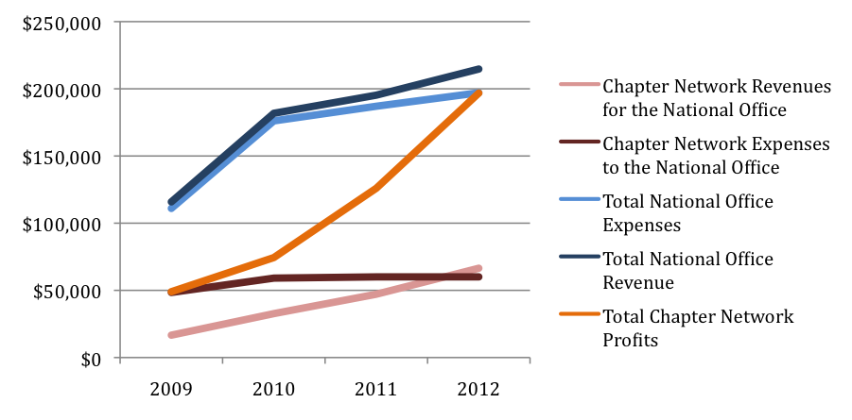

Chapter Network Revenues for the National Office is the revenue the National Office receives through fees and profit-sharing with its Chapters. Chapter Network Expenses are the expenses incurred by the National Office to train, support and oversee Chapters.

Total Chapter Network Profits is the total amount of money earned (net profit) through Ventures on Campus.

