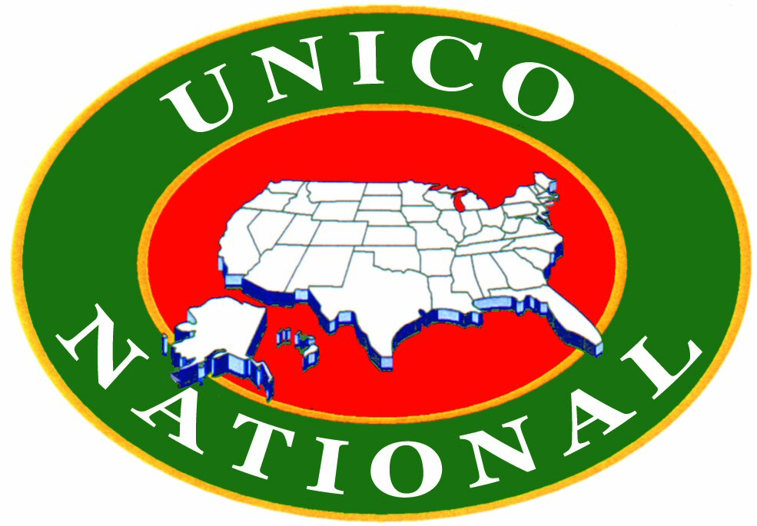

For Immediate Release

UNICO Announces Initiation of Fund to Aid Abruzzo Italy Earthquake Relief

UNICO has set up a Disaster Relief Fund to accept donations to help those affected by the earthquake that struck the town of L’Aquila and surrounding towns located in the Abruzzo region of Italy.

The earthquake, hit at approximately 3:30 am with a 6.3 magnitude by the U.S. Geological Survey, has resulted in 91 deaths, approximately 1,500 injured and is believed to have left tens of thousands homeless.

President Kathleen Strozza said, “UNICO National extends its heartfelt sympathy to those who lost relatives and the thousands who have been left homeless by the Abruzzo Earthquake.
Our thoughts and prayers go out to them.”

If you would like to donate, please send your tax deductible donation payable to:
“UNICO Foundation”
Earmarked Disaster Relief Fund”

And mail to:
271 U.S. Highway 46 West
Suite A-108
Fairfield, NJ 07004.

UNICO Foundation is a 501(c)(3) corporation.

UNICO, which means unique or one of a kind in Italian, was founded in Waterbury, Connecticut by Dr. Anthony P. Vastola in 1922. Members, in 131 chapters in 19 states, work to support charitable, educational, scientific and literary projects while promoting Italian heritage and combating negative stereotyping.

For further information, please contact Sal Benvenuti, Executive Administrator at 1-800-877-1492 or at unico@unico.org. Visit our website at www.unico.org.

