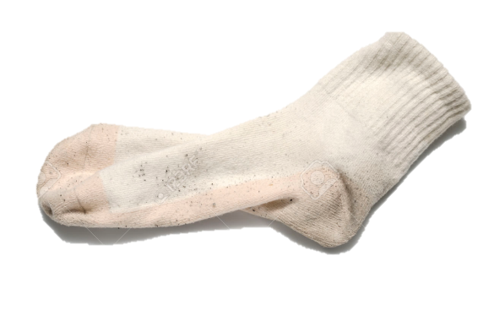

***WHAT DO THESE 3 HAVE IN COMMON?***



***THEY ARE USED BY MILLIONS OF GIRLS WHO DON’T HAVE THIS***

Q:

A:

***7 MILLION SOUTH AFRICAN GIRLS MISS SCHOOL EVERY MONTH***

***BECAUSE OF THEIR PERIODS.***

***HOW MANY GIRLS CAN YOU HELP US KEEP IN SCHOOL?***

***JUST $1 CAN KEEP A GIRL IN SCHOOL FOR 1 MONTH***