
Life is precious and all children deserve to have someone to love and protect them and care for their needs. However, all too frequently this is not the case for far too many children, particularly those in the court and foster care systems. When domestic violence, substance abuse, parental illness, or other factors render the infant’s home unsafe, a foster home must be found to care for the child. These infants and children end up in the system because they are not afforded love, protection and care. Compounded by these issues, medically fragile foster care infants and children face special challenges early in life; whether it is prematurity, a heart condition, medical compilations due to drug exposure or other congenital defects. If they survive the medical traumas, without the nurturing loving touch of a parent who cares, they are doomed to become just another tragic statistic in our failing foster care system.
“Early intervention includes the process of anticipating, identifying, and responding to children’s needs in order to minimize their potential adverse effects and maximize the healthy development of babies and toddlers.”

There is a need for compassionate, capable, trained and knowledgeable nurses willing to embrace medically fragile foster care infants and children and provide them with a loving, safe and nurturing home environment. So, it is with great excitement and hope that I present this request to you for Global Giving funding consideration. Your Foundation’s history and dedication to meeting the needs of children leads me to believe that our agency fits within your mission and scope of services. Angels In Waiting (AIW) is a nonprofit 501(c) (3) established in 2005 to meet the needs of the most vulnerable population of America’s foster children, the forgotten medically fragile preemies. Our mission is “to move medically fragile foster care infants and young children into private residences under the care of Registered and Licensed Vocational Nurses as their foster parents.”
We are seeking your funding support for $50,950 to assist us in meeting this urgent need. Your support will enable us to secure nurses that our medically fragile infants so desperately need to provide appropriate loving and safe homes. We will supplement the nurses’ medical expertise with training and education in early childhood development to address the specific and individualized needs of these children. These services will allow us to collectively salvage the
medical, physical, social, emotional and developmental lives of children before they become entrenched in an inescapable cyclical system and damaged beyond repair.
I have attached information about the critical needs, our agency and our plans to address those needs for your review and consideration. They say pictures speak a thousand words; some of our photos are graphic; but, they tell the story about the difference we are making and can continue to make with your foundation’s support. I am asking Global Giving to become a partner with us to help us address the needs of our most vulnerable population, our medically fragile foster care infants and children as we spread the word (become their voice) throughout America. Your support will give us creditability and help us leverage other funding sources to meet the needs of our children.
Thank you for this opportunity to share our program and services with you for your funding consideration. If you have any questions or need more information, please contact me as time is of the essence.
Sincerely,

Linda West-Conforti
Founder, President & CEO
Encl:

History Background
As a registered neonatal and pediatric intensive care nurse for over twenty-five years, I witnessed an alarming pattern in the number of medically fragile foster care preemies and infants who were becoming wards of the court and foster children within hours of their birth. Left alone in neonatal intensive care isolette for months, not knowing if they were going to be picked up to be fed, or picked up to be poked 5 times for an IV, existing alone- with out the touch of a loving parent. They had nurses who tried to hold or comfort them; however with a demanding patient load and work schedule of nurses, holding and comforting a preemie is a rare luxury for today’s NICU nurse!
I noted these preemies and infants were soon designated as “failure to thrive” usually with a magnitude of medical complications. I took notice as they’re affect changed and they became withdrawn, listless and were subsequently discharged to nursing institutions and group homes, only to be returned to our pediatric units. Their only relationships were transient ones as they were moved in and out of hospitals, nursing institutions and group homes and only returning to their same group home or institution if their bed was not replaced by another infant or child. These infants were not going to nurturing home environments; they had no home to go to and were on the path becoming products of an ill-equipped systemic institution, not at all conducive to effective parenting.
When I inquired about their placements and expressed the need for them to have consistent caretakers; no matter what county they came from, the story was always the same: they are special needs foster children and hard to place. We do not have readily available foster homes that can meet their critical medical needs. As a nurse, whose life and career is dedicated to improving the outcomes for others, I was determined to make a difference in this growing population of America’s Forgotten Children. I started to inquire about and research available services. In this research, I came across a unique opportunity for nurses. In California nurses can become independent providers for foster children, billing Medi-Cal directly for their in home nursing hours. Coupled with this, nurses can become licensed foster parents in various counties to have a child place in their homes. This blend of nursing and foster parenting meets a child’s need for love and care found only in a family home environment while offering nurses a unique way to serve the pediatric population. This inspired me to create a network of nurses to expand the services to these children and “Angels In Waiting” was born in 2005.
Rescuing the Starfish
As the old man walked the beach at dawn, he noticed a young man ahead of him picking up starfish and flinging them back into the sea.
Finally, catching up with the youth, he asked him why he was doing this.
The answer was that the stranded starfish would die if left until the morning sun.
"But the beach goes on for miles and there are millions of starfish," countered the old man. How can your effort make any difference?"
The young man looked at the starfish in his hand and then threw it to safety in the waves. "It makes a difference to this one," he said.
Minnesota Literacy Council
AIW is a nonprofit tax-exempt 501 (c)(3) public charity. The Board of Directors consists of professionals from the medical, educational, social service and business fields. AIW is dedicated to recruiting qualified nurses to provide loving homes, nursing care, and other needed services for medically fragile foster care infants and children. We help facilitate the child's move from hospitals, group homes and institutions into private residences under the care of Registered and Licensed Vocational Nurses as their foster parents. We provide two essential ingredients for these children to heal – loving home environments and individualized nursing care.

Problem
Nationwide, more than 500,000 children live in foster care. In California, which has the largest foster care population than any other state, the number of foster children has tripled in the last 20 years. Many of these children who have suffered abuse and neglect have fallen through the cracks of our fractured child welfare system.
Foster Care Statistical Outcomes
- 50% do not complete high school
- 62% are incarcerated before their 24th birthday
- 80% of the prisoners were foster children

Increased teen pregnancies and epidemic drug use by pregnant women have resulted in an escalating number of premature births - children with medical and developmental complications. Concurrently, there are a growing number of cases where children become medically fragile at the hands of their parents and a return to their biological home is not in the child's best interest. The foster care system is heavily burdened with an influx of medically fragile infants and children who need our help. Local resources have been, and continue to be, strained to the limit in dealing with the expanding number of these and other medically fragile foster children. The foster care system, while a protector of and quasi-surrogate parent for these children placed in their care, is not an adequate parent. These children lack consistency in the lives at every level. A child may have as many as four to six different social workers assigned, depending how long they are in the system. Most of them also experience multiple placements during their tenure in the system. The children are harder to place with the average foster parent because of their special needs and they become the forgotten members of our society, left alone in hospitals and institutions inevitably identified as failure to thrive.
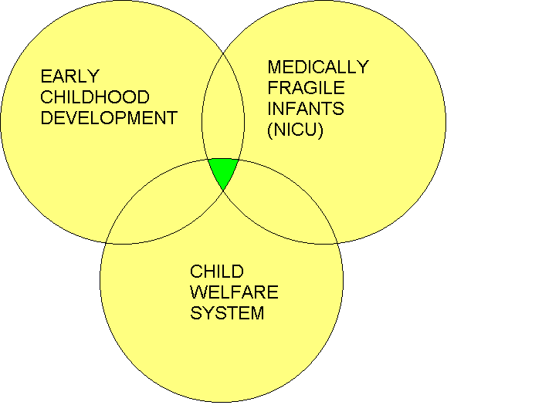
The medically fragile population of children includes those who are technology-dependent children, such as those who need mechanical ventilation, renal dialysis, and apnea monitors. Others may include children with acquired immune deficiency syndrome (AIDS), cystic fibrosis, and those with physical and mental conditions that will likely impair development, such as Down syndrome and cerebral palsy. Children with delays in speech, cognitive, language, and self-help skills may also be included.
Infants who spend long periods of time in hospitals, especially those receiving life-sustaining care, face several developmental barriers. Normal sensory and social exploration may be inhibited. (Feeding tubes, for example, prohibit the infant from experiencing sucking, swallowing, and tasting.) Documented behavior of infants and young children confined to hospitals for long periods of time show that they are often passive and distracted. They make few attempts to communicate verbally. They show little interest in tasks that require eye-hand coordination. Their range of expression is often narrow. And they show an inhibited perception of their abilities to move.
For acutely and chronically ill infants, a lengthy stay in a hospital means living in an environment that is often unpredictable, chaotic, and non-supportive. Despite their developmental needs, these infants generally cannot access community-based intervention services provided by law for the seriously-ill children who are confined to hospitals.
There is an increased tendency of readmission into hospitals because of nosocomial infections and inadequate medical care when these children are placed in institutionalized nursing and group homes. Studies show these children will exhibit emotional, developmental, and behavioral issues early on in childhood that will amplify as a child grows older in these settings.
The Birth of a Foster Care Preemie
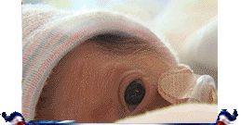
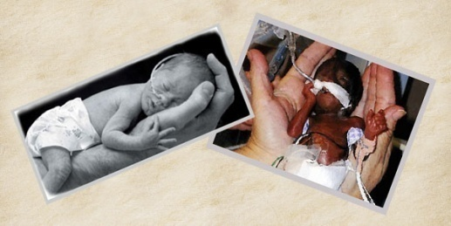
As the tiny ones battle for their life with undeveloped organs, they are also going through brutal drug withdrawal. The constant poking with needles to draw blood and IV starts does not impart a warm and fuzzy beginning to life. They are often tied in unnatural positions on the bed to ensure they don't pull out breathing tubes and are often not medicated enough for effective pain management.
Many preemies will have a four to six month course in NICU, never knowing whether they're being picked up to be fed or poked for some other painful brutal procedure. They can benefit from nurturing home environments once their hospital stay is over, but need tremendous amounts of love to overcome their memories of the torture necessary to save their lives. The paradigm for medically fragile preemies is the multiple areas of development affected, which includes chronic health issues, vision and hearing loss, delayed fine motor and intellectual functioning as well as behavioral and attention deficit disorders.
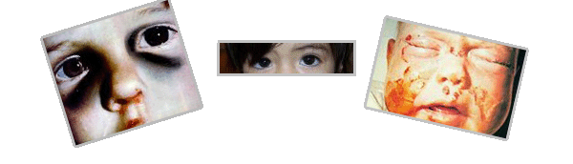
The Abused Ones
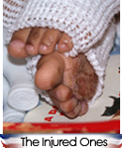
The injured ones are placed from many counties at all times of day and night when emergency measures need to be taken by people they don't know. They are tossed into the hands of strangers and they are frightened, disoriented and wary. They may have been beaten, burned, tormented or terribly neglected. They may have suffered any number of other atrocious acts. Their birth parents have made bad choices or are victims themselves who cannot move beyond their own inner torment.
The children are taken with little or nothing but the clothes on their backs and the painful memories that brought them to this uncertain place - travelers in the system whose futures are uncertain. Depending on how long they are in the system, these children often have trouble bonding with people because they haven’t experienced loving and stable relationships or the joy of having a secure family home environment. The lack of connection often results in a lower quality of life and developmental delays.
Children in Foster Care
- 80 % are exposed prenatally to maternal substance abuse
- 40% are born at low birth weight or prematurely
- 80% have at least one chronic health problem (25% have three or more problems)
- More than half have developmental delay
- 10 to 25% have growth retardation

Heightened interest in early childhood intervention has sharpened the demand for evaluating the disabilities, needs, and development of medically fragile children. Many at-risk children who should be assessed are not.

Solution:
Approximately 15 years ago Medi-Cal created Home and Community-Based Services (HCBS) home and community based services. HCBS is designed to provide in-home care and support to recipients who otherwise required institutionalization in a medical facility for a prolonged period of time. Usually greater than 90 days. The institutionalized settings include but are not limited to group homes for the medically fragile, nursing facilities and pediatric sub-acute facilities. The primary goal of Medi-Cal’s waiver programs is to provide support to ensure that recipient’s medical needs can be met appropriately and safely in a home environment. This in-home nursing program offers a healthier existence and a more favorable upbringing for medically fragile or special needs infants and children in the foster care system. However, this valuable program for the medically fragile was never marketed. Most county officials and social workers are not even aware of nor do they use this service. Another aspect of HCBS is In-Home Operations (IHO). The purpose of IHO is to oversee the development and implementation of a home nursing program and to authorize quality medical, necessary medical and nursing care services.
Determined to make a difference and help these children, Linda West-Conforti, RN., discovered this valuable yet untapped resource. She signed up and became a certified as a foster parent for medically fragile children and an Independent Nurse Provider with Medi-Cal. Linda’s day begins and ends at home; an enjoyable and healthy setting for the medically fragile children in her care. She founded AIW to recruit and encourage other nurses to do the same.
In the time she's been a foster parent, Linda has brought many micro preemies with an array of medical complications back to health. Linda has also provided care for children with heart defects who require specific monitoring and an educated eye toward potential problems. These infants’ and children’s futures were bleak until Linda prevented them from going to institutional- like settings. Now, a short time later, the children have transformed medically and are in healthy, loving, permanent homes; well on their way to a more promising future.
Often the developmental delays in these children are due more to their medical deficiencies and long-term hospitalization, rather than cognitive impairments. With appropriate playtime educational therapies and on-going developmental assessments, these children usually meet or surpass developmental milestones. The special, consistent and loving care she provided gave them a fighting chance to become adoptable and placed in permanent homes well on their way to a happy and healthy childhood.
AIW understands the proper course of treatment necessary to improve the cognitive, behavioral and psychological outcome of medically fragile and drug exposed foster preemies and infants. The mission is to move medically fragile foster care babies and young children into private residences under the care of Registered and Licensed Vocational Nurses as their foster parents. AIW has set up a unique way to impact the life of a needy child beyond the hospital and clinical setting for the nurturing souls of nurses, “Clocking In At Home”. AIW will recruit and train dedicated experienced registered and licensed vocational nurses to reach out to the foster care system to give these children essential medical services, educational services, structure relationships, bonding skills and a nurturing home environment. The foster care nurses will understand the proper course of treatments needed to improve and strengthen the physical, emotional, cognitive and psychological outcomes of medically fragile and / or drug exposed foster care infants and children.
Early intervention focuses on
- Physical development
- Cognitive development
- Social development
- Emotional development

We help these infants children heal physically by changing their dressings and dabbing their crying eyes. We help them heal emotionally by soothing their wounded spirits and building their self-esteem. We help them heal psychologically by providing nurturing homes with positive role models dedicated to improving their quality of life.
AIW will provide “Wrap Around Services,” using a blend of both formal and informal services. The formal services will include occupational, physical, speech therapist and educational specialists. The informal services will include other service agencies, schools, the business community, cultural leaders, neighborhood leaders, clergy, advocates, seniors as respite volunteers, law enforcement, and others.
"We have seen firsthand how the prospects for their future improve with more individualized nursing care and attention in a nurturing and supportive home environment. AIW offers a healthy alternative to costly institutionalized housing of America's medically fragile children. "While we worry about the child's central lines, feeding tubes, and oxygen levels, the child can concentrate on chasing the family pet and giggling their way through the day."
In the years since its inception, AIW has recruited 20 nurses who have medically fragile children in their homes, with approximately 15 nurses who are in the process of obtaining the instruction from DSS and or Medi-Cal to become foster home nurses. In addition, we helped find private nursing homes for 80+ infants and children. AIW’s children have surpassed the medical prognosis and many are displaying above average cognitive, behavioral and developmental skills. Many of these children became adoptable because of AIW’s services.
Goals:
- Develop a marketing team to educate and train children services supervisors, medically fragile social workers and NICU medical staff in San Bernardino, Riverside, Orange, Los Angeles and San Diego counties on Medi-Cal's HCBS cost-effective in-home nursing care program.
- Recruit 25 qualified Registered and Licensed Vocational Nurses to become HCBS foster parents for medically fragile children in each of the respective counties (125) total.
- Provide 25 family homes for medically fragile infants and children in each of the respective counties (125) total.

Outcomes
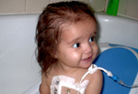
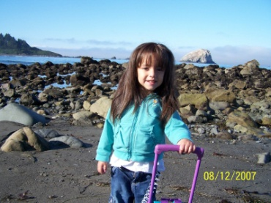
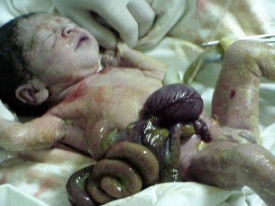
What better than a story of success about one of these children whose future was bleak. Alexia was born prematurely with a condition known as Gastroschisis. Her intestines had formed outside her abdominal wall and the wall had closed up around them, choking them from blood supply and systematically poisoning her. A condition we are seeing in alarming numbers due to methamphetamines use during pregnancy. Lexie's intestines were black and dead; only four inches of viable bowel could be saved and had to be surgically attached to her transverse colon. The loss of bowel makes it impossible to absorb the nutrients needed to sustain life. So, she requires an IV infusion of Total Parenteral Nutrition (TPN) that runs through a large blood vessel in her chest twenty hours a day - an intrusion that is hard on the veins and makes her prone to bacteria that cause blood infections. Many line placements for the IV have caused scarring and taxed the liver like excessive alcohol and a toxic lifestyle would.
Her liver and kidneys are further taxed by the antibiotics necessary to fight a host of infections. She has anemia because her kidneys are not working up to par, so I infuse IV Iron to help that and give her a shot every week to build up her red blood cells. Her gut is "leaky", so bacteria easily seep through the intestinal wall and cause blood infections. The short length of her intestines means the normal amount of immunities can't be produced so I infuse an immunity drug called IVIG every two weeks at home to help build her immunity. She likes to suck the flavor out of food rather than swallow, so it was necessary to put a Gastric Tube (GT) in her stomach for feedings and for medications that are impossible for her to swallow. She will require a small bowel transplant and a kidney transplant before her sixth birthday.
When I first cared for Lexie in the Pediatric Intensive Care Unit of a major hospital, she was eighteen months old and weighed a scant twelve pounds. She had just been admitted with yeast growing in her blood. Her hair was brittle and had a reddish tint mixed into the black hair - a tell tale sign of nutrient deficiency.
She had been living in her second medically fragile group home but had been in the hospital so frequently with blood infections that she had not had the time to bond with anyone from her new Group Home. Alone in the ICU, she was frightened and had learned to avoid eye contact. She had a flat affect when nurses and doctors talked to her and had learned to protect herself by withdrawing from us. She cried and struggled to get back to the safety behind the bars of her crib. When I reached in to pick her up, she used sign language to tell me to pull the bars of the crib back up. She had inappropriate attachment; once held and rocked, she did not want to let me go. The next day, she chose someone else to attach to.
During her six week stay in the hospital, my attachment to her grew steadily and I took the steps necessary to become her at-home nurse and adoptive parent. She was so used to avoiding eye contact to protect herself that it delayed her ability to walk to twenty-three months, and I had to teach her to keep eye contact with me. When she began talking, she would shriek, "We Home! We Home!" when we pulled up to our house. In the years I've had her, she has blossomed into an incredibly intelligent, beautiful four-year-old girlie girl with no fear of people. She talks endlessly, runs, laughs, smiles and finally shares her brother, knowing she is secure in our love.
She has not conquered every medical milestone in front of her. There are more than several organ transplants in her near future. But, at least with me as her advocate and caring for her at home, she is long over the surprise in seeing the same "nurse" greet her when she wakes each morning and is more prepared for the challenges ahead. I am her mommy. I am her nurse. She is my love. Charla Kingsley, RN, INP

Sustainability
AIW presented the Medi-Cal’s IHO to Riverside Department of Children’s Services supervisors. Approximately 20 key supervisors and public health nurses were present during the presentation. Within one week Riverside County used AIW’s Medi-Cal’s IHO program and placed several of their medically fragile foster infants and children in our recruited homes in both Riverside and San Bernardino Counties. Riverside County recently stated that our program has saved thousands of dollars within the first month and Riverside County Department of Children’s Service is currently requesting more Medi-Cal IHO foster homes with our recruited nurses as the care takers. Riverside wants to be able to remove their medically fragile infants and children from nursing institutions and group homes into our cost-effective and child focused family homes.
The need is clearly defined, throughout Southern California, thousands of medically fragile infants and children are in need of a loving home to heal, to thrive and be given a fighting chance. Together, as collaborative partners, we can give them what they deserve, a normal healthy childhood in a loving family home environment.
Kaiser Permanente has embraced AIW and its nurses, (many who are Kaiser Nurses). Kaiser Employees Giving Campaign has permitted Kaiser Employees to donate a portion of their paychecks to AIW. Kaiser is sending internal notices and articles to all staff about the agency and its efforts. The nursing magazines have offered to do feature stories on the agency and the outcomes for these infants and other foster children to help market this invaluable service for our medically fragile foster children. Kaiser has offered to help and support the mission and services of AIW in three critical areas:
- Individual giving Campaign
We are Guilty of many errors and many faults but our worst crime is abandoning the children neglecting the fountain of life.
Many of the things we need can wait. The child cannot.
Right now is the time bones are being formed, blood is being made senses are being developed. To the child we cannot answer "Tomorrow."
The child's name is
"Today."
Gabriela Mistral
Nobel Prize-winning poet from Chili
- Marketing and referrals throughout the Kaiser Permanente Medical Group
- Use of their public relations and media departments
AIW will seek similar campaign and funding support services from other major medical facilities that serve medically fragile children in each of the respective counties.
AIW will actively market and recruit through nursing, magazine, nursing publications and nursing job fairs. Several of the magazines have already contacted us to do feature stories on our program, “Clocking In At Home”. The targeted magazines that are primarily Southern California focused are Nurse Week, Nurse Advocacy, RN Magazine, LVN Magazine and Working Nurse. Through this media venue we will recruit and educate nurses to care for medically fragile foster children as foster parents in their homes and bill Medi-Cal as an independent nurse provider in an alternative nursing venue.
AIW will research and submit grant applications to other foundations, especially those whose focus is on the improving health access and services for the low income population; such as foster children. We are requesting and would appreciate any added funding referrals your foundation may want to offer. In addition, AIW will design and develop an individual donor program for additional unrestricted funding support.

Project Budget
Marketing Team: Five nurses @ $200 per day Per Diem @ 2 days per week @ 8 weeks - to educate and train Children’s Services Administrators and Workers and hospital NICU staff about AIW and its foster placement services in each county | $40,000.00
Office Supplies | $1,500
Printing: Development and printing costs of Brochures, Flyers, Posters | $4,000
Banners: Display Banners for Marketing | $1,250
Advertising: Magazine ads for recruitment of foster care nurses | $3,200
Total | $50,950.00

