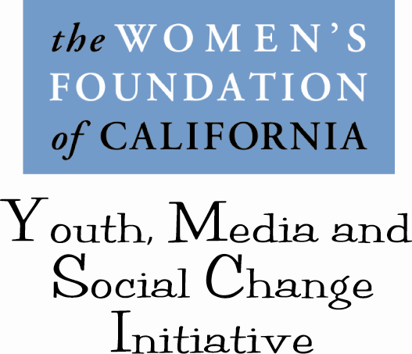

The Women’s Foundation of California program, Youth, Media and Social Change Initiative seeks to address the role that media and popular culture plays in promoting gender stereotypes and normalizing gender-based violence. We believe that messages and images that position women as objects and men as hyper-masculine and violent can contribute to unhealthy ideas and behaviors around gender, gender roles and relationships. The major objectives of this work are:
- To raise awareness of the proliferation of gender stereotypes and gender-based violence in the media and the impacts on young people.
- To build the capacity of young people to think critically about the things they consume.
- To build movement among young people by creating opportunity for dialogue, resource sharing, education and tools for social change action as it relates to addressing gender-based stereotypes and violence.
- Provide opportunities for young people to contribute to the creation of media content that is healthier, less violent, and more balanced in its representations of gender, race and class and to use media (in all forms) as a tool for social change.

- To support young people as leaders and advocates and youth-led movements addressing critical issues impacting young people and their communities.

The Women’s Foundation of California sees media as an effective tool for engaging youth in social change action. New media in particular (blogs, networking sites, podcasts, digital video, computer generated music, text messaging) provides for immediate engagement and expands the opportunities for user generated content thereby giving youth the power to tell their own stories, voice opinion, participate in peer learning and connect with other youth activists. Because of the immediate access and interactive nature of digital media there is unlimited potential to build movements around issues impacting young people by using media as tool for distributing content, sharing information and creating dialogue across a broad spectrum of the youth population.

The Foundation has found that its youth grant partners are already using media as a tool for engaging young people in their work. Our interest is to build the capacity of organizations to use a gender justice lens in their work and support the use of media in combination with youth leadership strategies to develop critical thinking, awareness and youth-led social change. To achieve these goals we are instituting three strategies in 2008-2009.
- Grantmaking to support youth media, media advocacy and media literacy strategies. (December 2008)
- Beginning in January 2008, convene a learning community of organizations (including grant partners) that helps to build capacity in specific areas of media use and media literacy and provides space for sharing of best practice and promotes collaboration. The learning community activities will include two two-day meeting with training, presentation, case studies etc. and an online social network for the learning community to share resource, tools and engage in advocacy and public education. The learning community will serve to build individual and organizational capacity to understand how gender stereotypes play a role in gender-based violence, sexual health, positive self-identity and other issues that impact the well-being of adolescents and young adults. Finally we will facilitate learning’s to help youth and adults understand how they can use media, particularly new media, to build on and expand their community organizing, advocacy and movement building work.
- Social networking space for the learning community including a blog: www.youthchangemedia.typepad.com and a Facebook group: Youth, Media, Social Change Initiative.
- Future Plans:
  - A Public Education campaign geared towards youth that is interactive and helps to raise awareness of the ways that popular culture reinforces gender stereotypes and normalizes gender-based violence. Within the campaign there will be opportunities for engagement and advocacy action. The specifics of the campaign will be a collaborative effort between the Foundation, the learning community and an advisory board.

  - Convening a national round-table of like-minded organizations and funders to talk about what we can be done collaboratively to address gender stereotypes and gender-based violence that stem from images and messages in media and popular culture.

For more information about the Initiative please contact program officer, Maya Thornell-Sandifor, at mayat@womensfoundca.org or 415-837-1113 ext. 303.

