Water control and sustainable water use in coffee

A public private partnership project in Central America between
Nestlé S.A, ECOM Group, IDE International and Rainforest Alliance

Coffee is usually not irrigated but recent experiences show that significant increases in yield, speed of plant growth and of quality can be achieved with supplemental irrigation during periods of water stress, especially during the flowering period

The purpose of this project is to test, introduce and monitor low cost drip irrigation in coffee in Central America and embed this technology into socially, environmentally and economically sustainable certified coffee value chains.

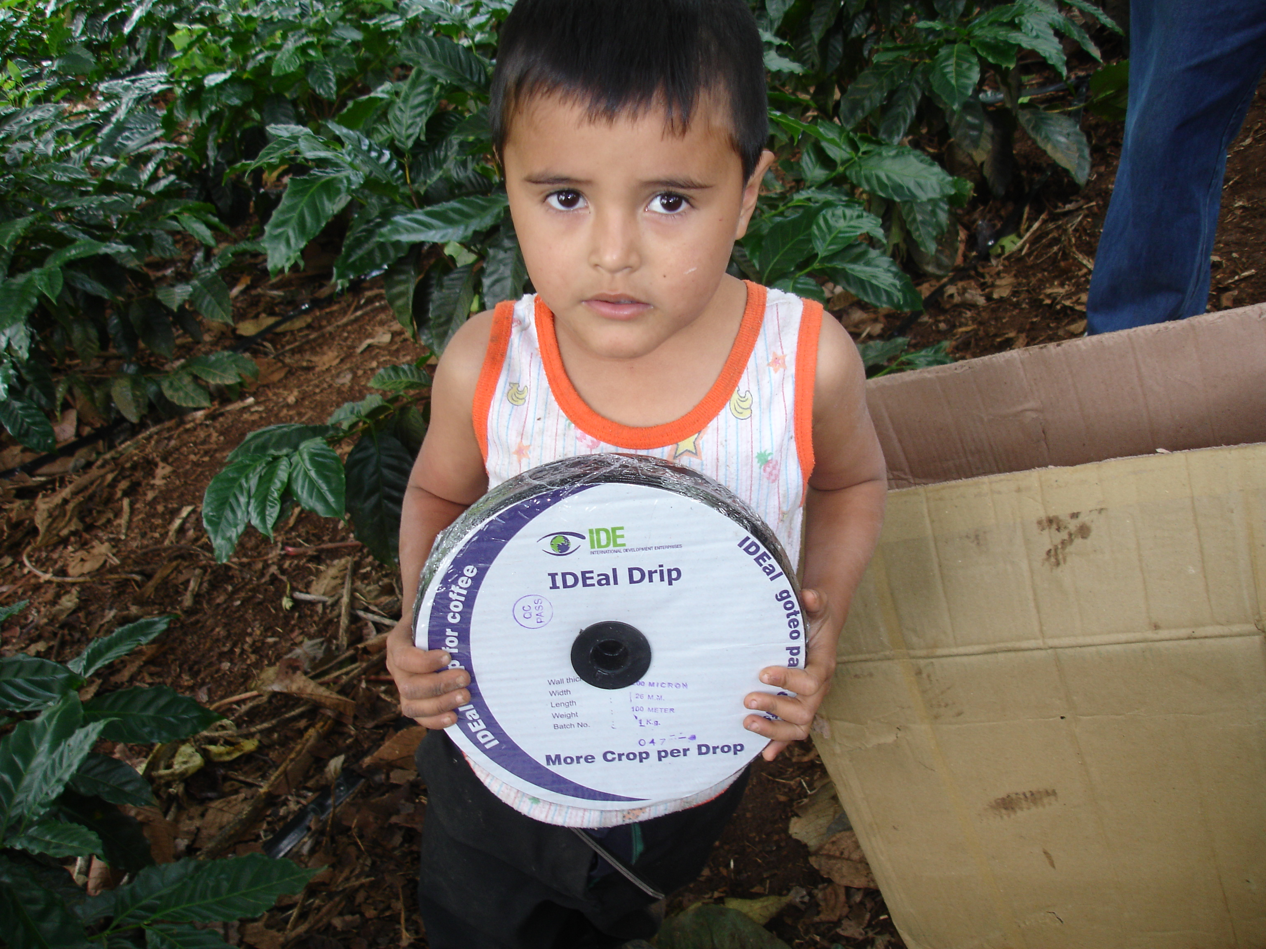
IDE, an international NGO committed to increasing the incomes of small farmers, has developed low cost drip irrigation systems in India and Nepal and is transferring this technology to Central America and adapt it to the specific conditions of coffee farms. These farms are often located at very steep hills and it is thus necessary to develop simple pressure control systems.

Supplemental irrigation is especially important during the flowering season and the presence of water stress during critical phases of plant growth can affect yields and quality negatively.

From 2008 onwards, an external systematic and scientifically based monitoring will be implemented. This component is supervised by the Swiss College of Agriculture, Zollikofen, Switzerland.

Statement from visit of personnel of Swiss College of Agriculture, Zollikofen, Switzerland.

Visit to the Micro Irrigation Project in Nicaragua
May 19 through June 3, 2008

Lydia Pluess,Simon Spöhel, Zollikofen, June 26, 2008

From May, 19 to June, 3rd, the authors visited the Matagalpa and Jinotega region of Nicaragua to study the ongoing irrigation activities in coffee and to test and adapt tools for irrigation management. We visited 7 fincas, where micro-irrigation systems had been installed this year or the year before: 3 fincas belong to the cooperative SOPPEXCCA, and are small-scale producers. 3 fincas are partners of Exportadora Atlantics (EA) and one farm is owned by EA itself. On each farm we discussed irrigation management with the producers and the technicians.

What the Lydia Pluess,Simon Spöhel, Zollikofen said: Besides, it can be said that the farmers have a good feeling for the systems and manage it quite well. In the field we encountered all kinds of system designs; basically every system was adapted in a unique way to the plantation. Farmers have their own way how to operate the system.

What the producer said, The effect was visible in some plantations. Irrigated plants seem to be more vigorous and all farmers told us that vegetative growth during the dry season was almost double of usual. We could see 1.5 year old plants which already started to flower. Due to strong vegetative growth leaves of irrigated plants are lighter green. Some farmers therefore apply an additional dose of urea in the dry season. Farmers and technicians are convinced that the irrigated plants will grow better during the rainy season, too, because they have advanced root and foliage systems compared to the non-irrigated plants.

Most farmers prefer now to irrigate young plantations. They see the main benefit of irrigation in the continued vegetative development of the young coffee trees during the dry season which brings the plants one year earlier into the productive cycle.

What the technician said: The analysis of the capacity of the water source on a farm remains crucial to decide whether irrigation systems can be installed or not. Moreover, the capacity of the water storage is decisive too. The problem occurs mainly in places, where discharge rate of the water source is lower than the flow rate during irrigation

Results:

Producers like, Gonzalo Castillo, Francisco Valenzuela, Eduardo Kuant, Ivan Jiménez
Alex Talavera Alaniz , René Martin Paguaga Buitrago and Julio Rodríguez Benavidez.
said, we believe that it is a technology that helps to the invigoration of the plant giving vigor and like supplementary watering helping to the plant maintaining the necessary humidity so that it can be developed with all their potential.

The results show in field, more flowering, formation of fruits and production (of 6 to 8 sacks of 46 kilos more per hectare) in the parcels with watering compared to don't water them.

The cost of the micro irrigation system and the easy thing of managing are also positive aspects, we consider that in one year we can pay the investment and to use the system more for five or six years.

Now with the changes of the climate we have seen that the rains are year to year more irregular, to have a system of supplementary irrigation as part of the necessary tools of the farm, it assures that when suffering those changes of frequency of rains the cultivation it doesn't suffer for lack of humidity.

Participating small coffee producers will earn annually an average of $1,000 -$1,500 per hectare net of input costs.

A pilot project started in 2006 and introduced low cost drip irrigation systems in 11 farms in Nicaragua. Although no scientifically based systematic monitoring was available, the results in 2006 showed significant increases in yield of between 40 and 60 % and also a much faster growth of young plants; in newly planted fields, coffee trees started its first yields already after 2 years compared to 3 years in non-irrigated plots.

In 2007 monitoring was done on several farms with the “old” method, comparing 20 single trees of the irrigated plot with 20 trees of a non-irrigated plot. All results indicate superior values for the irrigated coffee. However, we don’t know to what extent these figures fulfil scientific criteria and we consider the results therefore mainly as qualitatively. On one finca, coffee quality was analyzed: irrigated coffee was superior to the non-irrigated coffee and reached quality of a “speciality coffee”

In 2008 technicians started monitoring activities and use the data collection sheets, they can acquire experiences how to proceed with the monitoring and we will therefore be in a good position to establish more monitoring plots next year.

In 2009 the selection of monitoring plots will be crucial. The objective remains to install at least 20 monitoring plots, which represent different types of plantations in different agro-climatic zones

Data-loggers were installed in the field which record temperature and humidity for the next 7 months. The data will have to be read out in January 09. Though the irrigation-season is probably over for this year, it will be useful to get the first climatic data directly from the field.

In young plantations an additional characterisation of the trees will be done in January, at the end of the rainy season. We added this activity because we expect differences in vegetative growth during the rainy season, mainly because irrigated plants have a better root-system and can therefore make optimal use of the available moisture and nutrients in the rainy season

