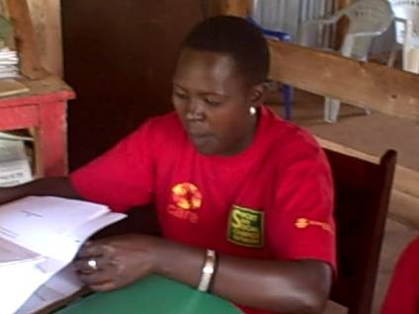
250 children, girls, youth and elders directly participated in the discussions on this harmonized draft constitution. They shared with passion what they hope this constitution should contain. Children were particular about protection, medication and education. The girls want a constitution that looks at their unique needs especially reproductive health, entitlement to inheritance and access to equal opportunities.

The youth being majority in the population feels sidelined as the harmonized draft constitution only has two paragraphs which define them. They want a more presence in the constitution which also gives them at least 5% of all elective and appointive bodies.

The elders and community members were very clear about agriculture. Kenya depends on agriculture for its economy and it’s unfortunate that nothing significant is mentioned in the constitution about it. They want agriculture enshrined in the constitution. Security ranked second and they want every Kenyan security protected by the constitution.

TYSA wants Sports enshrined in the constitution. We are known worldwide as a sporting nation. It is up surd if we do not back this by an inclusion into the constitution
We thank all those who contributed to this project. Globalgiving sponsors and KCDF for donating the Harmonized Draft Constitution of Kenya Copies

TRANS-NZOIA YOUTH SPORTS ASSOCIATION (TYSA)
P.O BOX 2511-30200, KITALE, KENYA.
0203530057, 0725 200099, 0721 115487
Email:tysaktl@yahoo.com,info@tysak.org Website: www.tysak.org, www.tysakenya.ning.com

PEOPLES’ FEEDBACK
14/12/2009
HARMONIZED DRAFT CONSTITUTION OF KENYA
Community Elders and Members input.
They had the following input:
- Agriculture be recognized and be supported by the constitution and measure put in place to PROTECT farmers. Agriculture is the back bone of our economy and livelihood
- That the president is directly elected by the people of Kenya and he or she is authority to rule the country. ‘ we don’t want position of the prime minister’
- Citizen security be explicitly outlined in the constitution and be made one of the Human Rights
- The constitution to state clearly the citizenship of a Kenyan is not by Identity Card. Scrap the section in the Identity Card which asks where you were born and replace it with where you stay. This is to promote nationhood
- Citizen above 60 years receive pension regardless of whether they were employed by government or private firms. They should receive FREE medical treatment
- Medical Care be made Free to all
- Marriage Certificates be issues through the village elders to strengthen family
- The constitution to declare the number of voters each constituency should have. Both the minimum and maximum
- The constitution should state that in order to recall a seating Member of Parliament 25% of the total registered voters is needed
- Remove the Kadhi Court. We are all equal in the eyes of this constitution
- Make secondary education free and compulsory for the country to industrialize
- It is our concern that so much power is being given to parliament to enact the unfinished business in this constitution. This is dangerous.

Youth Input
The youth represent a large proportion of the Kenyan population, yet this they are on the periphery of the constitution;
- Youth should be included in all the aspects in article 13 on the National Values and Principles;
- Ensuring full participation of youth
- At least 5% of members of elective or appointive bodies shall be youth
- Recognizing special responsibilities to youth with disabilities
- Under the Bill of Rights addition inform on article 40: every youth has a right to:
- Protection from discrimination, neglect or abuse
- Not to be subjected to violence,
- Not take part in hostilities or recruited into armed conflict and be protected from situations of armed conflict
- Youth ministry and departments for youth be held by the youths
- Sports is enshrined into the constitution

Girls Input
In recognizing the unique needs of the girls, the constitution to make provision:
- Free sanitary towels
- More girls schools
- Increase job opportunities for girls
- Free secondary school for girls from low income families
- Girls friendly health facilities
- Vocational training facilities for girls
- Family inheritance for girls be enshrined in the constitution

Children Input
In very simple terms, the children want a constitution that:
- Ensures all children go to school
- Protect them from parental abuse
- Food, shelter and clothing are provided by family and or state
- Free medical care for all children and should not be compelled to bring their parents before receiving treatment. A child should walk into a hospital and be treated.
- Right to play is enshrined in the constitution. We want to play

Participants and distribution
Category | No.
Children | 30
Girls | 43
Youth | 148
Elders and community Members | 29
Harmonized Draft Constitution Copies distributed | 46

