Lutisuc - Mexico
Sonora is a state, located in the northwest of Mexico, in the border with Arizona, USA. It has 7 different native ethnic groups: Yaqui, Mayo, Pima, Seri, Cucapá and Tohono O’tham, plus the Kickapoo people, who migrated and established in Sonora a century ago; recently, new migrant groups precedent from the south of Mexico have arrived. In all cases, their ancestral culture still maintains the basic characteristics, but because of the constant contact with occidental culture and the globalization that the world is confronting, they are loosing little by little their cultural identity. During this process of culture mixing, the mother tongue plays a very important role, because the language is where each group expresses their values, traditions and their way of seeing life. Most social problems could be prevent or diminish through actions that strengthen the person essence and dignity, and also having in mind the values and elements that conform their cultural identity.
Because of this, Lutisuc is giving special attention to the project of elaborating didactic material in native languages and Spanish, to provide extra support to the bilingual teachers that are working really hard on maintaining these minority languages alive. This material is thought to work with kids from kindergarten through elementary school. While playing they are also practicing their mother tongue. This material is printed with live colors or black and white inviting them to coloring it, easy designs and bilingual texts that are always related to their cultural tradition.
Other important activities of this program are the artistic stimulation workshops. Lutisuc’s team and plastic artists that we invite to join us go to the communities and play with the kids, their parents and teachers. For at least a week each time, full time, the kids draw, paint, learn about different artistic techiniques, and most important, see, listen and learn while playing, about their heritage.
The program where all this is developed is called “Learning by playing”. We have collaborated with different communities like the Pima, Seri, Mayo and Yaqui tribes by doing didactic material in their native languages.
The main objective of this program is the preservation of the language as a culture foundation of the different ethnic groups located in Sonora. By making these didactic games, the kids of the communities become more interested in their own language, and start practicing with their parents and friends different words. This is also a way to learn Spanish for those who don’t speak it.
Next, we present a recompilation of the projects that we have done in this program, which conforms the “Aprender Jugando” (Learning by Playing) Collection:

LEARNING BY PLAYING
The first project in this program was made in the year 2003 and it was a didactic material in Yaqui language. The drawings in this project were made by boys and girls from a yaqui community. Every drawing had the word in yaqui for that object and also in Spanish and has a special meaning for their culture. | 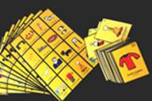  Lottery and Memory Game
The second project (2004) in the “Learning by Playing” program was with the Pima community. The drawings where also made by boys and girls from the Pima group. Every drawing had the name for that object in pima language and also in Spanish.  Lottery and Memory Game | 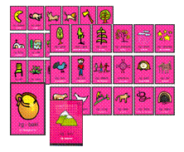
The third project (2006) is a memory game, and we worked with girls from the Seri group, this time the game is focused on sea animals from the gulf of California. These animals are very important for this ethnic group, they live by the sea so, these are all animals that they observe in daily basis. | 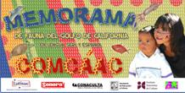  Memory Game
The fourth project (2006) is a booklet with a Yaqui legend called Ju’u Suawaka La Estrella Fugaz (Shooting Star), a text in Yaqui and Spanish. | 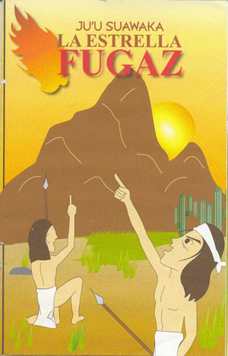
The Fifth project (2006) is a booklet in Yaqui and Spanish named Jabesa Ne? (Who/What am I?) , where kids can have fun completing and coloring the different drawings and solving the riddles in it. | 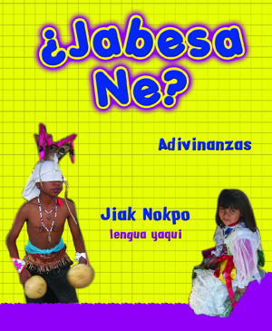
The Sixth project (2007) is a booklet in Yaqui and Spanish called Jiak Nok Jiawaim (Yaqui Alphabet) a working notebook for elementary school kids. | 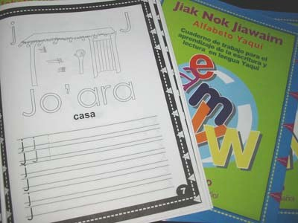
The Seventh Project was supported for our Global Giving friends! (2008). Iti’s a CD called Ili Usi Bwikam (Kid singing) that contains 15 different songs for kids in Yaqui and Spanish, with a little booklet where you’ll find the lyrics for each song in both languages. | 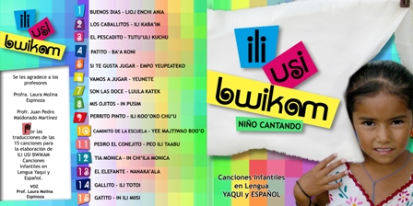
The eighth project (2008) is The Yoreme Mayo Marathon, a bilingual board game with 240 questions about the history, tradition and actual life of the Mayo people. | 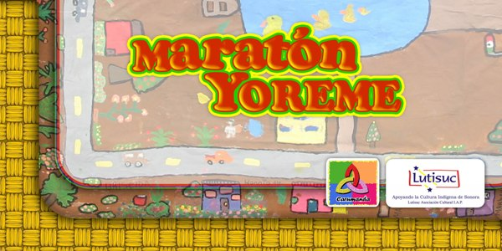
The ninth project (2008) is the one put in consideration to Global Giving, a Lottery and Memory Game in three languages: Kickapoo, English and Spanish. Here, we show you some of the kid’s drawings. | 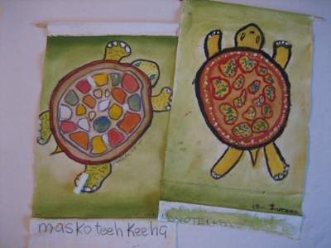
Lutisuc and PETY worked together to accomplish the fourth, fifth, sixth and seventh projects. PETY (Educative Project for the Yaqui Tribe), is an organization of the Yaqui tribe that work, since 1994, in the creation of didactic material for kids of elementary school, and new methods for teaching and learning in classrooms with an intercultural bilingual view, and at the same time give strength to the investigation and development of the yaqui language and culture.
With the other groups (Pima, Mayo, Seri, Kickapoo) we work with prominent members of their communities (traditional authorities, cultural promotors, mentors, etc.)
When each project is ready, Lutisuc always provides first the indigenous community with the didactic material. This project is thought to be used in classrooms and homes but is also thought to leave a small part (10% - 15%) of them to offer and make donations, so children and teachers from non-indigenous schools can learn more about indigenous children across Sonora, and begin to understand each other. If it is money recauded from this material, we will use it for reimpresion of more didactic material.
This is a way of accomplish our strategy of working in three areas: in indigenous communities; in the urban population of Sonora, particularly among those of substantial means; and, most crucially, in bridges between the two.
Our current project it’s going to be our first material in three languages, considering that Kickapoo people have three of them: Kickapoo, English and Spanish. The Lottery and Memory Game is going to have 54 images, make from drawings of the Kickapoo kids. Animals, the colors, members of the family, etc., will be present in it, so the children can play and learn at the same time about the Kickapoo heritage. We’ll print 300 sets; a Lottery and a Memory Game by set. For that, we need $1,500.00 dollars. Our Global Giving friends can be sure that their donations will be very good receive and apply totally and directly to this goal.

August, 2008.

