PROJECT REPORT

IMPACT ANALYSIS
OF
MANDESHI TARANG

(THE COMMUNITY RADIO OF MHASWAD)

Prepared by: Anuradha Ray

Date: 2nd April, 2009

Situation-
Mandeshi Tarang a community radio running at 90.4 MHz was started in 16th December’08 under the aegis by Mann Vikas Samajik Sanstha a NGO working for the empowerment of rural and marginalized women in Satara District of Mhaswad and Hubli & Dharwad in Karnataka. The NGO also intends to be a partner in the growth and overall development of all, irrespective of caste; creed; sex; religion etc. in Mhaswad and other villages of the Satara district.

Target group is the people of Mhaswad and surrounding areas under coverage.
Main aim of the Radio Station is to become an effective medium for the people to share views, showcase talent, gain knowledge and increase awareness ensure overall social; economic and cultural growth of the area.

Why this impact analysis is important-
It is a community radio by the people, for the people and of the people of Mhaswad and surrounding areas. The radio station has been broadcasting programmes since last 4 months or so (started from the 16th December 2008). Therefore getting a feedback from the community and acting upon the outcomes of the feedback and suggestions becomes essential for those who are responsible to take it forward by giving due cognizance to likes, dislikes and expectations of the people which have been expressed through the survey conducted.

Survey size-
Number of people surveyed-120

Findings-

It was found that:
- Out of 120 people who were surveyed 20 people had not heard of Mandeshi Tarang. 6 out of 22 females and 2 out of 16 children are not aware of Mandeshi Tarang.

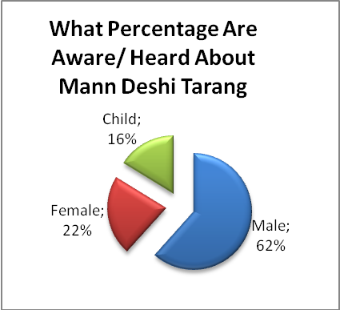
- It was good to know that a number of people i.e. 44% bought a radio after coming to know about Mandeshi Tarang.
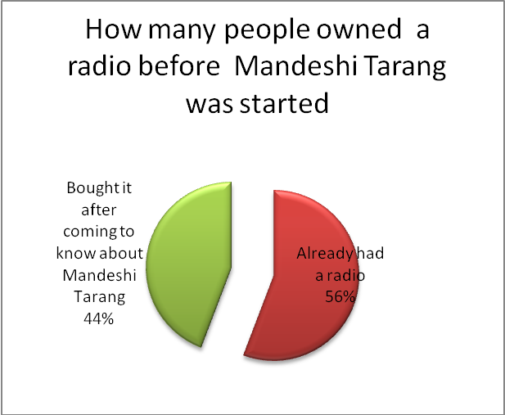

3.Majority i.e.91% said they liked listening to Mandeshi Tarang.

4.Program Preferences-
a.52% people stated that they like listening to Mandeshi Tarang because the programs broadcasted are of their choice.
b.An interesting finding is that irrespective of the age group, jokes and stories top the list, while kitchen tips and information from Tadnya is least preferred at 3% and 2% respectively.
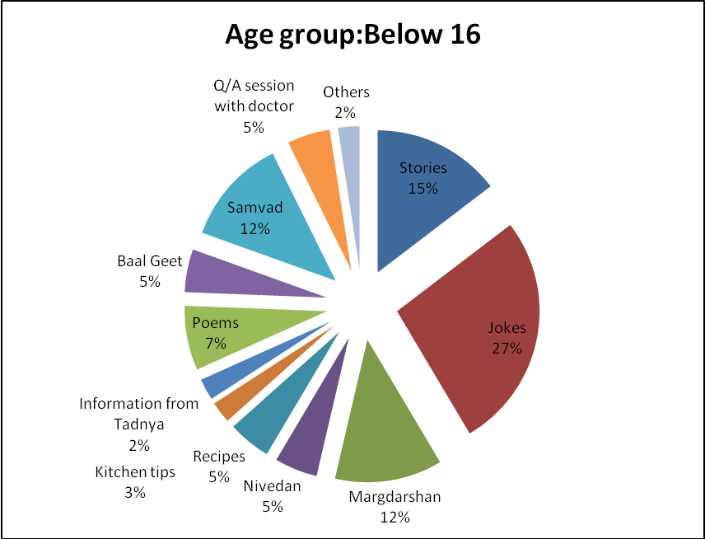

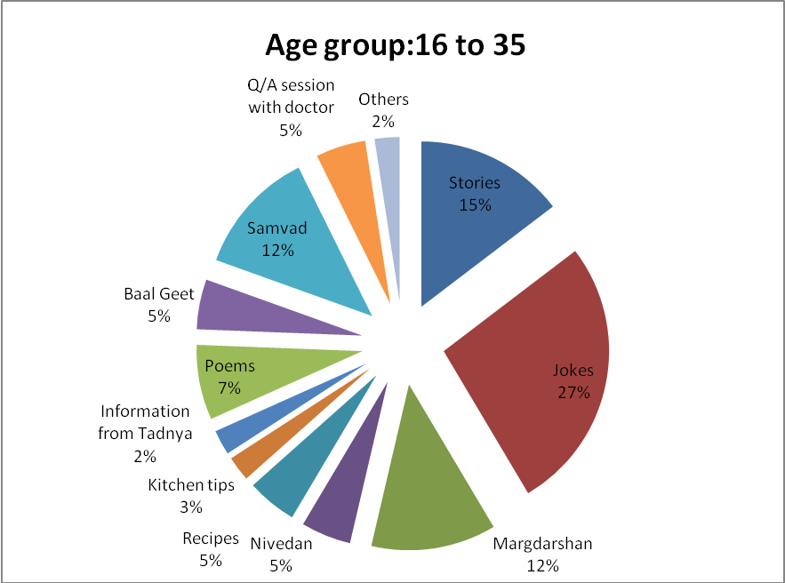

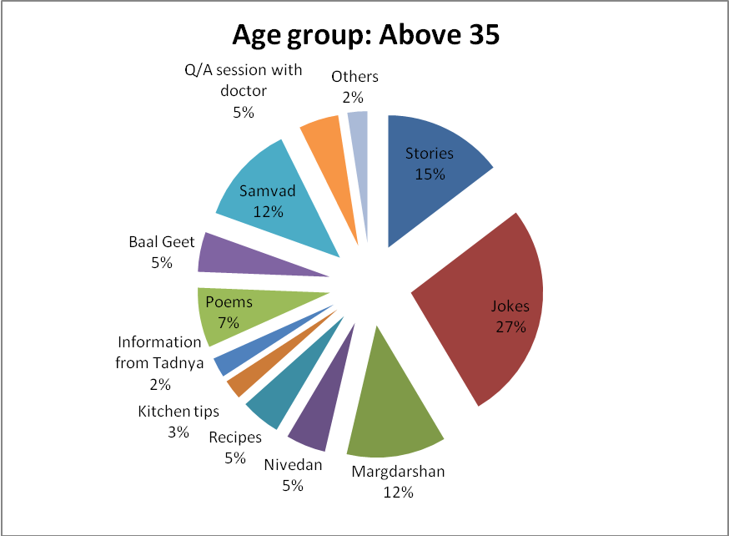

c. Another notable finding is that one-fourth of the people like listening to radio because they are impressed by the announcers. 46% people found the announcers liked because of their communication skills.

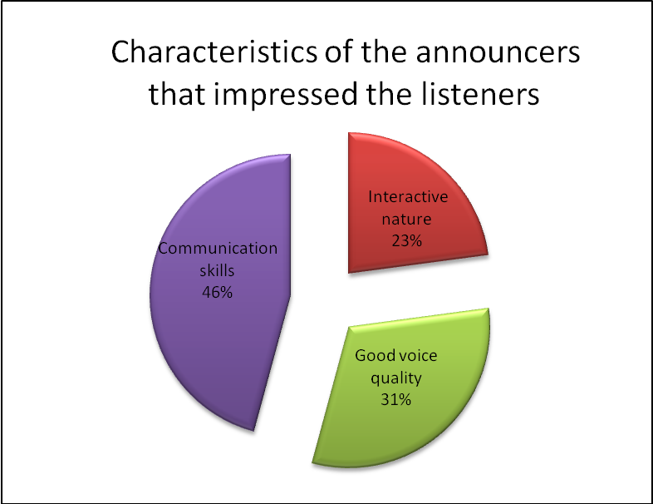

d.Out of the 9% who did not like listening to Mandeshi Tarang, 46% stated programs as boring to be the reason.

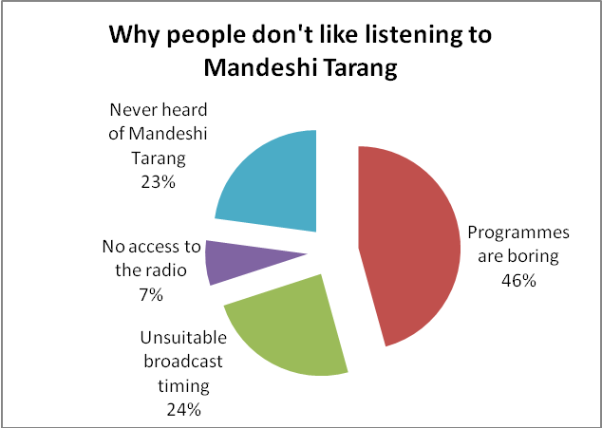

5.Time-

- Majority of the people i.e. 63% think the timing of the broadcast is correct.
- Most of the people listen to Mandeshi Tarang daily(46%) or atleast more than 7 times a week(38%). The morning time slot (49%) is the most preferred slot.

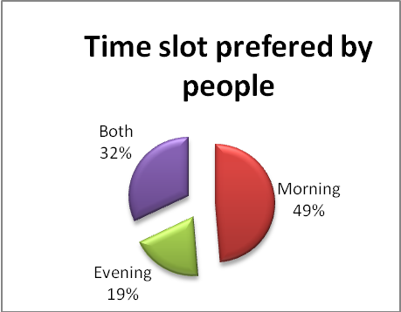
6. Utility-

a.73% found Mandeshi Tarang has proved to be useful to them in their life – by increasing their knowledge; enabling them to showcase their talent and motivating them.

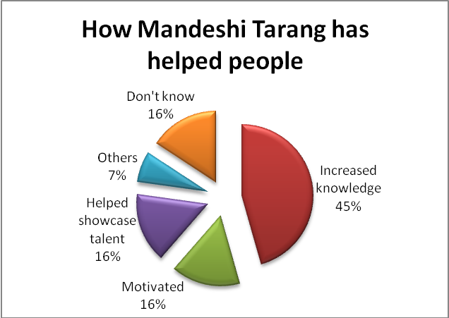

b. Of the 30% of the people who want more entertainment programmes to be included, 91% are more than 16 years old. Majority of the children (66%) want value education to be a regular part of Mandeshi Tarang.

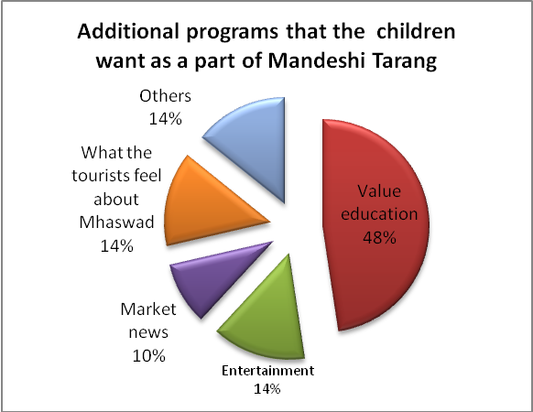

7. Others-
Almost 67% of the people had not given any feedback earlier.
Few of the feedbacks given by people are-
- The radio station is doing a fabulous job.
- More entertainment based programs should be included.
- The time slot needs change.
- Awareness of first aid and other common diseases & medical problems should be provided through various programmes
- More songs should be played

Observations & Suggestions-

- Many people are not aware of Mandeshi Tarang itself so it is vital to create awareness about the Radio Station.
- Quite a good number of people tune to the radio only at 7:30 am which is why they are missing the 1st ten minutes of daily broadcast. Therefore programs might be started on standard IST commonly acceptable like 7 O’clock or 7.30 O’clock or so.
- Few people expressed getting bored while listening to radio programmes due to
(a)monotony in the program formatting ;
(b) few programs are presented as monologues.
- One common comment received was that in few programmes of interview and conversation it appeared that statement/dialogues are being read from written text/ books
- Majority have not participated in Mandeshi Tarang (57%). Many are not even aware that they can participate in and contribute to Mandeshi Tarang. So, Mann Deshi Tarang may make special effort to create awareness among the community by specifying how people can participate and contribute, like they may be told to
  - Convey their wishes (birthdays; wedding; festivals etc); condolences (on death; accident etc)
  - Write script
  - Get their songs and story narrations recorded
  - Advertise their products & services
  - Sponsoring programmes
  - Giving quality and timely feedback, etc.

****************************************

Vote of Thanks
I would like to convey my sincere thanks to Chetna Madam for providing me the opportunity to get the feel and experience the working of the community radio and get associated with it and letting me to do the project titled “Impact Analysis of Mann Deshi Tarang (The Community Radio of Mhaswad)”.

I also thank to the entire team of Mann Deshi Head Office & Mann Vikas for their guidance, support and cooperation.

Special thanks to Vijay Bhau, Rekha Madam, Vanita Madam, Yadav Sir, Mahesh and Shubhangi- without their involvement, mentoring and encouragement, it would not have been possible for me to complete the project.

Last but not the least, I extend my heartful thanks to the people of Mhaswad who took keen interest and used their valuable time, energy and effort to suitably answer the survey questionnaire to enable me to cull out the data and subsequently assess and analyse the impact .

Anuradha Ray

