Project Title: Trees Cultivation to Lessen Impact Global Warming
By Andi Asriadi Rauf

Summary
Funds provided by the Global Giving donors $ 1461.25 and using to bought 690 trees; 150 mango trees, 150 nephelium tree (lychee) seeds, 100 teak tree seeds, 100 guava trees, 100 starfruit and 90 trees mahogany on January 16, 2010. Next the tree we planted together with residents in several locations in West Java includes tree planting in front their houses.
Approximately 15 people to be volunteers in planting these trees because they thought this program very useful, because the trees planted to produce fruit that can be sold to meet household needs.
Meanwhile, star fruit trees, and guava trees planted in the garden of stone people, and is expected in one year was fruitful, and the results can be sold in the market to meet the needs of the family.
To date a total of trees we have planted 1662 trees are scattered in west Java province. So that this program will continue to planting trees mangrove in the coastal sea of Java in Sukabumi and your support always needed so that our target of planting 1 million trees can be realized.
Haris local community say, "Contributions and tree planting is very useful for people, because in addition to making the environment cool and beautiful, also provide lessons for local people to love their environment, and productive trees will help other people to meet the needs of families, because the fruit is very easy to sell on the market. Therefore, we would like to thank the donors who have provided assistance through Puspem Foundation and we also hope that this assistance can be continued so that this program can be replicated in other areas in Indonesia.

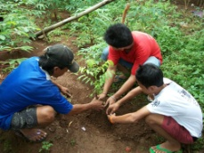 | 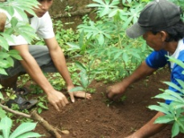
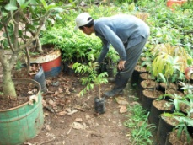 | 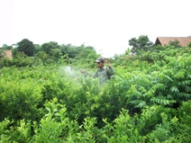  Puspem garden trees nurseries
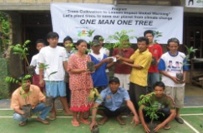 | 