Kilimanjaro Association of the Spinally Injured
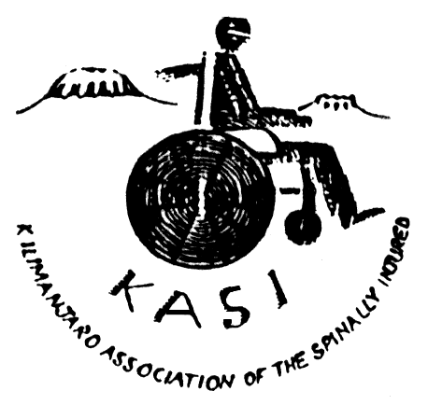
KASI

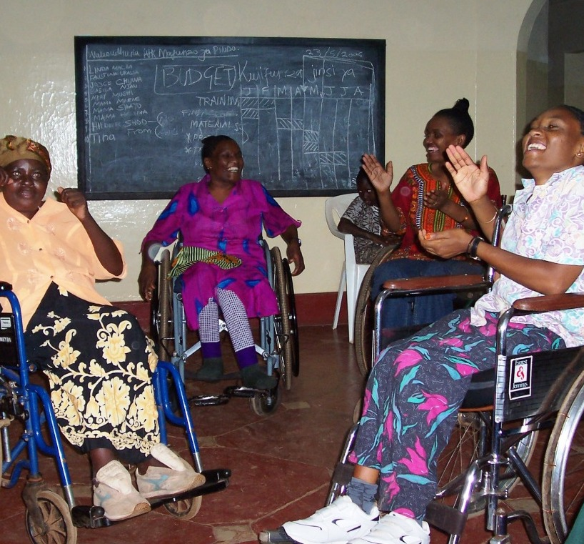 | 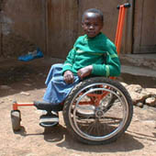 | 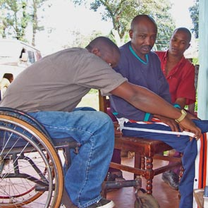
Women with spinal cord injury have specific challenges. KASI provides a forum for disabled women to meet and plan ways to improve their lives through mutual support, income generation programmes and sharing life skills. | Less than 2% of disabled children attend school. Children with mobility disabilities require wheelchairs and accessible schools to be able to receive their right to education. KASI lobbies for inclusion of disabled people in all aspects of society. | KASI Member Abdullah trained as a professional Wheelchair Technologist and now makes appropriate, locally made wheelchairs for other disabled people. KASI’s Wheelchair Financing Committee works to raise funds to contribute to the costs of wheelchairs for members who cannot afford them

Kilimanjaro Association of the Spinally Injured

P.O. Box 10034,
Moshi,
Kilimanjaro,
Tanzania.

Tel: +255-27-2754217
Mob: +255-754-268-149
Email: kasi_kili@kilionline.com
kasi_kili@yahoo.com

HISTORICAL INFORMATION ABOUT KASI

In 1991, the current Executive Director and founder of KASI, Henry Nyamubi managed to mobilize his fellow disabled compatriots who willingly supported the idea of forming the Kilimanjaro Association of the Spinally Injured (KASI). It started as a self- help group of spinally injured people who live in Kilimanjaro Region, with a view to undertake initiatives of addressing issues that affect them as a result of their disability. KASI is a voluntary community based membership association, not for profit, non-political, non-governmental, that is controlled by men and women with spinal injuries, aiming to mobilize other people with disabilities to bring about lasting changes for the benefit of all persons with disabilities.
It is the first organisation of its kind in Tanzania and East Africa. KASI is officially registered under the Associations Act with the Registrar of societies, Ministry of Home Affairs, on 08/04/1993, as Society No. SO.7744. KASI works by the principles guiding Non Governmental Organizations (NGO Policy) in Tanzania to fulfill its objectives in the best interest of its members. We are the only organisation that represents the unique needs of people with spinal cord injuries (SCI) in Tanzania, as well as addressing wider disability issues. KASI operates from offices currently located within YWCA buildings in Moshi Kilimanjaro.

BACKGROUND TO SPINAL CORD INJURY AND THE FORMATION OF KASI

Spinal Cord Injury is a condition that results from injury or trauma to the spinal cord resulting in mobility and sensation disability. In Kilimanjaro region 40-80 people get Spinal Cord Injury every year from motor accidents, falling from a height, falling while carrying a load on the head (particularly women), mining accidents and TB of the spine.
Estimates suggest that the incidence of Spinal Cord Injury is 40 cases per million. There are approximately 1,380 new cases each year in Tanzania, but in total only 100 - 120 people are treated per year in all hospitals. The majority of sufferers are young people from both sexes who are much depended upon by their families.

It is generally a miracle to survive more than 2 years after the injury. Those who eventually survive, face tremendous difficulties as a consequence of disability involving loss of movement and sensation.
Spinal Cord Injury brings with it the end to educational and employment opportunities. Living conditions are very poor, because village homes cannot meet a disabled person’s needs. Due to mobility restrictions and isolation, depression sets in, often leading to rapid deterioration of health.

Rehabilitation services are few and far apart, and assistive devices like wheelchairs, urinary equipment are not readily available to most people in Tanzania. There is a serious lack of skills and facilities to deal with Spinal Cord Injured people, and it is not a well-understood condition even among medical and social professionals in the country. Spinal Cord Injury is a killer disability in Tanzania where most people die within 2 weeks to 2 months from complications arising from their injury, pressure sores and UTI being the major causes of death.

People with spinal cord injuries can lead productive lives if they can get adequate treatment and rehabilitation; and if the society they live in is ready to adapt to their needs and concerns. They can do most things that the rest of the community can. They can work, study, socialise, have relationships and have a family of their own.

OUR VALUES
Kilimanjaro region has a population estimated at 1 500,000 people.
People with spinal cord injuries are marginalised, and are overlooked by mainstream development interventions. This makes them some of the most deprived and vulnerable people in low-income countries. Mobility disabled people are among the poorest of the poor as a consequence of their disability. “Disability is both a cause and a consequence of poverty. Eliminating world poverty is unlikely to be achieved unless the rights and needs of people with disabilities is taken into account”

Women in particular face a ‘double discrimination’ and all our programmes make special provision for advancing the position of disabled women. The KASI Women’s sub-committee (KASIWOC) is working to tackle the stigma and exclusion faced by individuals who are disabled and female.

KASI believes that people with spinal cord injuries can lead productive lives if they are provided with adequate treatment and rehabilitation; and if the society they live in is ready to adapt to their needs and concerns.
KASI believes that disability is a human rights and social issue related to attitude and access to equal opportunities and we subscribe to the social model of disability as opposed to the medical model.

We believe that all people have the same fundamental rights to determine their own futures and control decisions that affect their lives, and that all people have the same rights to:
- Education, Mobility, Enough food and clean water, A livelihood, A home and relationships, Health care, Safety and Recreation

We in KASI believe that people with disabilities are their own most powerful advocates, and strive to build a democratic, representative and dynamic organisation, which actively campaigns for the rights of ALL people with disabilities.

KASI recognises that Women and girls with Disabilities experience particularly severe oppression and exploitation. Special care is taken to support initiatives of Women with Spinal Cord Injury and other disabilities to raise their status in society.

KASI does not discriminate on the grounds of race, colour, nationality, age, religion, tribal or ethnic origin, gender, sexual orientation, marital status or impairment.
We uphold values of integrity through accountability, honesty and fairness in our operations.

KASI’s VISION, MISSION & OBJECTIVES

VISION
The vision of KASI is “The Best and sustainable life for people with Spinal Cord Injuries”

MISSION
The mission of KASI is to “effectively facilitate the rehabilitation and social reintegration of people with spinal cord injuries.”

KASI’s work involves:
- Advocating for basic rights and equal opportunities in health, education, access and employment.
- Increasing knowledge among persons with Spinal Cord Injury about health issues associated with Spinal Cord Injury, and raise community awareness of spinal cord injury.
- Addressing poverty through skills training and income generating activities for its members.

KASI objectives include:

- To promote the rights and welfare of persons living with Spinal Cord Injury
- To raise awareness on the situation of people with Spinal Cord Injury and provide correct information about Spinal Cord Injury
- To assist people with Spinal Cord Injury to organise themselves and pursue initiatives that will improve their quality of life
- To advocate for inclusion and full participation of disabled people in the mainstream of their social-economic community life
- To work in collaboration with other organizations which deal with Spinal Cord Injury, other disabilities and rehabilitation

ACIVITIES
In order to achieve its Objectives, Mission and Vision, KASI implements the following activities:
- Members’ training meetings to increase their knowledge about related health and social issues
- Assisting members to access appropriate wheelchairs and other essential assistive devices
- Supporting initiatives of Spinal Cord Injured people especially women to raise their status in society
- Providing individual and group counseling
- Conducting regular home visits to KASI members who are already at home
- Supporting the establishment of income generating activities for its members
- Promoting local production of appropriate assistive devices and availability of proper medical and rehabilitative care for Spinal Cord Injured people
- Promoting recreational activities for people with disabilities
- Collaborating with other Disabled People’s Organizations (DPOs) to influence government and development agencies to adopt disability inclusive policies

It is estimated that between 300-500 people with Spinal Cord Injury live in Kilimanjaro region and our activities benefit more than 1000 people.

MEMBERSHIP
Membership is voluntary and is open to persons with spinal cord injured in Tanzania. KASI has Associate and Honorary membership. Currently KASI has more than 100 active members who can attend at meetings regularly and has documented over 250 people with Spinal Cord Injury in all the 5 Districts of Kilimanjaro Region.
Although KASI was formed to focus on issues and concerns of people with spinal cord injury, the constitution allows members who have other forms of disabilities and non-disabled people.

MANAGEMENT
The Principal organs of KASI are the General Assembly and the Executive Committee and the Secretariat. The General Assembly is composed of all the members and is the supreme organ of KASI. The Executive Committee, or other organs established under its authority are subordinate and accountable to the General Assembly. The Executive Committee has the authority to appoint the Secretariat and various sub committees. The Executive committee holds quarterly meetings and the Membership meets twice annually.

The KASI Secretariat currently consists of the Executive Director, Bookkeeper and an Administration Secretary

KASI has strengthened its capacity through input and training of its elected leadership. They are highly knowledgeable on their roles in the functions of the organisation resulting in the organisation being democratic, transparent and accountable.
KASI staff have been trained in skills on how to manage the day-to-day activities of the organisations, planning, implementation and monitoring of activities. KASI has in place internal policies, improved management and organisational systems of operation, annual work-plans and a 5-year strategic plan. At KASI we are acutely aware of the need for volunteers to help especially in fund raising missions.

KASI PARNERSHIPS, NETWORKING AND RELATIONSHIP WITH GOVERNMENT, OTHER AGENCIES, DPOs AND NGOs

KASI has built links and maintains strong relationships, networking and collaboration with various stakeholders, at the local, national and international levels.
Through working on common disability issues, KASI raises the profile of people with spinal cord injuries. We collaborate with other local DPOs, the national disability umbrella federation, Government, NGOs, INGOs, and public service providers. The following are some examples:
At local level KASI has excellent demonstrable relation with local and central government. KASI has spearheaded celebrations by all local DPOs of the International Disability Day, and the formation of an umbrella federation of DPOs (SHIVYAWATA). We collaborate with other agencies like the Kilimanjaro CBR Programme, K.C.M.C. and TATCOT, Mawenzi Regional hospital and TACAIDS Regional Facilitating Agency. At national level, KASI’ work is recognised by the Ministry of Health and Social Welfare, World Health Organisation county office, The British High Commission, Rotary Club, and the VodaCom Foundation among others. KASI has been consulted extensively on issues of National disability policy and MKUKUTA (PRSPs). Networking between KASI and SIAU, DWSO, KPO and QUAPAZ has been invaluable to share ideas and experiences. We have participated at International forums on Mainstreaming disability into development aid, Millennium Goals and disability, developing wheelchair standards and developing guidelines on CBR.
KASI has received requested to establish chapters in Arusha, Tanga and Dar es Salaam.

SUMMARY OF CURRENT KASI PROGRAMMES
Prior to the formation of KASI, there were hardly any meaningful services such as education, health, provision of mobility appliances and rehabilitation being provided to people with spinal injuries. Many people with spinal injuries remained ignorant of their human rights, accessibility to health and mobility appliances, because they lacked a forum to articulate their needs. Spinal Cord Injury curtailed their educational and employment opportunities, as they also never participated in any meaningful programmes to improve their status, a factor that contributed to their slow general development.

1. Peer Group Training
This aims to improve the quality of life for wheelchair users, in particular people with Spinal Cord Injury, through the sharing of knowledge and experience by providing appropriate rehabilitation services (peer-group training) to improve the health, mobility and independence of people with spinal cord injury so as to facilitate their greater participation in society.

2. Local Production and Distribution of Appropriate Wheelchairs
This aims to support people with disabilities, in particular Spinal Cord Injured persons, to access appropriate wheelchairs that meet their individual needs, and promote their reintegration into mainstream society
KASI has established a Wheelchair Financing Committee (WFC), which coordinates the provision of appropriate, locally made wheelchairs to directly reach people with Spinal Cord Injuries. Beneficiaries experience greater mobility and independence and are able to participate in wider initiatives for their improvement in quality of life, greater self-esteem and dignity, and increasing potential for income-generation. The wheelchairs are produced at Wheelchair Workshops in Moshi, and Arusha.

3.Tie & Dye and Batik Production by Disabled Entrepreneurs.
This aims to reduce poverty of people with spinal cord injuries through the creation of sustainable livelihoods. The project supports the establishing and equipping of an accessible workshop for disabled entrepreneurs to produce goods for sale. Training will also be given to increase the range and quality of production.

4. A Study on Factors that can Promote Self Care Among Persons with Spinal Cord Injury in Tanzania: This aims to determine ways of enhancing self-care among PWSCI in Tanzania.
This study tests a new paradigm for care of the medical aspects of disability on a premise that a large proportion of disability can be adequately managed through self-care. This approach would reduce dependency on professionals; facilitate more efficient use of medical resources and lead to improved self-esteem and quality of life among those affected. The WHO Disability and Rehabilitation Unit (WHO/DAR) and AIFO – Italy, support this research initiative.

5. Disability Networking Among Organisations In Kilimanjaro
This aims to establish a joint effort by organizations in the Disability Sector to advocate for improved policies and their implementation for people with disabilities in Moshi district. All Disability Organizations in Moshi join to advocate and lobby for improvement in implementation of policies that affect people with disabilities (especially children); and increase understanding on existing policies that affect people with disabilities, understanding on disability awareness and rights issues

6. Mainstreaming HIV/AIDS Into Disability Organisations
This aims to advocate and lobby for inclusion and equal participation of all disabled people in the fight against HIV/AIDS.
KASI in its effort of mainstreaming HIV/AIDS into Disabled Peoples Organizations has established the project as one of strategies that will address the risks faced by disabled people in the fight against the HIV/AIDS pandemic through influencing policies, legislations, economic, social and political development structures in Moshi (Urban) district.

DFID Issues Paper on Disability, Poverty and Development February 2000 p 1

