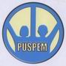
Education for 100 Banda Aceh Orphans
By Andi Asriadi
Summary
Education programs in Bakoy refugee barrack, Banda Aceh today is still implemented, although with very limited funds, still waiting for help from GlobalGiving donations. The results of monitoring and evaluation conducted on January 7, 2010 shows encouraging developments, because the average students who participate in this free educational programs get high grades in their respective schools.
Puspem need to convey that educates children who until now still get coaching, as well as parents today continue to expect help from GlobalGiving donations. While children who have moved students in housing that prepared by the government are still many who often come to learn for free at the barracks evacuation. That's why this program is meant for young students.
One named Maulina student who have moved into housing that has been prepared by the government saying, "I along with my friends almost every day at learning always came to study in this barrack evacuation because I love learning how to really discuss the matters, so easy to digest, and all issues discussed and learned exactly what was taught by teachers in schools. Therefore, it is hoped to donate to GlobalGiving this free educational program can also be carried out near the housing of the victims of the earthquake and tsunami disaster ".
We have received donation $ 32.50 from GlobalGiving and have used for implementation our program in Bakoy refugee barrack.
You can see all our activities from film project belows;
- Education for Tsunami orphans 1 http://www.youtube.com/watch?v=6QmcNJoK2Kg
- Education for Tsunami orphans 2 http://www.youtube.com/watch?v=E8sAmOlNriM
- Education for Tsunami orphans 3 http://www.youtube.com/watch?v=jlaaCgV1f74
- Education for Tsunami orphans 4 http://www.youtube.com/watch?v=PL_rvSRljIg
- Education for Tsunami orphans 5 http://www.youtube.com/watch?v=mR8YDGT30eg
- Education for Tsunami orphans 6 http://www.youtube.com/watch?v=gLgtEMJIRJo
- Education for Tsunami orphans 7 http://www.youtube.com/watch?v=Og_wC22krVI
- Education for Tsunami orphans 8 http://www.youtube.com/watch?v=CHjaJoDSO7E
- Education for Tsunami orphans 9 http://www.youtube.com/watch?v=qM1E2qOVpSs
The needs of today in this project, among others;
1) Additional nutrition for children
2) Help the school facilities
3) Salaries of teachers / volunteers who devote themselves in this program.
4) Scholarships for children orphaned.
Therefore, your help will mean so much to rebuild their life after an earthquake and tsunami destroyed this province. Again, we wish you many thanks for all your help and attention to Acehnese orphans children of tsunami victims.
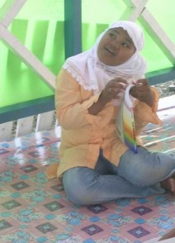  Maulina one student who always came to bakoy counseling to learn | 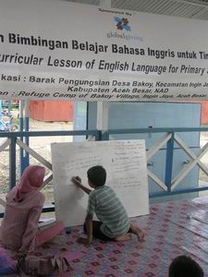
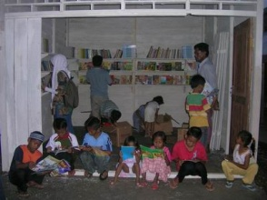  Puspem Library in Bakoy refugee barrack | 