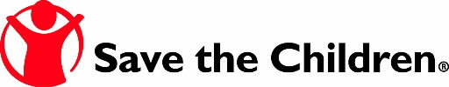

Yordi: Helping his Family through Safe Water and Healthy Practices

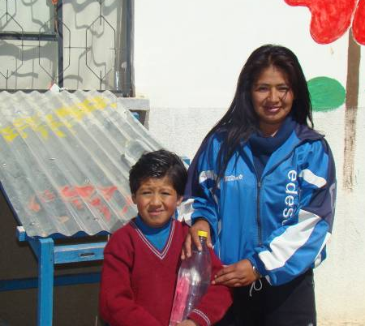

Yordi with his mother Maria with a SODIS bottle and
the SODIS structure to disinfect their family’s water.

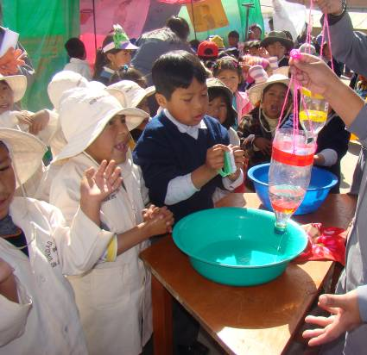

Children learn when and how to properly wash their
hands with soap and water.

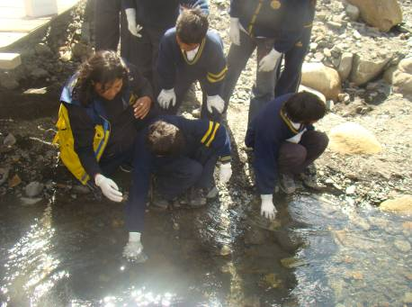

Children learn how to test and analyze nearby water sources to ensure that safe water is available so that their families will not get sick.

