1.1.1. Football competitions, tournaments and trainings:

This first football competition brought together 12 schools from UNICEF child friendly schools. These teams were selected from all over the country and were made of girls aged 7 to 13. The purpose of such an activity is to inculcate the culture of sport in the mentality of the Rwandan youth, much as a new culture can be ingrained from an early age, most girls and women will be able to campain against genderbased violence and their rights through sports as well as they grow up. The overall objective was to empower women through sports. This event took place in four different Provinces namely Kigali City, Western, Eastern Pr I and Eastern II. Each Province had three primary school teams that competed and the winners were Kanyiya (from Kigali City), Rubona (Western Province), Rubona Ngoma (Eastern Province I) and Kiziguro (Eastern Province II). The 2 teams that came first received sports equipment (whistle, balls ...).

These are the winners of that competition
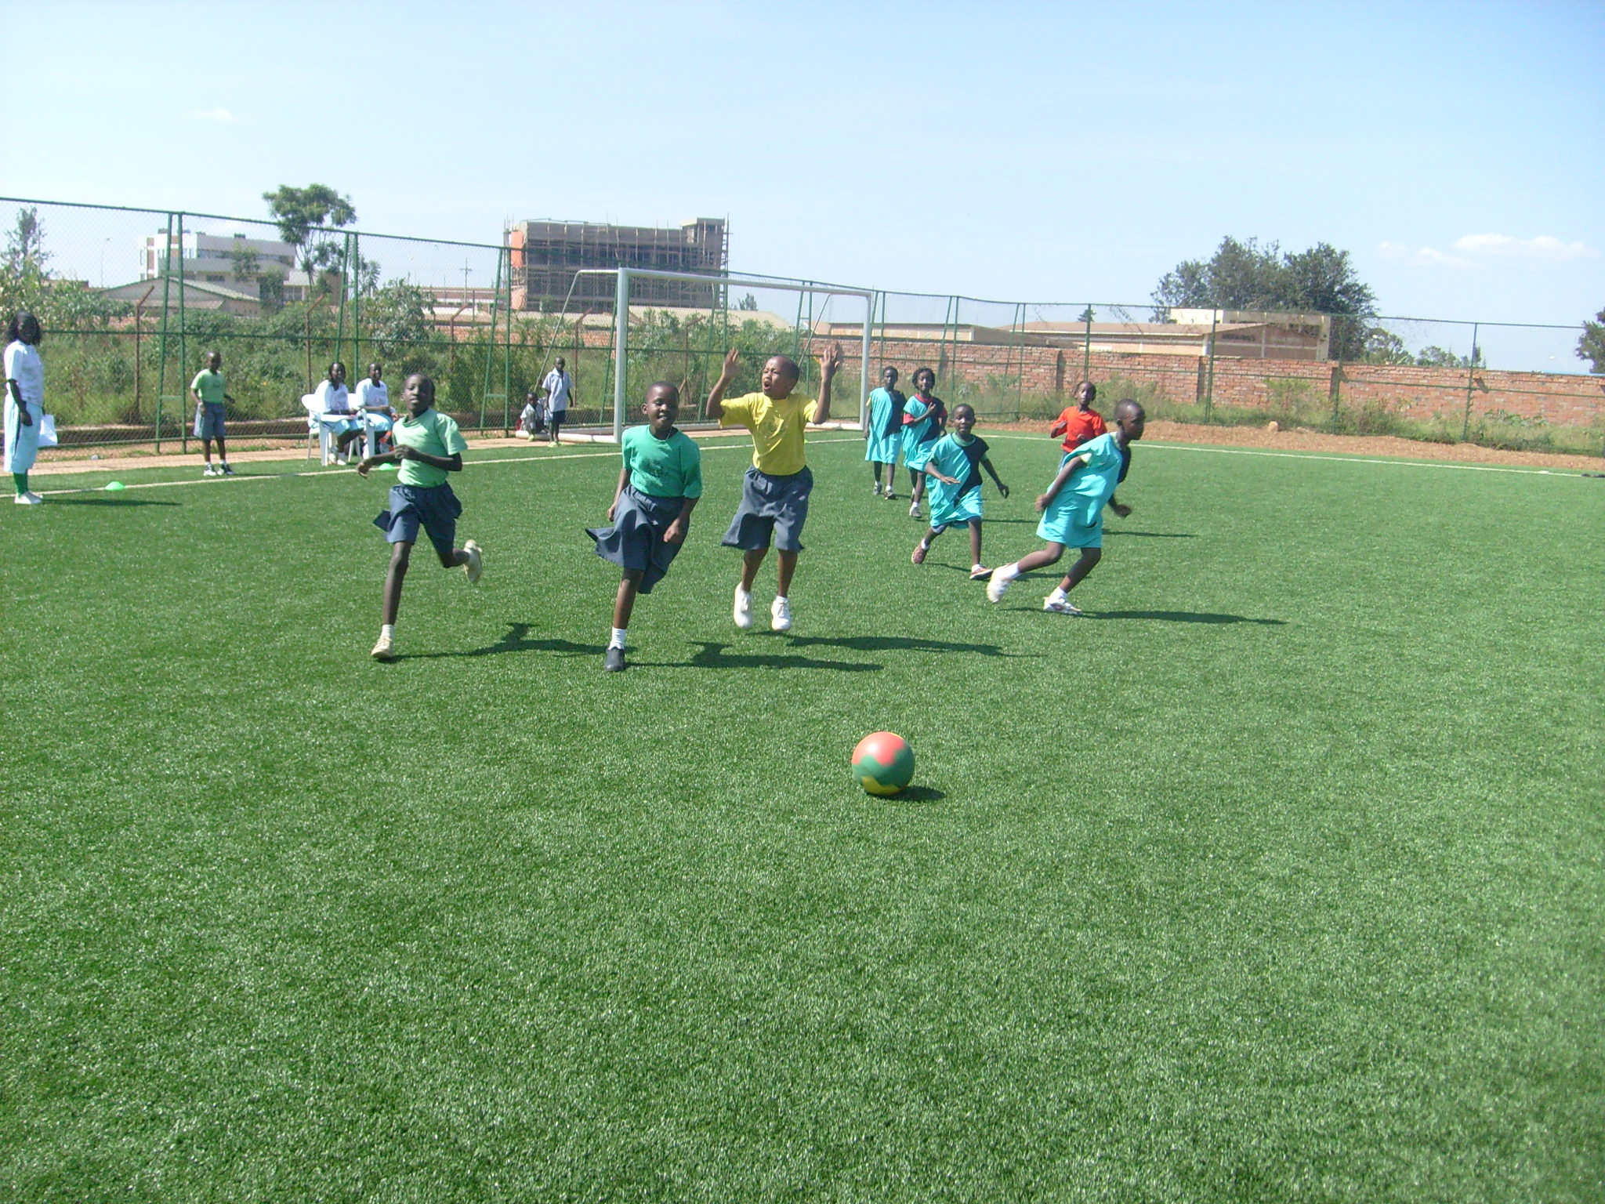
Sites | Teams | 1^{rst} | 2nd
Kigali City | Kanyinya
Kigali City | Kabuye
Kigali City | Ndera
Western Province | Mubano II
Western Province | Rubona
Western Province | Kanama Catholique
Eastern Province I | Nyakarambi
Eastern Province I | Rubona (Ngoma)
Eastern Province I | Rukira
Eastern Province II | Kabarondo B
Eastern Province II | Mukarange Catholique
Eastern Province II | Kiziguro

From 20 to 30 April 2010
AKWOS has started sensitizing girls from the age of 7 to 13 to grow knowing that playing is part of their rights and through participation they learn more during tournaments ,workshops such as teamwork,children’s right,unity and reconciliation,reproductive health leadership skills,Gender Based Violence and awareness on HIV and AIDS.
We believe educating a woman ,you are developing a nation but educating a man you are developing an individual

This competition was held at Nyamirambo Regional Stadium. 12 men's and 4 women’s teams were participated separately. Then women’s

