OUR ACTIVITIES
Soccer and Volleyball Events
Soccer and volleyball tournament was the first event organized at the district level. It involved 20sports groups from within Trans-Nzoia district and 5 from outside. The event took place on the 26th December 2001 at Kitale Technical Training Institute.
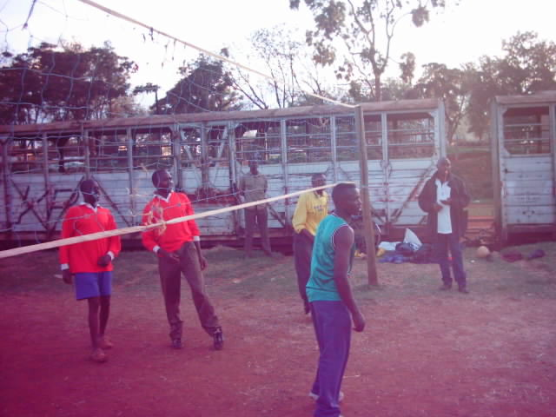 | 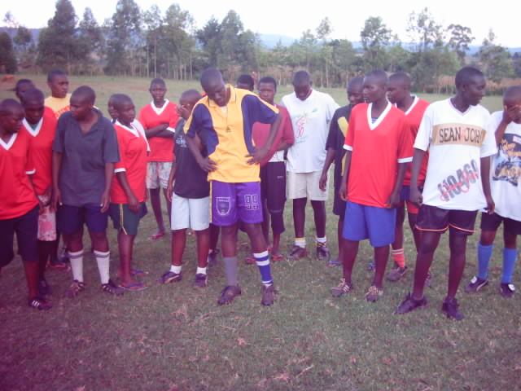
Sports Extravaganza.
This activity was carried out in Kaplamai Division at Sibanga play ground during Easter holiday. This event included men, women and children and covered soccer, volleyball, bicycle racing, darts, pool table, athletics, cross country among others. Over 20,000 people participated in this event.
Capacity Building
Training on Leadership group management , sports management are some of the areas in which tysa affiliate members have been trained in.
Schools Programs
One of our learning institution affiliate member, St.Anthony Boys High School lifted the National Secondary Schools Games Soccer Championship 2003 while Wiyeta Girls Secondary school, another member lifted the same trophy for Girls 2004..Tysa has supported the schools with trainings and organized tournaments
Bicycle Racing
Bicycle Transport (commonly known as boda-boda) Bicycle transport is a common and wide spread means of transport and major means of livelihood for the young people in Kitale. Tysa organized and mobilized the bicycle transporters and the community and build shades.

