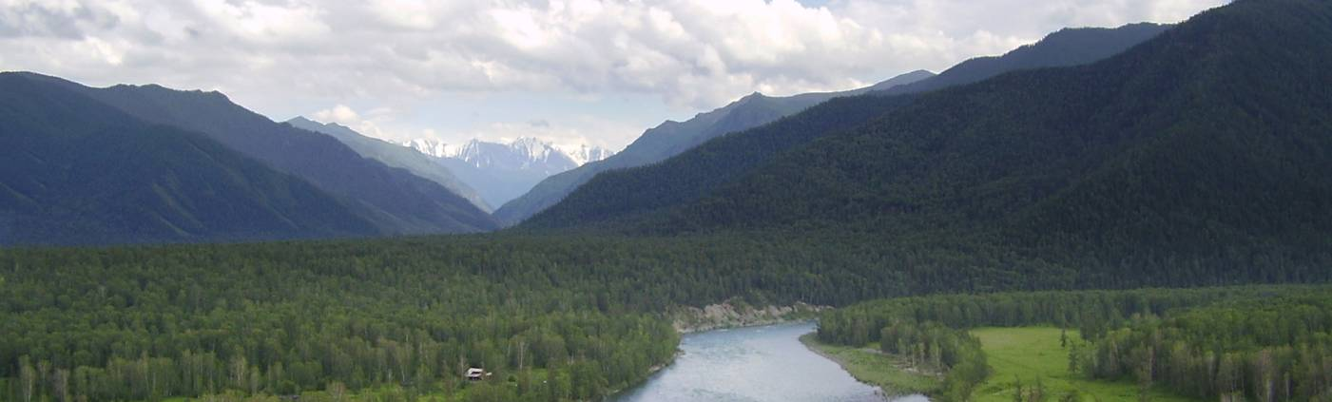

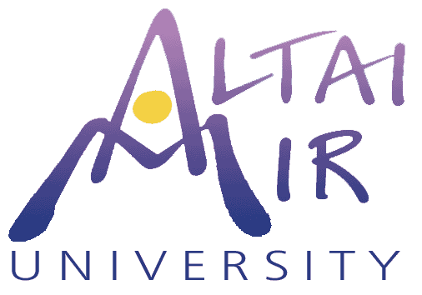
Letter of Inquiry to Trust for Mutual Understanding
Project Title: Training Indigenous Altai People to Survey and
Register Their Traditional Communal Lands
Contact: Carol Hiltner, Carol@AltaiMir.org, 206-525-2101
Submitted: January 21, 2008 for Summer, 2008

The Challenge
After perestroika in the early ’90s, the traditional farm and grazing lands of rural Russia were set aside for local ownership, pending surveying and registration. The mountainous homelands of the indigenous peoples of Altai have been included in this provision. Land not registered by 2010 will revert to the government. Without assistance, very few of the indigenous communities can afford this cost. Because of the climate in this mountainous region, the surveying season is only about two months. It is therefore essential that we start in 2008.

This is simultaneously a cultural and environmental issue. If indigenous Altai peoples are displaced from their lands, not only will their cultures suffer, but their traditional knowledge of how to care for these unique ecosystems will be lost. American groups concerned about global sustainability recognize the huge cultural/environmental cost of displacement of Native Americans, and feel an urgent need to support the indigenous Altai people to preserve the global heritage unique to the Altai Mountains. Many international programs support the culture, and many support the ecosystem, but to our knowledge, none have tackled the crucial challenge of keeping indigenous people on their traditional lands. Less than two years remain to survey and register these lands.

The Project
Summers 2008-9: Two teams (each consisting of six American volunteer surveying instructors, three volunteer Russian technical translators, three Russian land law and registration experts, and one volunteer international organizer) will spend one week travel time plus three weeks training community surveyors and local registration administrators in Altai Republic’s ten regions.

The training will consist of surveying and registering as many large tracts of communal land as possible, as prioritized by the local indigenous communities. The two focuses are to survey land that will remain as communal heritage and not be divided up for private sale, and sacred or cultural heritage land.
Primary institutional partners
Russian NGO “Association of Altai Land Reserves,” Altai Republic
“Vladimir Land Center” established by American NGO “Rural Development Institute”
American NGO “Engineers Without Borders”
Novosibirsk State Technical University
Siberian Academy for Public Administration

Amount Being Sought from TMU for Summer 2008 - $74,990
(Please note that we are requesting allowance for transportation of the Russian legal advisors from Vladimir, an integral part of the team, to provide training on the registration process, as well as for the translators needed to assist the American trainers in the field.)
American invitation, visa, registration (13x$160): 2,080
American airfare to US/Novosibirsk (13x$2300): 29,900
Airport transfers Moscow (13x$70) 910
Local car, gas, driver (2x24days@$100/day): 4,800
American per diem (2x7x28days@$50/day): 19,600
Translator per diem (2x3x26days@$50/day) 7,800
Russian legal advisor airfare Vladimir/Novosibirsk (2x3x$600): 3,600
Russian legal advisor per diem (2x3x21@$50/day) 6,300

Schedule for Project Implementation
(May be adjusted to fit travel schedules and availability of funds)
Spring 08 Ten Altai regional coordinators contact villages to:
- collect signatures for communal land surveying and registration
- select local trainees
- assist with preparation of necessary land documentation and agreements
- arrange for accommodation of survey team

For Americans, the process to receive visas takes a minimum of two weeks.

Summer 08
June 27 The first American team leaves the US for Russia.
June 30 Americans join Russian team members in Novosibirsk.
July 1 Team arrives in Altai (and will participate in El Oyin – the Altai National Cultural Celebration – in early July). Surveying is scheduled with three days (plus a day for travel and rest) in each of four regions.
July 24 Team leaves Altai.
July 26 The American team leaves Novosibirsk, arriving in the US on the same day.

August 1 The second American team leaves the US for Russia.
August 4 Americans join Russian team members in Novosibirsk.
August 6 Team arrives in Altai. This group will visit the remaining six regions.
August 29 Team leaves Altai.
August 31 Team leaves Novosibirsk by air, arriving in the US on the same day.

September 08 Evaluate results and needs and lay groundwork for 2009

