INTERNATIONAL CONFERENCE
ON GENDER EQUITY IN SPORTS FOR SOCIAL CHANGE REPORT

Association of Kigali Women in Sports

AKWOS 

In partnership with:

NIKE 

Under the high patronage of:

MINISPOC

With the sponsorship of SULFO Rwanda Industries.



Kigali (La Palisse)- Rwanda, 23rd- 24th June 2008

Guests of Honor
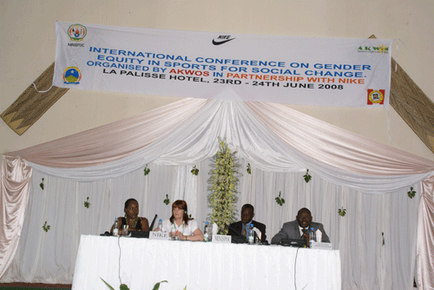

Facilitators

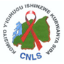



Table of content
Acronyms and abbreviations 3
Overview 4
Rwanda profile. 4
AKWOS general infomation 5
History 5
Our vision 5
Our mission 5
Our objectives 5
Our partners 6
Our projects 6
Contact: 7
Backgound 7
Introduction 7
Conference objectives 8
Conference Expected Results: 8
Target Group 8
Strategies and methodology used in preparing and hosting the Conference 9
The course of the conference 9
Opening ceremony 9
Presentations and debates 12
Sexual gender violence 12
Key issues and strategies for improved women’s empowerment in peace building and prevention of SGV 13
Women’s empowerment in sports for HIV prevention 14
Importance of feminine leadership for women’s development 16
Networking for improved women empowerment for social change 17
Empowering of young girls on leadership skills through sports 18
The importance of sports in strengthening capacity of women’s political leadership, 20
The networking for improved women empowerment for social change 21
Women’s empowerment in sports for promotion of women legal rights 22
Visit of genocide memorial site 24
Friendly match between AS KIGALI and AFSCO (DR Congo) 24
Women’s expo for income generating products 25
Cocktail reception and cultural troupe dance 26
Closing remarks 26
Annexes: 28
Annex 1: Detailed conference program of the conference 28
Annex II: Kigali Declaration of the International Conference 30
Annex III: List of participants to the conference 0

Acronyms and abbreviations

- ABFS: Association Burundaise des Femmes Sportives (Burundian Women Sports Association)
- AFESCO: Association des Femmes Sportives du Congo (Congolese Women Sports Association)
- AIDS: Acquired Immuno-Deficiency Syndrom
- AKWOS: Association of Kigali Women in Sports
- AKWOF :Association of Kigali Women in Football
- APR FC /RPA : Rwandese Patriotic Army Football Club
- BCC: Behavior Change Communication
- CNLS : Commission Nationale de Lutte contre le SIDA
- CNOSR: Rwanda National Olympic and Sports committee
- DHS: Demographic Health Survey
- DRC: Democratic Republic of Congo
- FUFA: Federation of Uganda Football Association,
- GBV: Gender Based Violence
- GDP: Gross Domestic Product,
- HIV: Human Immuno-Deficiency Virus
- KIST: Kigali Institute of Science, Technology and Management
- MDG: Millennium Development Goals
- MIGEPROF: Ministère du Genre et de la Promotion Familiale
- MINISPOC: Ministry of Sports and Culture
- NGO: Non Government Organization
- NURC : National Unity and Reconciliation Commission
- NWC: National women’s council-
- OVC : Orphans and other Vulnerable Children
- RDF: Rwandese Defence Force
- RIWAS: Regional Initiative for Women Advancement through Sports
- RNP: Rwanda National Police
- RTP: Right To Play
- SGBV: Sexual Gender Based Violence
- SGV: Sexual Generated Violence
- SIDA: Syndrome d’Immuno-Déficience Acquise
- SOS: Save our Self
- SSCI: Sport for Social Change Initiative
- STI: Sexual Transmitted Infections
- TB: Tuberculosis
- UN: United Nation
- UNICEF: United Nations Children Fund
- UNIFEM: United Nations Development Fund for Women
- YCA: Youth Cooperatives and Association

Overview

Rwanda profile.

The country of Rwanda is situated in central Africa. Its total area of 26,338 square kilometers is bordered by Uganda to the North, Tanzania to the East, the Democratic Republic of the Congo to the West, and Burundi to the South. Landlocked, Rwanda lies 1,200 kilometers from the Indian Ocean and 2,000 kilometers from the Atlantic Ocean. In Rwanda’s center, mountainous terrain gives way to the rolling hills that give the country its nickname, “Land of a Thousand Hills.” Due to its elevation, Rwanda enjoys a temperate, sub-equatorial climate with average yearly temperatures of around 18.5°C.

The country’s administrative structure and associated terminology are made of four geographically-based provinces (North, South, East, and West) and the City of Kigali, these being further subdivided into 30 districts, 415 sectors, cells and, finally, villages (Imidugudu). Although regular efforts have been made to develop the service sector and stimulate investment in the industrial sector, the Rwandan economy remains dominated by agriculture. According to the 2002 General Population and Housing Census (RGPH), more than 8 out of 10 people are employed in agriculture, including 81 percent of men and 93 percent of women. Agriculture accounts for the largest share of Rwanda’s Gross Domestic Product (GDP), 1 roughly 45 percent in 2003, followed by services at 36 percent and industry at 19 percent at constant 1995 prices.

The per capita GDP at constant 1995 prices was Rwf 76,089 in 2003 compared with Rwf 77,631 in 2002. According to the 2002 RGPH, the country’s population numbers 8,128,553 people. Although Rwanda suffered a major loss of human life (more than one million people) in the 1994 genocide, the population remains essentially the same because more than one million former refugees who had been living for years in exile returned at the end of the war and genocide.

Population density is high across the country and is increasing steadily: 321 inhabitants per square kilometer in 2002, compared with 283 in 1991 and 191 in 1978. The population is essentially young, with 67 percent of all Rwandans under the age of 20. In terms of gender, the 2002 RGPH shows females to be in the majority (52 percent) while males make up 48 percent of the population.

The illiteracy rate remains fairly high: 36 percent of Rwandans age 15 years and older do not know how to read or write and only 4 percent of women are able to read. Sixty percent of the total population is considered literate. The education level of Rwandans age 6 years and above is also low. According to the 2002 RGPH, one in three people is completely uneducated (34 percent) and nearly 60 percent of all Rwandans have received no education beyond primary school. Only 5.8 percent have reached the secondary school level, while those receiving education beyond the secondary level make up less than 1 percent of the population. HIV/AIDS is a major problem in Rwanda. HIV/AIDS affects all population strata, especially young women, sex workers, orphans and other vulnerable children (OVC), prisoners and truck drivers.

AKWOS general infomation

History

It was a challenging task to the few women players who actively participated in football. It took us 2 years to convince and have mothers mobilize then finally got a breakthrough as we started getting more and more players. We started forming teams and coach football. In 1997, ladies decided to rub off history and took initiative to encourage women football.

The association started as AKWOF. AKWOF (Association of Kigali women in football) was formed in 2001 by all chairpersons of teams/ clubs from the provinces that were developed during “Urumuli” women football campaigns.

It constituted an Executive committee of founders and 4 team/ club chairpersons, whose mandate was mobilize, plan and seek support to develop and sustain women football in Rwanda from grassroots (i.e. sector, district) to national level.

After the International Conference on Gender Equity on Sports for Social Change, that took place in Kigali, 2007, there was a recommendation that we should introduce other sport displines hence the name of Association of Kigali Women in Sports (AKWOS) rather than AKWOF, so this is how we came to be AKWOS.

Rwanda’s cultural belief of Women doing sports and Genocide were major set backs. It was immoral for women dressed up in shorts and T-shirts to go to public places. It was believed that women should never get involved in sports and developed stigma since they were meant to take care of the domestic chores.

Our vision

Have a self sustained Rwanda women sports association and sports professionals
Promoting women with disability through sport e.g seat volley ball
Supporting women initiatives in Africa regions, by teaching them and talking of our experience

Our mission

Empowering women in Rwanda through sports and education

Our objectives

- Promote women soccer in Rwanda and in the region,
- Draw the women’s attention to sports activities,
- Assist Rwandan women promote their rights and self confidence,
- Promote awareness among Rwandan women about the dangers of the HIV/AIDS pandemic,
- Create through women sports a forum for integration and reconciliation,
- Provide a meeting point between the elite and uneducated women for exchange of ideas

Our partners
- Nike
- Nike is the world’s leading designer, marketer and distributor of athletic footwear, apparel, equipment and accessories.
- Women Win
- Women Win is a fund that empowers women and girls through sports globally.
Astrid Aafjes, Executive Director (+31 (0)6 51194006)
- UNICEF
- LET ME PLAY
- Right To Play
- Global giving
- FASD
- MAMA CASH

Our projects

Women’s Soccer for Unity
Genocide left many of women survivors traumatized and with no more value for life, at the bed rock of society. No hope for change. This lady had lost hope for the future by integrating her in sports she gained self confidence and is now capable of mobility others.
Women’s Soccer for Unity, Rwanda
This project entails training female trainers, coaches, referees, and match commissioners in order to establish a solid Women Soccer Federation. Women’s soccer is a catalyst for unity and reconciliation.

Children's Voice, Rwanda
This project entails giving young homeless girls the opportunity to go to primary school and perform sports there. The children are also offered to tell their lives story during a radio show called the Children’s Voice, which is broadcasted in the Kigali area. Only in march 2007 alone AKWOS was able to put 20 children in this program.

Contact:

Mrs. Félicité Rwemarika, Executive Director, AKWOS
P.O. Box 3065 Kigali, Rwanda, Cell phone: 25008303398
E-mail Address: felicite_rwema@yahoo.com or akwos2007@gmail.com.
Website: www.akwos.org

Backgound

Introduction
The 2003 Magglingen Declaration recommended the inclusion of women, girls and other
marginalized groups in sports initiatives as a priority. In 1998 the 2nd World Conference on
Women and Sport in Windhoek, Namibia made a “Call to Action” for increased cooperation
between women’s organizations and recognized the role of sport in the advancement of girls
and women.
Sport can add significant impact to international development and cooperation work for the
benefit of women and girls empowerment and promotion of broader gender objectives such
as human rights awareness and empowerment, prevention and increasing awareness on
HIV/AIDS, peace building and prevention and response to sexual and gender based violence.
Sport can give women and girls access to public spaces where they can gather, develop new
skills, gain support from others and enjoy the freedom of expression and movement.
Sport helps to promote education, communication and negotiation and leadership skills,
which are central to women’s empowerment. Despite the potential of sports as a mobilizing
and empowerment tool for women, there has been limitations in terms of networking and
information sharing on best practices and challenges in women empowerment in sports for
women’s social change in different fields.
It is with the above background that Association of Kigali Women in sports, with an overall goal
to empower women through sport and education to improve their rights, break barriers between
social class, raise women’s standing in society; enhance unity and reconciliation, boost
self-confidence and prevent HIV/AIDS, is planning to hold an international, Africa region
conference on Women empowerment in sports for social change.

Conference objectives
- To share best practices and challenges in women empowerment in sports for
social change;
- To Promote the importance of sports as a means for bridging cross – cultural differences
and conflict and engendering attitudes which enhance cooperation, peace and development;
- To Provide an opportunity for increased networking for improved women empowerment
in sports for social change
- To develop strategies for promotion of women and girl child empowerment through sports;
- To develop a joint program for promotion of women’s empowerment in sports for social
change by the different partners

Conference Expected Results:
- Participants increased awareness on best practices for women empowerment through
sports for social change.
- Establishment of a networking mechanism for information sharing on women’s
empowerment in sports for social change between partners
- Challenges and gaps for women’s empowerment in sports identified and
recommendations developed
- A joint program developed for promotion of women’s empowerment in sports for social
change

Target Group
- Around 70 women in sports will be invited to attend the seminar. Among them:
14 women will be invited to represent different women empowerment in sports
programs from different countries in Africa excluding Rwanda as the host country;
- 20 women from women associations federations at national level to participate
in competitions;
- 20 women from Burundi to participate in friendly soccer competitions;
- 5 International experts to give presentations on women empowerment for social
change in the different fields;
- A team of 5 conference planners and facilitators at national level;
- 15 members from women NGOs for women promotion in sports and human right

Strategies and methodology use in preparing and hosting the Conference

- AKWOS developed a proposal and shared it with its partners to mobilise funds for the event
- We set up a preparation committee made of AKWOS partners and staff
- We hold technical meetings and specific sub commissions
- Booking of conference rooms and hotel to accommodate foreign guests
- Extended invitations to local and international participants requesting them to prepare their presentations according to the theme and goals of the conference
- Hosting the conference, designing and insuring distribution of the final report

The course of the conference

Opening ceremony
Félicité Rwemalika (AKWOS chairperson) welcomed the participants and thanked the government of Rwanda as well as the city of Kigali for their support in this conference on women empowerment in sports for social equity. Thereafter, she outlined the main aims of the conference which were creating social change through sports, extend the network and improve women empowerment in sports. She introduced Mrs Lesley Kavanagh, the representative of NIKE Company which is in partnership with AKWOS.

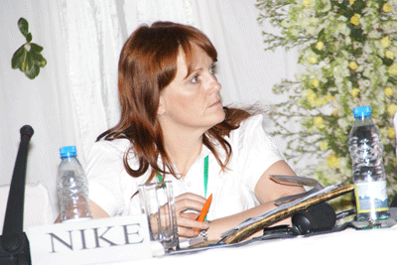
Mrs Kavanagh pointed out the fact that NIKE believes in the power of sports in order to improve women involvement in sports. Since NIKE and AKWOS entered in partnership characterized by experience learning, capacity building and friendship. In addition to the great support given by the government of Rwanda notably the Ministry of Sports and Kigali Cit, NIKE provides funding and equipment to AKWOS.

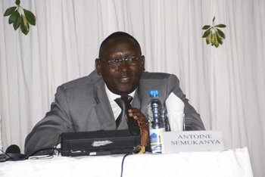
Mr Antoine Semukanya, Deputy Executive Secretary of CNLS, and founder member of AKWOS acclaimed the great job AKWOS achieved to develop women’s involvement in sports and emphasized on the hard task of developing women’s sports across the country.
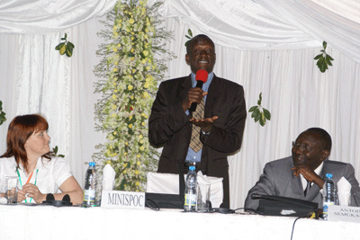
The official opening of the conference has been done by the Minister of Sports and Culture, Mr Joseph Habineza.
After welcoming the guests, Mr Habineza, strongly recognized the determination and commitment of Mrs Rwemalika in promoting women empowerment in sports, and reminded the guests of the motto: «In sports you don’t always score but never give up". He as well thanked NIKE for making women in sports its priority. The Minister stated about the conference recommendations that should guide decision makers, donors and stakeholders in future actions to be undertaken.

He recognized the commitment of AKWOS and NIKE to gender equity in developing countries especially in most disadvantaged places like rural areas. He pointed out few important steps to change the mentalities and way of thinking in county side such as women encouragement to change their habits and opinion on sports, and convince populations on gender equity.

Minister Habineza explained that a new policy was adopted in the cabinet to improve women equality as 52% of the Rwandese population are women; he also strongly disapproved the barriers imposed on girls/women education especially in secondary and university level. He eventually recommended sports as a way of communication which would develop gender equity, and asked for resolutions that would lead to actions. Mr. Habineza ended his remark by declaring officially opened the International Conference on Gender equity in sports for social change and wished a successful workshop to all participants.

Presentations and debates

Sexual gender violence

In his statistics he showed that crime increased greatly from 2006 to 2007.

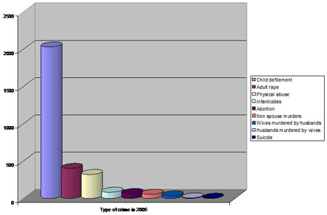
He declared that sports could help prevent and reduce Gender Based Violence (GBV) and acknowledged the guests about the establishment of a branch called Gender Desk (supported by UNIFEM) in 2005 which deals with GBV.

In order to fight against GBV the National Police created a helpline and experienced assistance for victims of GBV. Their key solutions to prevent GBV are the increasing of public awareness about GBV issues, the improvement of trust, mutual respect, and cooperation between the police and the community, the increase of legal support and reinforcement of counselling services in collaboration with women associations and NGOs.

However some challenges are also faced such as GBV is not well defined in the Rwandan laws; there are limited human resources and a strong resistance to changes.

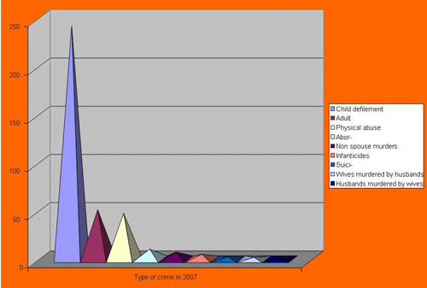

Debates

What actions are taken to take charge of victimized women and are sports included in the program? (By Mrs Dienebou Sanogo, President of the Women and Sports committee in Mali), Mr Muligo explained that effectively some actions, though recent, were taken but that the cultural customs had to be first overcome. He pointed out that this issue was now facilitated by the partnership with AKWOS.

Why did crime rise in 2007? (from women parliamentarians)
Mr Muligo explained the reason for the increase in crime was due to the fact that talking about SGV was no longer a taboo and women now dared to speak aloud.

Key issues and strategies for improved women’s empowerment in peace building and prevention of SGV

He explained that sports are essential for social development, growth and social change and also to enable interaction between different backgrounds. Mr Rwendeye declared that sports could be used as a tool to combat SGV. He outlined the role of sports towards women. Sport is widen space for women to express themselves, Sport breaks the myth of women weak physically because she can run as fast as men or even faster, can contribute for social, physical and mental development.
Sport targets an important part of each human being, which often gets forgotten in peace building: the body and its emotions. It helps people to work in organize way and show their talents. Some sports may serve as tools of self defense against physical violence

In its mandates, UNIFEM provides technical and financial assistance in empowering women in developing countries. It works to reduce feminized poverty and violence against women.

Strategies of UNIFEM include advocacy, capacity building of women organizations and promoting of gender equity. Up to now, UNIFEM provided support RNP in the establishment of Gender Desk and the National Institute for the collecting and reporting of SGV statistics. In his conclusion Mr Rwendeye explained that sports demystify gender stereotypes and can lead to democracy. He emphasized the role of campaigns against SGV in to promoting female participation in sports.

Debates

“What can UNIFEM do to promote sports for women, especially as it is still in development in Rwanda? How can you help youths (which are 62% of the population) to get involve in sports and not fall in the social vice? (by Julienne by Mukandekezi, vice president of the Olympic Committee in Rwanda).

Mr Rwendeye explained that social barriers for young ladies/women involved in sports still exist and it is responsibility for all (the government, national and international organization, local community) to sensitize the population on the benefits of sports for peace building. As for the assistance to the youths, Mr Rwendeye pointed out that it was mainly a task for UNICEF, but that any ideas or initiative would be welcome.

Women’s empowerment in sports for HIV prevention

He presented his case in five different points: Results of HIV prevalence in Rwanda, Sports and HIV, Women’s vulnerability towards HIV, strategies to prevent HIV via feminine sports, and challenges faced by the CNLS.

According to 2005 DHS, the HIV prevalence rate is 3% of the population; 2.2% from the rural areas and 7.3% from the urban areas. HIV prevalence in women is 3.6% in rural areas and 7.3% in urban areas.
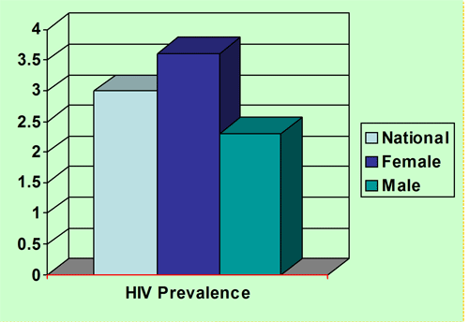

The prevalence of HIV for women is higher than that of men, and as women age increases the prevalence of HIV increases. The level of women HIV positive is of 21.9% compared to 13% for men. The reasons for this high percentage for women are generally due to the higher viral concentration in sperms, the weakness of the uterus region and the rape which was used as a war tool during the genocide.

Sport is good for the health as well as social life. One that practice sports is less likely to suffer from high blood pressure and increases his/her life expectancy.
The representative of CNLS suggested that women sports clubs should organize women according to their age range. An efficient communication program should be present between the feminine club supervisors and their members. A place where women could get assistance and advice should be established and sport is among the best opportunities.

The associations should be involved to promote health and all HIV preventive measures (abstinence, faith fullness, and condom). At last, sport clubs should be established and expanded throughout the regions.
The most important challenge CNLS is facing is that BCC messages spread through media campaign, public meetings, and education sessions for the general populations are not effectively achieving expected results. We need to reinforce strategies to decrease the HIV prevalence and we are convinced that sports may strongly contribute.

"The more educated the people are, the more they are exposed to HIV compared to rural areas, how come?” (by Florence Bagunywa Nkalubo, Vice President of FUFA)
The representative from CNLS explained that population in urban areas seemed to not take seriously the prevention against HIV as they generally think to know enough about it.

Importance of feminine leadership for women’s development

She put forward several key points in her presentation. She generally emphasized on the importance of feminine leadership for women’s development and explained that in Mali several women associations were present which strengthens women’s power. She also pointed out the challenges that could be faced namely the lack of financing for sports activities for women, the non-implication for former sportive women, the lack of consideration for sports as a means of social and economic development, the lack of presence of women in key positions in order to promote women in sports.

Mrs Sanogo then proposed few recommendations notably the creation of communication centres in women sports clubs, means of financing, and creation of youth clubs in order to encourage feminine sports.

Debates

"In order to facilitate sports in Rwanda, clubs should be created in each village (umudugudu), however it might be financially too expensive, what solutions can you offer?”
Mrs Sanogo answered that women could practice sports on their own each day or in small committee assisted by an instructor.

Intervention from Julienne Mukandekezi: "Sports is quite accessible in Rwanda, though infrastructures like golf and swimming pools availability depends on ones financial status, however sports is first of all a way of thinking. The Olympic Committee in Rwanda organises administrative lessons on sports, however women don’t always come to sports conference. "
Mrs Mukandekezi’s recommendation is that developing countries need to work on the lack of presence of women in sports center, conference and formation.
"How efficient is the police force in Rwanda, is corruption present, and is sports present in the police?”

Mr Muligo explained that corruption was severely punished in Rwanda and that strict actions were undertaken to tackle it. He also explained that sport was done once a week in the police. Mrs Violet Kabarenzi, consultant in the RNP, added that a RNP women network worked on enrolling women in the police.

"How did Mali manage to create so many women sports associations?”
Mrs Sanogo explained that these were civil associations where she introduced sports.

Networking for improved women empowerment for social change

Mrs Bagunywa started her presentation reminding the audience that in the year 2000 every country in the world agreed to 8 Millennium Development Goals (MDG’s) aimed at halving world poverty by 2015. Amongst the 8 and most important is MDG 3: Promote gender equality and empower women.
To achieve this goal, different initiatives have been undertaken and RIWAS is one of them. She briefly introduced RIWAS; the Regional Initiative for Women Advancement through Sports, a non governmental Organisation. Therefore, she explained RIWAS’ goal which is connecting to each other in many ways through sports in order to make use of all our resources and inner strength to create a good change, to promote and empower women through sports.

She also put forward a proposal structure for RIWAS whereby it would be composed of a general assembly made of 20 members ; 2 from each country represented (Uganda, Kenya, Tanzania, DRC, Rwanda, Ethiopia and Erithrea) ; a steering committee and a secretariat. Mrs Félicité Rwemalika was elected President of RIWAS, Mrs Florence Bagunywa Nkalubo Vice President. The mission statement of RIWAS is to generate skills through sports by sharing information, to secure the inclusion of human rights, equality of women and to bring forward the distinctive perspective of women through sports

Its objectives are to generate knowledge and information, facilitate women’s team spirit & building individual and organizational capacities of girls through sports, strategies to reduce the social isolation experienced by marginalized women.

The role of RIWAS is to support women’s tournaments, extend membership, support RIWAS members, increase RIWAS influence, improve financial situation and share information.

As long as Social Change is concerned, the situation of women needs to be deliberately, purposefully and radically improved in order to cause social change

"Would RIWAS be involved in all the regions? Would you be able to completely follow your policies? " (by Mrs Sanogo)
Mrs Bagunywa Nkalubo explained that RIWAS could expand onward if it works well but that for the moment it only included the regions. She then explained that RIWAS had an organised system where each policy or issue was worked through the secretariat.

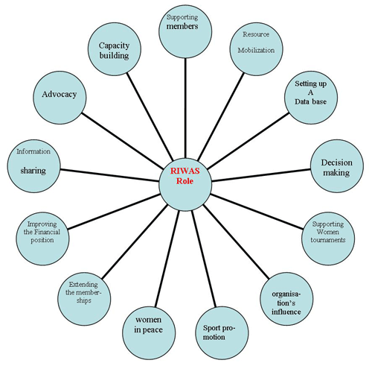

Empowering of young girls on leadership skills through sports

She outlined RTP’s program: a healthier and safer place through sports, Sports as a way to improve children situations, include all children in the different programs and make no discriminations, work with local partners, HIV pprevention, include disabled children, and girls.
In order to develop girl’s skills RTP tries to boost up girls self esteem, pprovides leadership opportunity and achievement.

As a result this challenges gender norms, develops social networks and reduces isolation. Right To Play suggests to involve families in these programs so as to make a positive change and present positive role models for young girls

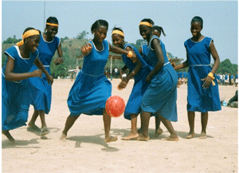

Debates

"How do you choose your partners?” (by Dave Cobban, NIKE)
Lisa Okun explained that RTP used first to work with refugee camps, and local partners, but before choosing a partner they first of all need to see the benefits for the kids before considering a new partner.

"Do you work more with sports or educative games?” (by Mrs Sanogo)
Mrs Okun explained that RTP generally focuses on educative games as they are more accessible to a greater number of children simultaneously.

"Do you have only girls’ team or mixed teams?” (by Julienne Mukandekezi)
Mrs Okun explained that RTP doesn’t have a team as they prefer to involve all the children in sports. However when planning programs on HIV education girls and boys can be divided if it helps girls to feel more comfortable.

RIWAS recommended socialisation as the key to encourage girls to get involved in sports. It also declared that girls be given the same opportunity as boys.

"Do RTP have an appropriate program for disabled children? How RTP does overcome the space availability problem? "
Mrs Okun explained that the games were modified (or adapted) in order to be accessible to disabled children as well as non-disabled ones. As for the space availability issues she explained that RTP always tries to find solutions and be innovative.

Violet Kabarenzi, also recommended that funds should be mobilized to assist girls in need through sports.
Mrs Sanogo ended the discussion with a last recommendation claiming that AKWOS should try to touch the media and entertainment so as to captivate children and women.

The importance of sports in strengthening capacity of women’s political leadership, experience of Rwanda

Mrs Mukazibera emphasized on the particular role that sports had in the physical fulfilment as well as the self esteem. She pointed out as well that sports was daily present in women’s everyday life and that fortunately some managed to make their activity/passion, their profession like the professional swimmers.

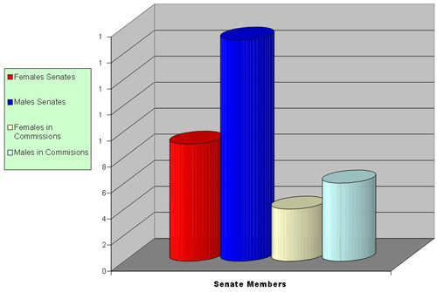
Judicially speaking Mrs Mukazibera reminded the guests that a minimum quota of 1/3 in the different institutions was given to women, and that 24 seats in the Deputy Chambers were distributed to women.
With the new associations and organisations which emerged for the women these latter now possess a way of lobbying and be heard just as the parliamentarians women managed to get a sports day for the parliament members. Eventually Mrs Mukazibera recommended that each woman firmly oppose herself against discrimination, benefits from the political will present in Rwanda without just being a number in a minimum quota but by demonstrating her capacity and professionalism in the tasks she undertakes.

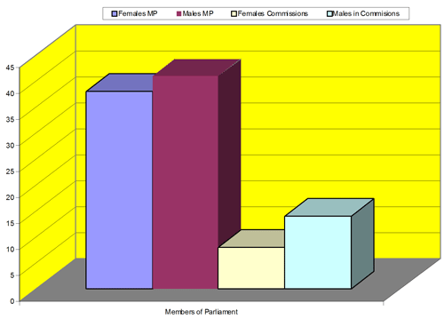

The networking for improved women empowerment for social change

The Care International representative briefly introduced her organisation which uses sports in several of its programs. Sport for Social Change Initiative (SSCI) is a new poverty reduction model. SSCI looks to incorporate sport-based programming into existing and new development projects. (SSCI) believes that the inclusion of sport in development and education programming will create lasting individual and social change.

What is networking?

She particularly emphasized on the importance of developing networks and expand the associations and organisations’ network. She reprimanded the associations which introduce themselves as qualified in some areas where they are not just to gain funds.

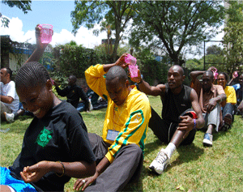
Our role in networking is to coordinate, facilitate, advocate and motivate

Recommendations:

- Work for more cooperation between the different networks.
- Participate and volunteer
- Have an efficient organisation: human resources management, sports management, event management and communication & public relation.
- Increase membership and partnership in order for the associations to have a greater impact on population.

Women’s empowerment in sports for promotion of women legal rights

She outlined the fundamental rights of the individual. Mrs Rwimo listed the numerous violence inflicted to women, particularly during war conflicts. Mrs Rwimo claimed several negative points like: The traditional Rwandese society which considered women as inferior. The great number of women suffering from poverty

Recommendations:

Need the suppression of cultural aspects regressing woman’s condition.
List on data the level of feminine poverty
Include women in the development program.

Discussion:

Mrs Uwimariya Pauline, the representative from DRC, emphasized on the importance of creating girls teams as a way to carry them away from precarious situations especially in countries suffering from political and social problems.

Mrs Mukazibera Agnes answered to the representative from DRC that it was primordial to analyse what the favourite children’s sports were.

‘‘Do you have any laws involving sports?’’ (by Mrs Dienebou Sanogo)

Mrs Mukazibera answered that it was first important to convince the different parties and areas in order to obtain results, but that a decree involving sports had been proposed.

Mrs Munyankaka Ancille, the representative of the National Council of Women as well as MIGEPROF, introduced some important points on women’s empowerment in sports for promotion of women legal rights. She emphasized on the positive evolution of Rwandese women’s way of thinking. She however regretted that Rwandese feminine teams were so few.

Mr Dave Cobban emphasized on the fact that following the 2010 World Cup which would take place in South Africa several organisations and associations would focus on Africa which would onwards have a positive impact on Rwanda and its associations. Mr Cobban then explained on the power of sports notably when used as a tool of communication by young girls and women, in order to encourage them to fight against any type of inferiority complex.

Visit of genocide memorial site
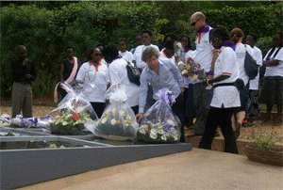
All the participants to the conference visited genocide memorial site at Gisozi in Kigali City. They condemned the tragedy and committed to use sports as a way to prevent genocide elsewhere in the world.

Friendly match between AS KIGALI and AFSCO (DR Congo)

A friendly match between the teams from Rwanda and DRC held at Nyamirambo Stadium ended by the victory of the host county by two goals to null.

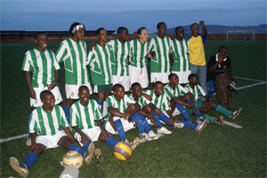
A.S KIGALI (Female Rwandan Team)

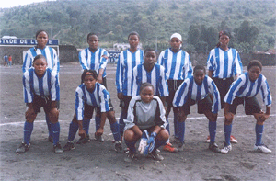
AFESCO FC (DRC Female Team)

Women’s expo for income generating products

During the conference, participants have had opportunity to visit exhibits from women organizations.
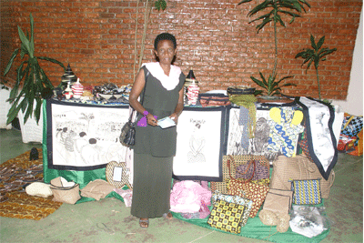

Cocktail reception and cultural troupe dance
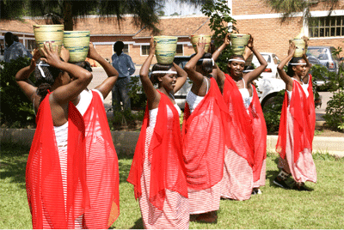

Closing remarks

We are thankful to the government of Rwanda for the institutional support, our international and local partners for their strong collaboration which resulted in helping AKWOS hosting the conference and achieving its objectives, the facilitators for their presentation, , the team that organized the meeting and Kigali City citizens for their warm welcome to our loved guests. Special thanks to the organizations and individuals who sponsored the conference: MINISPOC, Sulfo Rwanda Industries s.a, Nike, all the delegations which attended the workshop for their active participation.

Allow me to mention of the foreign countries represented to the conference: (1) Burundi, (2) DRC, (3) Germany, (4) Kenya, (5) Mali, (6) Netherlands, (7) Tanzania, (8) Uganda. Their presence is a symbol of friendship and commitment in contributing to gender promotion through spots.

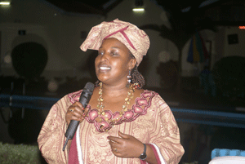
We wish a safe trip back home to all participants and hope to meet again in the near future to evaluate achievements towards implementing conference recommendations. We declared officially closed the International Conference on Gender Equity for social change.

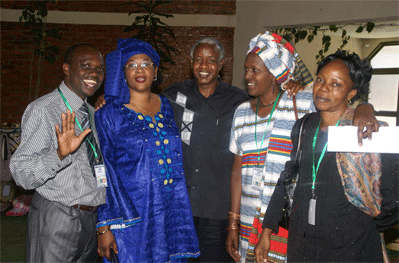

Annexes:

Annex 1: Detailed conference program of the conference

Day 1, 23rd June 2008

S/N | Time | Activity | Facilitator
1 | 08.00 – 08.15 | Arrival and registration of participants | AKWOS
2 | 08.15 – 08.30 | Welcome Remarks | Mayor of Kigali  City
3 | 08.30- 08.45 | Official opening | MINISPOC
4 | 08.45 – 09.05 | Sketch on women’s empowerment through sports | MASHIRIKA
5 | 09.05 – 09.30 | International frameworks for women’s empowerment  in Sports | NIKE
6 | 09.30- 10.00 | Key issues and strategies for implementation of  international frameworks for promotion of women’s  rights | Minister,  MINISPOC
7 | 10.00 – 10.30 | Short – Break | AKWOS
8 | 10.30 – 10.55 | Situation on SGV, Police best practices in its prevention and response and the existing challenges in its prevention | Rwanda  National Police
9 | 10.55 – 11.25 | Key issues and strategies for improved women’s  Empowerment in sports for peace building and  prevention of SGV | UNIFEM
10 | 11.25 – 11.50 | Women’s empowerment in sports for HIV prevention  and awareness raising | CNLS
11 | 11.50-12.30 | Discussion on key issues and strategies for women’s  empowerment in sports for HIV prevention and  awareness raising | CNLS
12 | 12.30-12.55 | Women’s empowerment in sports for promotion of  women legal rights | FERWAFA
13 | 12.55 – 02.00 | Lunch – Break | AKWOS
14 | 02.00 – 02.30 | Discussion on key issues and strategies for women  empowerment in sports for promotion of women  legal rights | FERWAFA
15 | 02.30-03.00 | Networking for improved women empowerment for  Social change. A case study of RIWAS | V/President –  RIWAS
16 | 03:00-03:30 | Promoting children/girls on leadership skills  through sports | RTP
17 | 03.30 –04.30 | Women’s expo for income generating products | AKWOS

Day 2, 24th June 2008

SN | TIME | ACTIVITY | Facilitator
1 | 08.00 – 08.20 | Women empowerment in sports for  women leadership skills development | Women Parliamentarians
2 | 08.20 – 08.50 | Discussion on key issues on women  empowerment in sports for women leadership  skills development | Women Parliamentarians
3 | 08.50 – 09.20 | Networking for improved women empowerment  for Social change. | Care International/  Nairobi
4 | 09.20 – 09.50 | Key issues strategies for improved Women empowerment  in sports for women leadership skills development | International facilitator
5 | 09.50 – 10.20 | Short – Break | AKWOS
6 | 10.20- 11.20 | Key joint Action points for promotion of women empowerment  for social change | MIGEPROF
7 | 11.20 – 12.00 | Develop conference preamble and declarations | Conference  Reporter
8 | 12.00 – 01.00 | Lunch - Break | AKWOS
9 | 01.00 – 02.30 | Visit to memorial site | AKWOS
10 | 03.00 – 05.00 | Friendly match between AS KIGALI and AFSCO (Congo) | Rwanda football federation (FERWAFA)
11 | 05.00 – 05.15 | Vote of thanks | AKWOS
12 | 05.15 – 05 .30 | Official closing | Mayor, Kigali  City
13 | 06.00 – 08.00 pm | Cocktail reception and cultural troupe dance | AKWOS
􀀁

Annex II: The Kigali Declaration of the International Conference

We, the participants from the member states of the Africa Regional Initiative for Women Advancement in Sports and representatives from government partners, Non- governmental organizations, civil society organizations, development partners and UN agencies attending the International Conference on Gender Equity in Sports for Social change held in Kigali, Rwanda, from 23rd – 24th June 2008;

Having testified from presentations given by the Minister of Sports and Culture in Rwanda, Representative from Rwanda Forum For Women Parliamentarians Representative from Rwanda National Police, Representative from United Nations Development Fund for Women, Representative from Rwanda National Commission On HIV/AIDS, Representative from Olympic committee and representatives from the non- governmental organizations;
Reaffirming the provisions of the regional and international frameworks for promotion of Gender Equality and Women’s empowerment such as the Beijing Platform of Action, CEDAW, Millennium Development Goals, Security Council resolution 1325, the General recommendation on violence Against Women, the convention on the Rights of the child (1989); General Assembly resolution 58/5 that recommends Advocate using sports as a means of promoting education, Health and Peace.

Aware of the still existing cultural barriers to girl child and women participation in sports, cultural attitudes and practices that inhibit girl child and women self confidence,

Aware that women and girl child HIV prevalence rates are higher than those of the male counterparts in the region;

Aware of the limited networking between organizations involved in promoting gender equity in sports for social change;

Deeply concerned about the gender gaps in terms of completion and limitation to women participation in Science and Technology;

Aware of the high numbers of women living below the poverty line and limited women’s skills for income generation;

Recognizing the high rates of Sexual and Generated Violence against the girl child and women.

Observing the limited support for women participation in sports in terms of financial and technical support for women empowerment in Sports

Committed to work towards promotion of women empowerment in sports for social change in close partnership with governments, UN agencies, development partners, , and. civil society
Convinced that promotion of women’s rights through sports requires a holistic approach and combined efforts.

We recommend as follows:

At national level

- Member states to allocate enough funds from the national budget for women empowerment in sports for social change
- Member states to fully mainstream gender in sports programs through development of appropriate policies and legal provisions.
- Member states to put in place relevant infrastructures for women’s sports facilities
- Member states to decentralize sports services at community level and put in place relevant mechanisms for women integration, so as to reach out to the rural women and girls.
- Use the media for promotion of women’s participation in sports for social change
- To sensitize communities on the importance of sport through drama, music, spot, T-shirts with specific messages.
- Use sports forums as platforms for social change in regard to women’s rights.
- To facilitate and support networks for promotion of women empowerment in sports and youth initiatives for social change.
- Advocate for training women as members of women councils and women teachers as sport coaches.
- To give financial and technical support for development of national sport program.
- To establish women sport centers that will also facilitate awareness rising on different issues including HIV/ AIDS, Sexual and Gender Based Violence (SGBV) and women’s rights.
- To encourage and facilitate younger girls to go to school and practice sport to acquire knowledge and be able to communicate and build their self confidence.
- To campaign on behavior change in regarding HIV prevention and management to both women and men through sport forum.
- To facilitate campaign against SGBV using sport forum.

At the regional level

- Joint advocacy for all member states to develop policies and legal frameworks for promotion of women empowerment in sports and legal rights where not adopted.
- Urge all member states to domesticate the General Assembly resolution 58/5.
- Using sports as a means of promoting education, Health and Peace.
- Urge member states to integrate sports within the HIV prevention and response programmes.
- Advocate for member states to facilitate programs for women empowerment in sports through training and organizing regional conferences for information sharing.
- Member states to give technical and financial support to facilitate the operations of the Regional Initiative for Women empowerments
- To establish a regional training center for women in sport.

At the international level (Development partners)

- To provide financial and technical assistance institutional capacity building for women organizations for women empowerment in sports for social change..
- Mobilize international and financial support for women empowerment in sports programs at regional, national and community level.
- To provide funds for women’s skills development for income generation activities through sports cooperatives.
- To provide financial and technical support for strengthening and development of women sports networks
- Support the coordination, monitoring and evaluation of programmes for Women empowerment in sports.
- To provide technical and financial support for developing documentation on best practices and challenges in promoting gender equality in sports for social change

To women and child girls

- To engage themselves in sports and related values (leadership, friendship, fair play, peace, unity and reconciliation, self confidence, self esteem, etc) for social change;
- To use sports as a means of promoting human right in general and women rights in particular;
- Put in action and share knowledge acquired during the present conference;
- Promote women sports as a means for bridging cross – cultural differences and conflict
and engendering attitudes which enhance cooperation, peace and development
- Develop strategies to sensitize men to create environment encouraging participation of
child girls and women in sports activities for social change,
- Promote awareness among the general population, child girls and women about the dangers of the HIV/AIDS pandemic, participate in prevention of STI/HIV/AIDS and opportunistic infections (TB, malaria among others)
- Create through women sports a forum for national, regional and international social and economical integration and cooperation,
- Strengthen all initiatives in relation with SGBV prevention and provide psychosocial support to families, women and child girls affected by this bad behavior.

Annex III: List of participants to the conference on gender equity in sports for social change
S/N | NAME IN FULL | FULL ADRESS
 |  | Country | Organization/Company/Association | Post occupied | Tel no | E-mail
1 | Mukaruziga Thérèse | Rwanda | NURC | Program coordinator | +250 08532051 | tmukaruziga@yahoo.com
2 | Twizeyeyezu M.Josée | Rwanda | AKWOS | Coach | +250 0859739 | Joset2008@yahoo.fr
3 | Rusimbi charles | Rwanda | Kigali city | YCA coordinator | +250 08562443 | Rusim2008@yahoo.com
4 | Beraho Ignace | Rwanda | CNOSR | President | +250 0312928 | Beraho2001@yahoo.fr
5 | Mukandekezi Julienne | Rwanda | CNOSR | V/President | +250 08408355 | juliekezi@yahoo.fr
6 | Rutaganwa Aline | Rwanda | CNLS | Technician | +250 08611110 | rutaganwa@yahoo.fr
7 | Dave Cobban | Netherlands | Nike | Marketing Director | 15035451711 | Dave.cobban@nike.com
8 | Bamurange Odette | Rwanda | NWC | Coordinator-northern | +250 08491746
9 | Mushikiwabo Thérèse | Rwanda | APR Football Club | Secretary General | +250 08586959 | vedadanie@yahoo.fr
10 | Uwimana Liberate | Rwanda | AKWOS | Coach | +250 08549830
11 | Umubyeyi Yvette | Rwanda | NWC | Secretary-southern | +250 08642429 | yv@yahoo.fr
12 | Maxime Rwandeye | Rwanda | UNIFEM | Programme coordinator | +250 08519816 | Maxime.rwendeye@unifem.org
13 | Zaneza Emerthe | Rwanda | AKWOS | Coach | +250 08431510 | emezaneza@yahoo.fr
14 | Banamwana Yvone | Rwanda | NWC-Kigali City | Coordinator | +250 08452957
15 | Rwimo Clotilde | Rwanda | Women’s rights | consultant | +250 08424835 | ruclodo@yahoo.fr
16 | Uwimbabazi Delphine | Rwanda | AKWOS | Coach | +250 08554490 | finadelz@yahoo.fr
17 | Mukarwema Josephine | Rwanda | Association Mwana Ukundwa | Assistant coordinator | +250 08562300 | amu@rwanda1.comn
18 | Munkurize Samantha | Rwanda | Umuhuza Association | Secretary | +250 08401238
19 | Umutesi Janvière | Rwanda | SOS | In charge of gender | +250 08818316 | Janufer2001@yahoo.fr
20 | Virginie Karagirwa | Rwanda | AKWOS | Coach | +250 08690679 | virginkara@yahoo.fr
21 | Niyodushima jeanette | Rwanda | AKWOS | Coach | +250 08462975
22 | Kayitesire Queen | Rwanda | Participant |  | +250 08856720 | queenkayitesire@yahoo.fr
23 | Tumwesigire Queen | Rwanda | RDF | In charge of gender | +250 08764570 | peacehilla@yahoo.fr
24 | Esther Denzinger | Germany | Participant |  | +250 03482827 | estherdenzinger@hotmail.com
25 | Lisa Okun | Canada | Right to Play | Project coordinator | +250 08304048 | lokun@righttoplay.com
26 | Umutoni Angèle | Rwanda | Amina magazine | Representative Rwanda | +250 08526664 | umutoni@yahoo.fr
27 | Mukayitete Annonciata | Rwanda | Rwanda Women’s Network | In charge of GBV project | +250 08862059 | annonciatamuk@yahoo.fr
28 | Kabarenzi Violet | Rwanda | Rwanda National Police | Gender consultant | +250 08434326 | vkabarenzi@yahoo.com
29 | Maggie B. Kali | Rwanda | AKWOS | Facilitator | +250 08302926 | Maggie.kali@gmail.com
30 | Auma Obama | Kenya | Care international | Social change in sports coordinator |  | obama@ci.or.ke
31 | Florence B. Nkaluba | Uganda | FUFA | Vice president | 0112385885 | flobagnam@yahoo.com
32 | Pauline Uwamaliya | RDC | AFESCO | President | +243808449832 | uwapaupau@yahoo.fr
33 | Mukazibera Agnès | Rwanda | Women parliamentarians | Vice president | +250 08302476 | Zibera2000@yahoo.fr
34 | Dienebou Sanogo | Mali | Carrefour des Jeunes | President | 67214469168875 | sdienebou@yahoo.fr
35 | Peter Nkurunziza | Rwanda | Care international | Education advisor | +250 08598524 | Peter.rw@co.care.org
36 | Hirabawe Angelique | Rwanda | Sulfo Rwanda Industries | Secretary, sales & marketing | +250 08461528 | isimbrangelique@yahoo.fr
37 | Mukamurigo Francine | Rwanda | NWC-Eastern province | Secretary | +250 08502429 | muligo@yahoo.fr
38 | Munyankaka Alice | Rwanda | NWC | Secretary | +250 08844339 | amunyanka@yahoo.fr
39 | Viola Nibogora | Burundi | ABFS | President | +257453846 | Nivi_200@yahoo.fr
40 | Julianna J.Yassoda | Tanzania | Ministry of sports | Assistant Director | +255754532852 | Matagi89@yahoo.co.uk
41 | Musanabera Agnes | Rwanda | Amani Football Club | Captain | +250 03626790
42 | Rubagira Christella | Rwanda | Club les Dauphines | Member | +250 08854782 | Chrisej72004@yahoo.fr
43 | Mwangaza odile | Rwanda | AKWOS | Member | +250 08510575 | odilemk@yahoo.fr
44 | Uwitonze Jean Pierre | Rwanda | AKWOS | Member | +250 08622823 | uwipeter@yahoo.fr
45 | Bamusiime Alice | Rwanda | KI ST | Gender focal point | +250 08675095 | bamusime@yahoo.ca
46 | Delphere Pirault | Rwanda | Care international | Deputy Reg. Director | +250 08302568 | Delpherep.rw@co.care.org
47 | Ayingoma Jean Pierre | Rwanda | CNLS | Social mobilization | +250 08473189 | ayingomaj@yahoo.fr
48 | Murekatete Caritas | Rwanda | AKWOS | Coach | +250 08616727
49 | Twizeyeyezu M.J | Rwanda | AKWOS | Member | +250 08599739 | Joset2008@yahoo.fr
50 | Mujawabega Godéliève | Rwanda | AKWOS | Member | +250 08590900 | mujagod@yahoo.fr
51 | Nyinawumuntu M.Grâce | Rwanda | AKWOS | Member | +250 08438639 | wumuntugrace@yahoo.fr

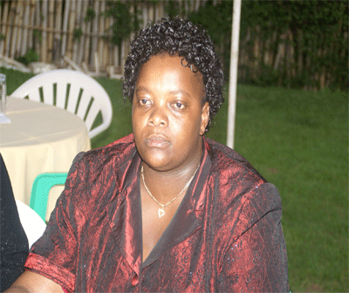
Mrs UWAMARIYA Pauline, Head of DRC Delegation and President of AFESCO: Association des Femmes Sportives du Congo (Congolese Women Sports Association)

Rwanda Demographic and Health Survey 2005, p 1 to 4
By the superintendent and Head of Crime investigation at RNP, Mr Maurice Muligo
By Mr Maxim Rwendeye, representative from UNIFEM.
By Mr Jean Pierre R. Ayingoma, in charge of social communication at CNLS.
By Mrs Dienebou Sanogo, president of the women and sports committee as well as the Olympic committee in Mali
By Mrs Florence Bagunywa Nkalubo, Vice president of FUFA.
By Mrs Lisa Okun from Right To Play
By Mrs Mukazibera Agnes, Member of Parliament, Chairperson of Committee on Education, Science, Culture and Youth
By the representative from Care International in Nairobi.
By Mrs Rwimo Clotilde, Independent consultant.
on Gender equity in sports for social change

