An Update on Fellowship Program

Submitted to

Global Giving

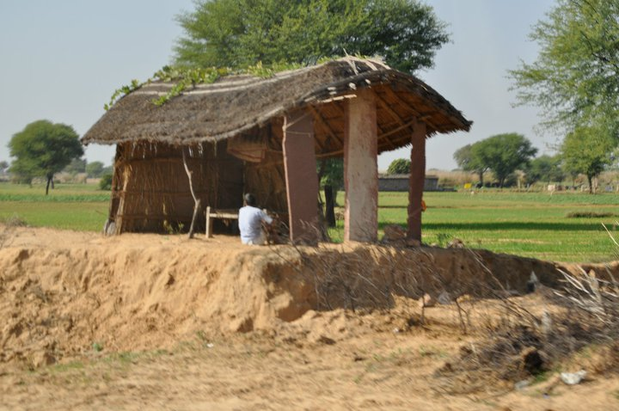

SEVA MANDIR

Udaipur Rajasthan, India

info@sevamandir.org

www.sevamandir.org

Activities done during January to August 2011

After the completion of two years of first batch of fellows a two days experience sharing work shop was organized early this year. It allowed former fellows and new fellows to interact and learn from each other. The new felloes were selected during the second day of the workshop Applicants were divided into four groups and were given different themes for discussions. The members of Selection Committee were observing all the participants and the discussions.

Individual interview of each of the applicant was conducted. A committee of 5 members comprised including the RIM National Coordinator Mr. Ranga Rajan. Of the 13 fellows 3 were working in Kherwada. One of them is focusing on issues related to Forest Act. Two others are working on the tradition of Dakaan (witch accusation). Two fellows are working in Badgaon block on issues of Caste Panchayats. Three other fellows are working in Jhadol block on issues of health and education and government schemes. The remaining five fellows are from Kotra block and are working on issues of Moutana (tradition of demanding compensation of a death).

The table below details all the fellows of this year and the issues they are addressing in their respective areas.

S. No. | Name of Fellow | Block | Issue
1. | Shri Babulal ji | Kherwara | Issues related to forest right act
2. | Shri shankar singh Ji- | Kherwara | Countering the tradition of Daakan (witch accusation)
3. | Smt.Laxmi devi | Kherwara | Countering the tradition of Daakan (witch accusation)
4. | Shri Amara ram ji | Badgaon | Caste Panchayat (issues in traditional caste councils)
5. | Shri Dhula ram ji | Badgaon | Caste Panchayat (issues in traditional caste councils)
6. | Shri Tulsi Ram Tavid- | Jhadol | Health
7. | Shri Kamal Lal Ahari | Jhadol | Education
8. | Shri Keshu lal badera | Jhadol | On Government Schemes
9. | Shri . Singa ram | Kotra | Moutana (tradition of demanding compensation of a death)
10. | Shri . Laxmal lal | Kotra | Moutana (tradition of demanding compensation of a death)
11. | Shri Dharam Chandra Parmar | Kotra | Moutana (tradition of demanding compensation of a death)
12. | Smt. Champa Devi | Kotra | Moutana (tradition of demanding compensation of a death)
13. | Smt. Jelki Bai | Kotra | Moutana (tradition of demanding compensation of a death)

An orientation workshop for the newly selected fellows was conducted on 20thto 21st of July. 13 fellows and their mentors participated in the orientation. The first day of the workshop, sessions were held on NREGA (Government employment program), ICDS (early childhood care program of Government), RTE Act (Right to Education act), roles and responsibilities of fellows and different government welfare schemes.
The second day, mentors and the fellows got together in smaller groups and prepared action plans for the first six months of their fellowship.
A number of senior sfaff members of Seva Mandir, thematic experts and the General Secretary of Seva Mandir also participated in the workshop and interacted with the fellows to share their advices and guidance.

