The Association for the Advancement of Liberian Girls

We Believe In the Children of Liberia

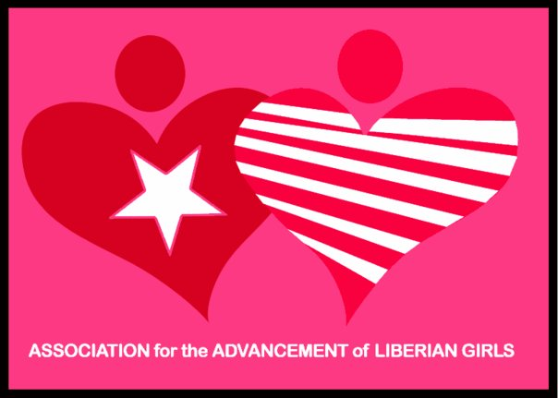

The Association for the Advancement of Liberian Girls

Stephanie Duncan

Global Giving Foundation Report

February/March 2015

**Liberian Girls Reading Room – Books In the Project**

On behalf of AALG’s team, I would like to submit our report for February – March 2015. Since the submission of the last report in, all activities surrounding the reading room project in Liberia has been on a stand still due to the outbreak of the Ebola Virus Disease in Liberia. Most of our volunteers, including myself, are currently working with the National Ebola Response Team on the opening of schools.

February 2014, Liberia, along with Sierra Leone and Guinea was hit with the world’s worst outbreak of the Ebola Virus Disease (EVD). According to the World Health Organization (WHO), over 5000 people have been infected with this deadly disease. Unfortunately Liberia has seen the highest number of Ebola cases and death to date. This resulted to Liberia’s President Ellen Johnson-Sirleaf issuing a State of Emergency. Schools were reopened in February 2015 after being closed for one year.

Our hope was to assist children going back to school with our Books in a Bag Project. However, we felt short of our goal. With things slowing getting back to normal in Liberia, we are planning to reopen the Reading Rooms the end of April 2015.

As always, thanks to donors like the Global Giving Foundation, for giving us the opportunity to create a positively impact our communities. We will continue to monitor the Ebola situation in Liberia. During which time, our team will continue with administrative activities, including receiving training and fundraising.

**PHOTOS**

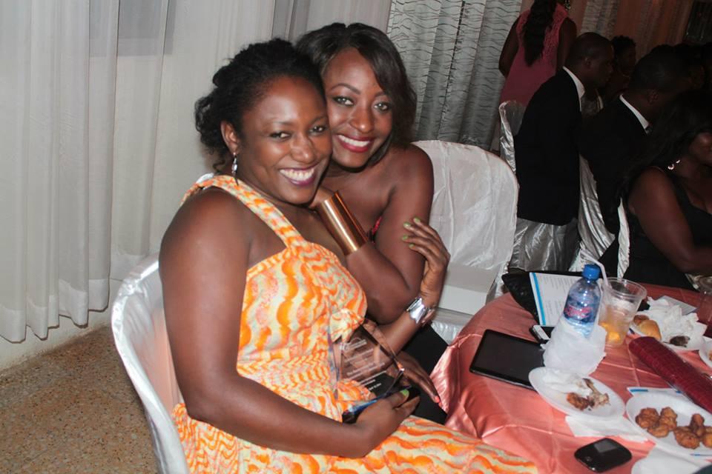

Ms. Duncan with Ms. Boo Brewer, receiving an award for humanitarian work from the Checago Bright Foundation.

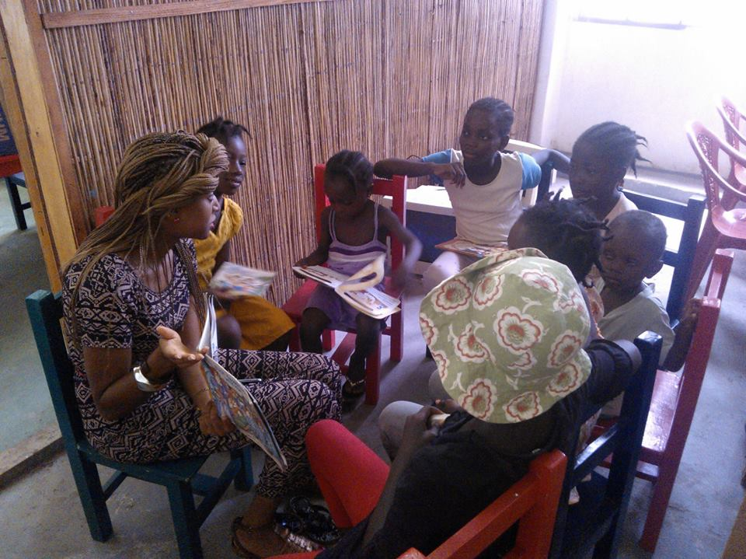

A volunteer reading to our children at the Jungle Reading Room in Congotown.

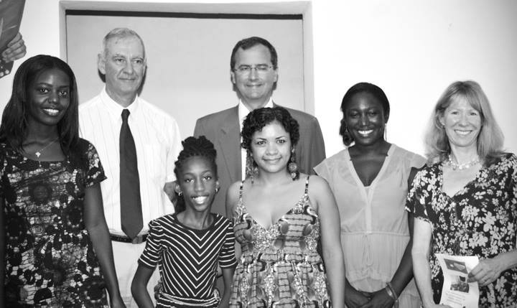

Our awesome team & sponsors: Yanumbe Marjean, Frederic Vloeberghs (Brussels Airlines & Honorary Consul of Belgium), Monahdee, Hon. Fergus Cochrane-Dyet (British Ambassador), Erika M. Ortiz Urey, Salamartu Duncan, and Mrs. Cochrane-Dyet.

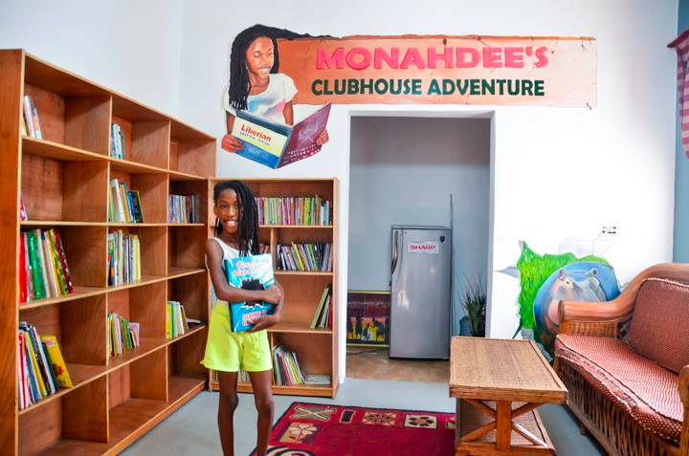

Monahdee, our inspiration for the reading room at the Creative Arts Center. Monahdee collected books for the children in the neighborhood. She wanted to share her joy of reading with children who didn’t have access to books. She is a community champion for starting this initiative.

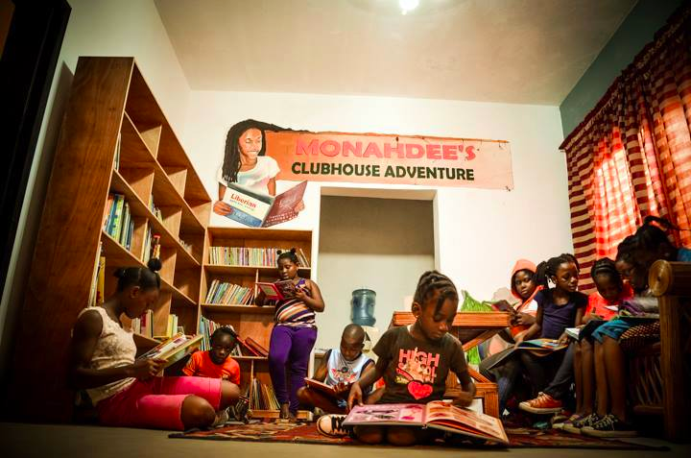

Girls who read ROCK!

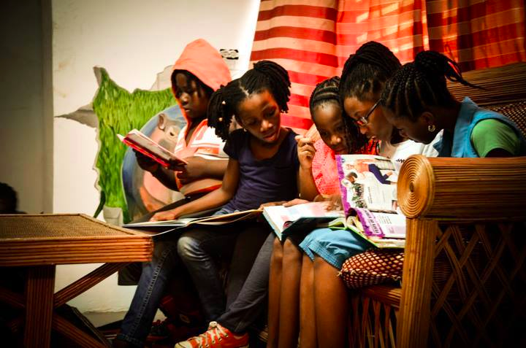

Girls who read ROCK!

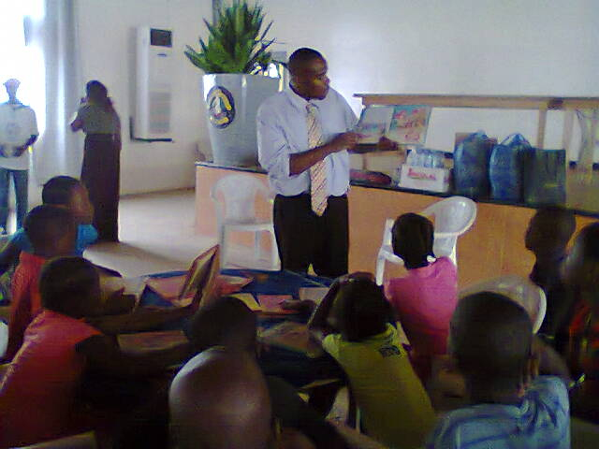 Reading Time at Paynesville City Hall, Liberia