Grassroot Soccer

In partnership with

Vijana Amani Pamoja

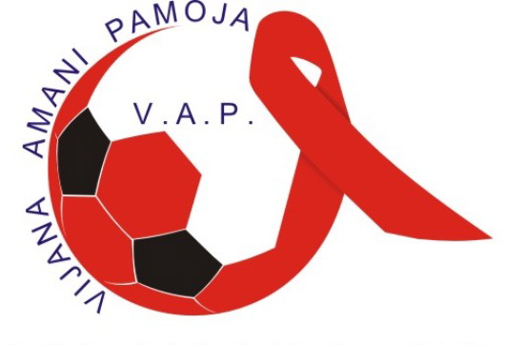



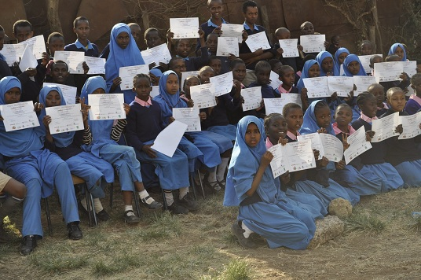
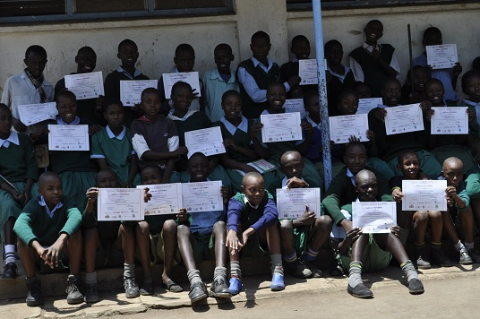


Quarterly Report

1st January 2012 – March 31st 2012



Background
Founded by former professional soccer players in 2002, Grassroot Soccer (GRS) trains African soccer stars, coaches, teachers, and peer educators in the world’s most HIV-affected countries to deliver an interactive HIV prevention and life skills curriculum to youth.

Vijana Amani Pamoja (VAP) is a charitable organization based in Nairobi that integrates social and economic values through soccer by creating a pro-active health environment.

As a Technical Assistance provider, Grassroot Soccer has partnered with VAP to provide support through curriculum/project design, training, and M&E system development. By transferring necessary skills, tools, and content, GRS aims build individual capacity as well as overall organizational capacity within VAP.

GRS began working with VAP in 2004, initially providing the Grassroot Soccer curriculum and delivering 3 days of training for their leadership and volunteer team. Over the last 6 years, GRS and VAP have collaborated informally and GRS provided revised curriculum materials to VAP in 2008. Support from Egmont Trust allows GRS to work closely with VAP to develop program specific and culturally appropriate curriculum materials, deliver evidence based training, tailor a monitoring and evaluation system and specific project tools that will actively measure the impact of VAP programs, and provide ongoing support as necessary.

Activities Undertaken

Skillz Kenya Intervention Delivery
From 12th January through March VAP conducted Skillz Kenya program at: Dr.Kraph, Kimathi, Dr.Aggrey, New Pumwani and Kariobangi South Primary Schools. A total of 13 interventions were conducted and 556 students out of 633 participants (88% retention rate) graduated from the Skillz Kenya program.

GRS Technical Assistance Visits
As part of the continuous programmatic and technical support from GRS, the two organizations conducted two refresher training courses for Skillz Coaches focused on strengthening M&E capacity within VAP. The trainings were done at VAP’s field office and led by Jamison Merrill, GRS’ Curriculum and Training Coordinator, who traveled to Kenya in late February.

2-day Refresher Course workshop: February 25-26
- Jamison facilitated a two-day refresher workshop for 15 of VAP’s Coaches
- The main aim of the refresher course was to brainstorm solutions to the challenges VAP faces in implementing SKILLZ Kenya as well as review GRS’ Big 5: vital conversations, safe space, personal connections, HIV experts, and praise.
- Additionally topics covered during the two days: pre-/post-quiz delivery, how to successfully debrief during sessions, and ideal coach-to-participant ratio.
- Jamison would have preferred to run more teachbacks during the two days, but the workshop was held at VAP’s field office and didn’t allow for enough space.

VAP Participation in Curriculum Development Workshop (CDW) with Mercy Corps: February 28 – March 1
- Under a sub-contract with International NGO, Mercy Corps, Jamison Merrill and Leah Dozier facilitated a three-day CDW at the Mercy Corps office in Eldoret, Kenya. The goals of the workshop were to collaborate with local, partner organizations and stakeholders, and to gather country-specific information to design the Yes Youth Can! (YYC!) Skillz Curriculum
- GRS received approval from Mercy Corps to engage VAP in the technical delivery of the CDW. As such, GRS invited Enouce Ndeche to help Jamison and Leah facilitated the CDW in Eldoret. All expenses were covered directly by GRS, under the sub-contract with Mercy Corps.
- Jamison and Enouce prepared for the workshop in Nairobi, discussing the current status of HIV, politics, and other issues affecting the youth in Kenya. They also reviewed and modified the 3-day workshop schedule.
- During the CDW, the group discussed important health and social issues facing Kenyans, including, HIV/AIDS prevention, peace-building, influence of politicians on youth, and gender-based violence. They also considered the most important health myths and discussed their impact on Kenya. Eight GRS activities were presented and in-depth discussions about each activity helped GRS design the curriculum overview.
- At the beginning of the third day, Enouce presented his Coach’s Story. Afterwards the group discussed the role of Coach’s Stories in the curriculum. The group thought very highly of the Coach’s Story activity and believes there is a place in the new curriculum.

One-day M&E training: March 2
- Jamison with VAP staff Oti (Programme Officer) and Opo (Logistics and Monitoring & Evaluation Officer) reviewed coach support visits (CSVs) and pre- and post-test sampling and delivery.
- Before the training, VAP compiled a list of questions and comments to cover with Jamison during the training. Topics covered included:
  - Coach support and expectation management.
  - Coach support visit delivery, feedback, and evaluation.
  - Coach development: how they can develop their coaches, what avenues to take, etc.

Youth Development Football (YDF) HIV/AIDS workshop
From 20th-25th February 2012, 20 participants from different organizations including MYSA, CFK, SEP, and VAP and teachers from various local schools took part in the YDF sponsored workshop that was held at Jericho Social Hall. The workshop included both theoretical and practical lessons on HIV/AIDS. The practical lessons focused on how football can be used to fight HIV/AIDS. YDF hired 4 VAP staff, Charles Otieno, Elizabeth Okinda, Boniface Kwasi and Robert Mukora, to facilitate the workshop. Elizabeth Okinda who attended the YDF training in South Africa led other facilitators in conducting the YDF modules and how it can be used.

YDF modules covered included:

- Understanding HIV biology and HIV development
- HIV/AIDS in conflict environment.
- HIV/AIDS and alcohol & drug abuse
- HIV transmission and prevention
- Managing HIV/AIDS through home based care practice
- Social drivers of HIV/AIDS
- Roles & responsibilities of a Coach in football for health

VAP joins Kenya Adolescent Girls’ Learning Network
The Population Council, in partnership with other organizations that have girl-focused programs in Kenya, hosts the Kenya Adolescent Girls’ Learning Network (also called the “Brain Trust”). From 22nd-24th February 2011, VAP was invited to attend a Learning Network workshop in Naivasha, approximately 2 hours from Nairobi in the Rift Valley Province. The workshop was meant to bring together adolescent girls’ program providers and experts to share learning, develop program guidelines, and strengthen programming for adolescent girls in urban Kenya. VAP was represented by Nancy Waweru, who delivered a presentation on the organization’s Mrembo Program, which is focused on the girl child. “Mrembo” means “beauty” in kiSwahili and the program focuses on delivering sexual reproductive health messages for girls 12-18 years old.

The Learning Network consists of three main components:

- Learning conversations: The core group of Learning Network members will meet monthly to discuss the different areas relevant to programming for adolescent girls. Each month’s discussion will focus on a different topic (e.g., conducting needs assessments, working with parents/guardians, developing leadership among adolescent girls, providing clinical services, and developing appropriate program topics and activities). The content of each discussion will be synthesized into a summary paper, and the overall content will be compiled into a set of tools and guidelines for use in adolescent girls’ programming.
- Technical assistance: Programs participating in the Learning Network have each committed to implementing at least one component from the learning conversations. Technical assistance is available in the forms of seed grants to provide initial funding for these activities, as well as sharing of knowledge and expertise among the participating members.
- Adolescent girls’ committee: Along with the learning conversations, a group of adolescent girls from the participating programs will meet monthly to discuss the topics of learning conversations, as well as plan exchange activities between the various girls’ programs. Representatives from the committee also will attend the monthly learning conversations. In addition, the network will coordinate mentoring opportunities—both professional and youth-to-youth—for the adolescent girls involved.

Streetfootballworld East Africa Network: Strategic Planning Workshop
As a follow up to the last strategic planning session in August 2011, streetfootballworld (sfw) East Africa Network members gathered again for a 2-day workshop in Nairobi January 29th-30th. The meeting convened 13 sfw organizations, including VAP, from across East Africa that are active in development through football. The goal of the 2-day workshop was to discuss the current and develop a new strategic plan for the sfw East Africa Network. The meeting ended with a clear framework of the new strategic plan document for sfw East Africa network that will be developed and absorbed by the entire group. The plan will also provide unique opportunity to exchange and develop key expertise and capacities that are vital for effective program delivery and overall operations.

Outstanding Skillz Coach!
Former graduate of the Skillz Kenya program, 19-year-old Zephaniah “Zephanie” Andefwa, is excelling as a new VAP Skillz Coach, and certainly a success story for the organization. Zephanie has been on the forefront and always on time when on the line of duty. He always reports to his assigned centres with all the needed materials: M&E, book, pen, whistle, stop watch, playbook, etc. and not forgetting his bag which he usually term it as “tool box”. VAP would like to give Zephanie a big KIIIIIIIIILO!

Ashoka East Africa
As VAP’s Executive Director, Enouce was invited to Asoka’s East Africa meeting on March 12. The meeting was a gathering of 35 like-minded people from across East Africa representing different organizations and institutions met at the Ashoka offices to learn, network and share their experience in accelerating social change. Asoka works to identify and invest in local social entrepreneurs who have new ideas for systematic social change. These innovators are elected as “Ashoka Fellows”, given financial and professional support and gain access to a global network of social entrepreneurs. In 17 countries across Africa, since 1990 Ashoka has supported over 350 social entrepreneurs who are implementing solutions at the grassroots level to solve the continent’s most pressing social problems.

Ashoka fellows in Africa are empowering people to create their own economic and civic opportunities, addressing the pandemic of HIV/AIDS and other health concerns, introducing more effective education systems, protecting the environment and natural resources, and solving conflict. Ashoka believes that building a critical mass of groundbreaking social entrepreneurs is an important step towards creating a vibrant, prosperous African continent. Ashoka launched its operation in East Africa in 2001 and it has over 40 fellows.

Enouce will stay connected to the Asoka network, and apprised of future Fellow opportunities.

Monitoring and Evaluation

Skillz Graduates
VAP had 556 graduates in 2012 Quarter 1. Approximately 45% of the graduates were male, and 55% female.

Nearly all of these graduates were within the 11-19 years old target age range for the Skillz Kenya curriculum, and only six of the 556 graduates were outside of this range, and were either 9 or 10 years old.

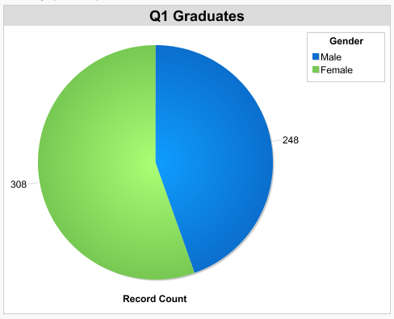
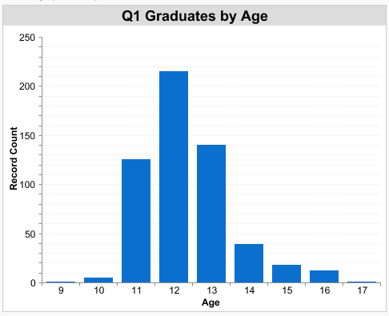
Overall, there was an 88% graduation rate for the 13 Interventions that took place during this time period. A graduate is defined as a participant who attends at least 7 out of the 10 sessions in an Intervention.

Pre / post survey
Pre and Post surveys were conducted with approximately one-third (n=187) of the Skillz Kenya graduates, and a 19% point overall change was observed in participants’ knowledge, attitudes and communication around HIV (from 69% to 88% correct).

The Pre and Post results show that GRS Skillz Kenya graduates are comprehending and understanding key messages from the curriculum. Key changes include a 34% point increase in recognition of having only one, faithful partner as a way to avoid getting HIV (from 50% to 84%); a 37% point increase in recognition that having sex with an older partner increases your risk of getting HIV (from 48% to 85%); and a 16% point increase in recognition that using condoms during sex is an effective way to avoid getting HIV (from 61% to 78%). There was also a large increase observed in knowledge relating to male circumcision and HIV transmission from mother-to-child.

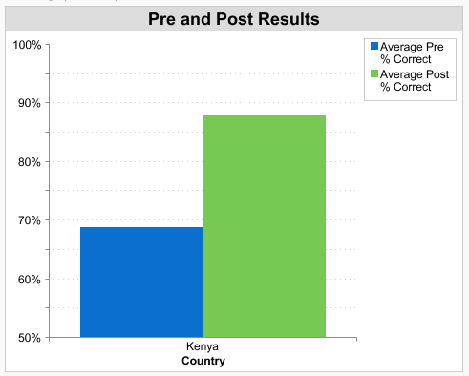
An increased number of graduates reported talking to others about HIV at the end of the Skillz Intervention. Most notably, there was a 51% point increase in communication with a parent or guardian about HIV (from 30% to 81%).

There was significant improvement in HIV- and gender based violence-related attitudes. After the Skillz Intervention, an additional 19% of graduates correctly recognized that it is possible for a healthy-looking person to have HIV (an increase from 70% to 89%) and an additional 15% disagreed that there were times that is was okay for a man to hit his wife or girlfriend (an increase from 67% to 82%).

Finally, there was an observed increase in an individual’s self-efficacy to make his or her own choices, with an additional 18% agreeing after the Intervention that they could resist peer pressure (an increase from 66% to 84%).

Challenges
Coaches were experiencing challenges when conducting pre and post surveys due to large numbers of student participants in some intervention groups which saw them trying to execute surveys with unmanageable groups of students.

With the support of GRS, VAP worked out a simple system of conducting pre and post surveys with a sample of Skillz participants, therefore decreasing the total number completing surveys, but increasing the overall quality of survey delivery.

Successes
A major success in Q1 was the opportunity GRS provided for VAP to participate as a local technical expert in the Curriculum Development Workshop GRS facilitated for the Yes Youth Can! Mercy Corps funded project. Enouce’s participation was an occasion for on site capacity building and an opportunity for GRS to provide direct feedback on program delivery. Enouce has shared with his team the tips and tricks he learned about both the content and logistics of delivering a training for a stakeholder such as Mercy Corps.

Enouce and Leah had several meetings in Nairobi the day before the CDW kicked off in Eldoret. They met with several local stakeholders and potential strategic partners including PATH /USAID, HIV Free Generation, Mercy Corps, One World Futbol (makers of the indestructible football), GOAL. Both VAP and GRS are following up on the leads and collaboration opportunities that were discussed.

