EMPOWERMENT

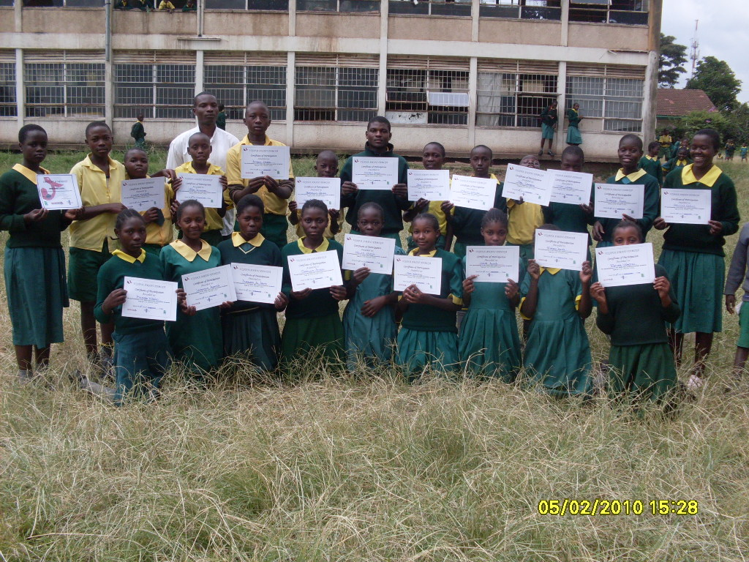
For the last couple of weeks, Vijana Amani Pamoja, VAP has graduated over 2,100 students from; Uhuru primary school, Jericho primary school, Baraka primary school, Jacaranda special school, Uhuru High school, and Chai community centre, Umoja and Feda community centres. Various through its interventions. All the participants went through the entire Skillz curriculum that was delivered as an after school program by VAP’s peer educators.Skillz curriculum is a newly revised version that entails 10 sessions that has a series of activities that include critical thinking,communication,self-esteem and decision making, among others. It requires active participation and creates a safe, team-based environment in which participants can comfortably share their feelings, beliefs, and ideas about HIV/AIDS. All the graduates were empowered with certificates that deemed them to become HIV/AIDS ambassadors and experts in their respective communities. “After having gone through the Skillz HIV/AIDS intervention, am now fully aware of the dangers that HIV/AIDS posses. I can now teach my peers and my family on how they can be pro-active against HIV/AIDS. “Said Sam Njuri, 13 years old graduate of Uhuru primary school. These graduates are expected to conduct peer education activities within their communities, reaching out to thousands more through formal and informal educational sessions.

REACHING OUT TO PEOPLE WITH INTELLECTUAL DISABILITY
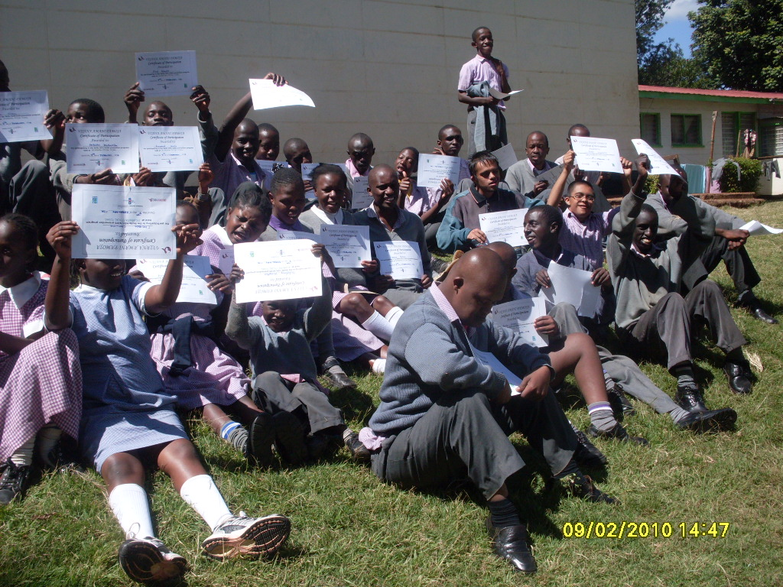

Graduates from Jacaranda Special School.

For the very time in the history of Vijana Amani Pamoja, VAP also involved and graduated students with intellectual disability from Jacaranda special school. It has been to the discover of VAP that people with intellectual disability are the most undervalued population and are mostly forgotten and ignored by the mainstream society to empower them as well with critical healthy information that render them to become more vulnerable to HIV/AIDS.A total of 450 students with intellectual disability were graduated from the Skillz HIV/AIDS intervention.’’ Iam truly amazed and thankful to Vijana Amani Pamoja for reaching out to people with intellectual disability whom very so often are down looked and have been mocked for so many years. With the trend that VAP is setting, the general society should also consider and include people with disability in awareness activities and messages.” Said Mrs. Jane Wafula, the school principal of Jacaranda special school.

THE DRIVE TOWARDS WORLD CUP
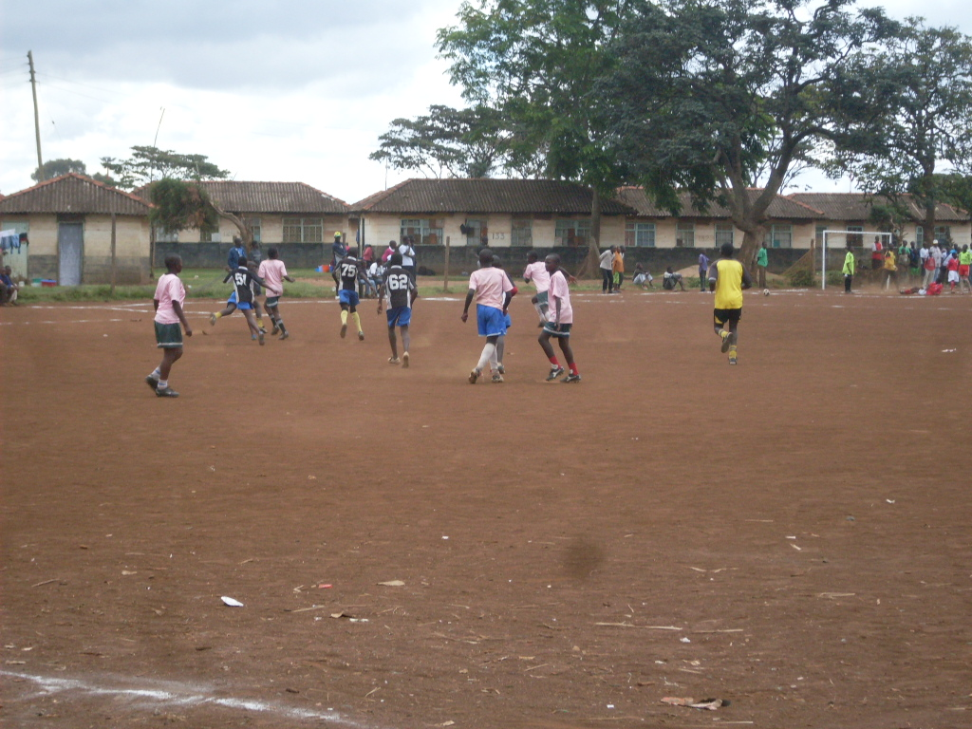

Local graduation soccer tournament

Vijana Amani Pamoja,through its strategic theme,(The drive towards world cup) is looking forward to graduating 3000 more students before the commencement of the first world cup game in African soil.VAP will vigorously be using the power and popularity of the game and its impact for being hosted in Africa to achieve its goals.

ACKNOWLEDGEMENT

VAP would like to thank all the partners and well wishers who have been donating towards its movement through Global Giving and NOT forgetting to thank Streetfootballworld and FIFA through its strategic alliance,(Football For Hope) grants that have been of great impact and value. We would still be requesting for more donations for us to achieve our mission.

