Immunization for Children and Young Mothers
Annual Progress Report, 2012
Submitted to
Global Giving

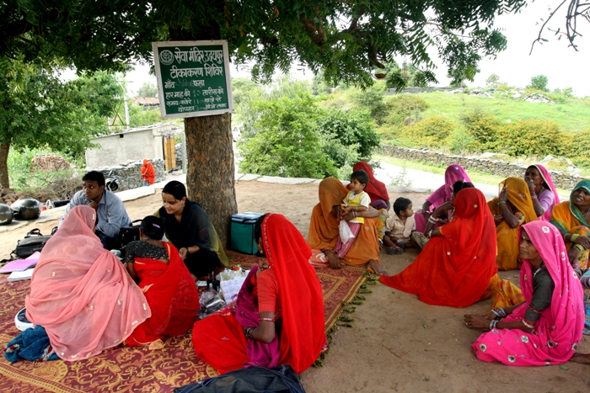

Presented by
SEVA MANDIR
Udaipur Rajasthan, India

info@sevamandir.org
www.sevamandir.org

Seva Mandir’s project, “Improving the Immunization Status in Rural and Tribal Areas of Udaipur District,” aims to improve the immunization status of children and pregnant women in those remote areas not reached out by the government health service providers. Camps are conducted on a fixed date and at fixed places by mobile teams. The mobile teams are monitored using date and time stamped photographs. To encourage demand, incentives are given in the form of 1kg of lentil for every shot of vaccine that a child receives and a set of utensil after he or she completes immunization. Services provided in these camps include immunization of children, antenatal checkups and vaccines for pregnant women, and treatment for childhood illness.

a) Regularity of Immunization Camps
Immunization camps are currently being run in 125 locations. During the reporting period, 1,167 camps were conducted against the target of 1,358 camps. A total of 191 camps had to be cancelled due to various reasons such as festivals, monsoon, and unavailability of ANMs. During the reporting period, retention and replacement of nurses has been a problem and accounted for many of the cancellations.

b) Immunization of Children
During the period 2011-2012, 1,131 children were registered in the camps. The details of each shots of vaccine received by the children are as follows:

Number of children received BCG shots | 668
Number of children received DPT / OPV (1st dose) | 1,158
Number of children received DPT / OPV (2nd dose) | 814
Number of children received DPT / OPV (3rd dose) | 686
Number of children received Measles vaccine | 603

c) Antenatal Care of Pregnant Women
At the camps, the teams also provide antenatal checkups and immunization for expectant mothers. During the reporting period, 1,553 women registered for antenatal checkups. These checkups consist of:

- Hemoglobin test,
- Urine test for checking risk factors (i.e. Eclampsia),
- Blood pressure test,
- Weight check and
- Routine physical examination.
Further, women are counseled on care they should take during pregnancy. In this reporting period, a total of 1,447 women received first dose of tetanus toxoid and 1,217 women received complete dose of tetanus toxoid.

d) Future Plans
A new initiative to immunize children in Balwadis (Seva Mandir run pre-schools) was to begin in April, 2011. However, it could only be started in July, 2011 due to delays in getting nurses. A new team was hired for each block and the new teams were given responsibilities of conducting immunization at Balwadis and a few camps at hamlet level. A lot of effort was put in planning the work schedule for the Block Immunization teams so that the Balwadis as well as the camps could be covered simultaneously within the limited time period. The teams were given a list of children with their immunization status, collected during the base line survey. For each Balwadi, three monthly visits by the team were fixed with consultation of a senior pediatrician, and the Balwadi Sanchalikas were informed about the schedule. The following was determined: a child over the age of one year who had not received any vaccinations is to be given measles and DPT in the first month, followed by BCG and DPT in the second month and last dose of DPT in the third month with oral polio drops each month.

During the reporting period, immunization at 100 Balwadis was completed wherein 952 children received immunization. This figure is much low as compared to the target of 296 Balwadis that had been set. This can be attributed largely to the initial delay due to unavailability of nurses. Also, in the starting months, many of the Balwadis did not get the information of the Immunization days and were found to be closed when the teams visited them. Later on, this problem was resolved through repeated reminders to the Balwadi Sanchalikas regarding the immunization days. Also, in a number of Balwadis it was reported that the government ANM was doing regular immunization and, therefore, the children were up to date with their shots.

Stories of Immunization Camps from the field

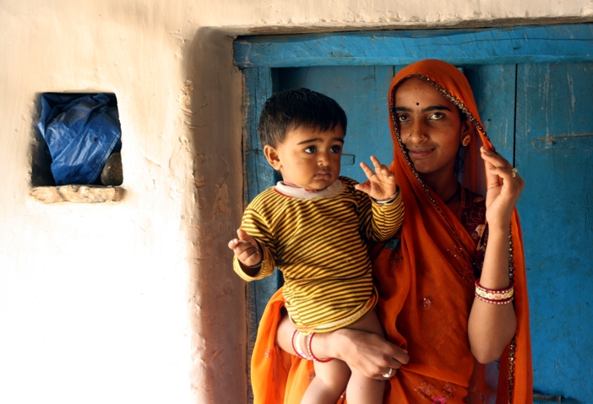A young 20-year-old woman named Yashoda quiets her young child who continues to cry after receiving a vaccination during one of Seva Mandir’s monthly immunization camps. Yashoda learned of the camp from the local BalSakhi (also known as friends of children, trained for neo natal and infant care), Babli, when she visited her home in the village to check the baby’s weight. Babli had explained the benefits of children’s immunization and informed her the date when the camp would happen. Yashoda walked over 7kms to attend the camp and says she will walk the distance to vaccinate her children in the future as well.

