Rural Schools
Annual Progress Report, 2012

Submitted to
Global Giving
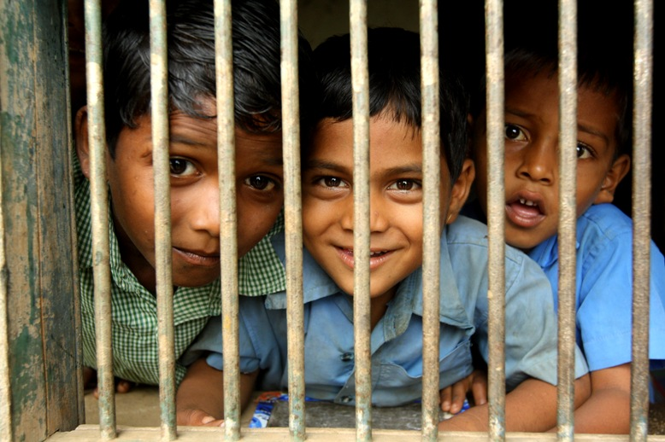

Presented by
SEVA MANDIR
Udaipur Rajasthan, India

info@sevamandir.org
www.sevamandir.org
Introduction
In rural Rajasthan, Seva Mandir works with over 150 village communities to establish and run Shiksha Kendras (SKs), (formerly known as Non Formal Education Centres), in remote hamlets. Their aim is to ensure quality education to children aged 6 to 14 from marginalized communities, not by replacing government schools, but by acting as a “Bridge School.” Through encouraging numeracy and language (Hindi) skills, SKs strive to secure the all-round development of children and prepares them for enrolling and retaining positions in official government schools.

About Shiksha Kendras (SKs)
The SKs are most often single teacher schools. Most teachers are from the local area and therefore understand the children’s unique needs due to their culture and livelihood. The average academic qualification of teachers is from class 8th to 12th but teachers are also able to receive further training from Seva Mandir. Regular teacher training sessions are conducted to ensure that teachers are given targeted and progressive support.

In our Rural Schools children are uniquely endowed. Children are taught as per their pace and style, and therefore a strict curriculum or syllabus is not enforced. Instead, Seva Mandir provides a set of guidelines which detail learning ability goals for specific time periods, and general teaching advice. This is one way Seva Mandir is critically examining the “conventional” way of teaching in rural government schools.

The Need for Education
Seva Mandir works in areas, predominantly tribal, where children face barriers to accessing quality education. The condition of schooling is often one of severe neglect with high rates of teacher absenteeism, poor pedagogical methods, a lack of learning materials, inadequate infrastructure, and above all, an apathetic atmosphere. In addition, parents and communities, in general, are not able to get the government to address such issues. Their own poverty creates pressures to put every available hand to work and therefore does not allow the resources for them to fight the battle for quality education. Strengthening community contribution and ownership of education is therefore crucial in building sustainable education to excluded rural children.

Current Status of SKs
Currently, 178 SKs are reaching 5,861 children, 43% of which are girls, in the five rural blocks in which Seva Mandir works illustrated below in tables.

Block wise details - the number of Shiksha Kendras (SKs) and teachers

Block | No. of SKs | No. Of Teachers
Kotra | 54 | 65
Jhadol | 43 | 48
Kherwada | 37 | 39
Girwa | 23 | 28
Badgaon | 21 | 22
Total | 178 | 202

Block wise details - enrolment of children till March, 2012

Block | Boys | Girls | Total
Kotra | 1,345 | 686 | 2031
Jhadol | 753 | 615 | 1368
Kherwada | 552 | 513 | 1065
Girwa | 436 | 398 | 834
Badgaon | 277 | 286 | 563
Total | 3,363 | 2,498 | 5,861

In reporting year 2011-2012, 11 SKs were opened whilst 20 were closed. The reasons for these closures vary significantly, and highlight the constant difficulties faced in poor rural communities. In some areas, SKs have closed simply because small class numbers have forced centres to merge with others. In others, the majority of children may have been accepted into government schools. The main challenge however appears to be that a number of teachers have left their positions whilst another was unable to be found. Some teachers of these teachers moved to other schools, whilst others were asked to leave since their performance was not sufficient.
Block wise details of new enrolled children are mentioned:

Block | Girls | Boys | Total
Kotra | 242 | 466 | 708
Jhadol | 209 | 223 | 432
Kherwada | 118 | 149 | 267
Girwa | 136 | 151 | 287
Badgaon | 95 | 114 | 209
Total | 800 | 1,103 | 1,903

During the reporting period, 1,903 new children, 42 % of which were girls, were enrolled in the SK program. Kotra Block, one of the most rural, tribal and remote blocks of Seva Mandir’s work area, represented the highest new enrolment.

Learning Outcomes of Evaluation
To measure the extent to which NFE students have been able to acquire new knowledge over the course of the year, standardized tests are conducted twice a year. An annual evaluation is conducted in the month of March and April and half yearly is conducted in November.

In the half yearly examination in 2011 a total of 4,230 students, took the exams. Their level wise distribution is given below:

Block | Level 0 | Level 1 | Level 2 | Level 3 | Total
Badgaon | 9 | 131 | 200 | 64 | 404
Girwa | 16 | 176 | 275 | 95 | 562
Jhadol | 16 | 310 | 476 | 197 | 1,001
Kherwara | 14 | 207 | 338 | 156 | 715
Kotra | 11 | 377 | 837 | 323 | 1,548
Grand Total | 66 | 1,201 | 2,126 | 835 | 4,230

Results: 20% of students scored level 3 compared to 2010’s 10 %. 50 % of students scored level 2 compared to 2010’s 13 %. 28 % of students scored level 1 compared to 2010’s 35%. 2 % of students scored level 0 compared to 2010’s 43%.

Mainstreaming
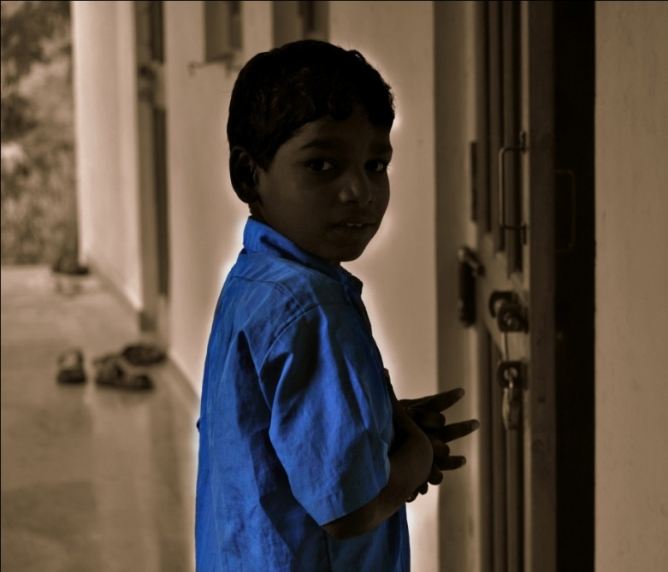
Once the students of the SKs have the initial foundation of reading, writing and mathematical abilities, they are encouraged to enrol in government schools (roughly the equivalent of class 3, however like the SK model defines an individual level of each child is determined by the instructor).

Generally students are either admitted in class 4 or 5, but a few children were also admitted to class 6. Class-wise breakup of children mainstreamed in each blocks are given below:

Block | Class 1 to 3 | Class 4 | Class 5 | Class 6 | Total
Badgaon | 56 | 4 | 35 | 31 | 126
Girwa | 34 | 17 | 48 | 41 | 140
Kotra | 115 | 18 | 62 | 140 | 335
Jhadol | 147 | 51 | 32 | 112 | 342
Kherwara | 140 | 26 | 30 | 71 | 267
Total number  (In percentage) | 492 (40.66%) | 116  (9.59%) | 207  (17.11%) | 395  (32.64%) | 1,210

Capacity Building of Teachers
Since most SK instructors have studied only until 8th or 9th class, trainings were conducted regularly to enhance their capacity. Capacity building is critical area of engagement for Seva Mandir as it serves the purpose of better opportunities for learning for children and also serves as a tool of motivation for instructors. This year 24 newly employed instructors attended the six-day initial training programme, and 84 more experienced instructors attended advanced training.

Instructor Meetings
Seva Mandir holds at least one instructor meeting every quarter to track progress made by the SK centres, children and instructors. It is also a platform for the aforementioned to discuss problems faced and ideas for improvement. This year, 36 were attended in total, and it is clear that engagement has been increasing. One outcome also has been the growing understanding of why paying Shiksha Shulk fees should be paid on time. Instructor meetings held in this reporting period block wise are given below:

Block | No. of meetings
Badgaon | 7
Jhadol | 4
Kotra | 9
Kherwara | 9
Girwa | 7
Total | 36

English Language Teaching
After a successful pilot study, it was decided through various teacher meetings and trainings, that English Language Teaching should be taken to all six blocks. The module for this training has 2 major components; first being basic English on which the teachers can directly work with children and second being basic English for building teachers’ capacity. These training sessions covered a variety of methods such as taught rhymes and songs with action verbs, flash cards of English words, and worksheets for regular practice.

Community Participation
A change in attitudes in regard to children’s schooling at a grass root level is fundamental in bringing about systemic changes in the provision of state education. A noteworthy change in village discussions is that children’s issues are now given a place of importance. By integrating the wider community with their children's education, communities are gradually acquiring greater awareness about quality education and voicing demands concerning the standards in government schools.

In addition, democratically elected village committees have the responsibility of monitoring, evaluating the centres and the work of the instructor, also paying the instructor’s monthly stipend. Parents are also invited to participate in two-monthly parents' meetings where they can interact with teachers and learn about what happens in the centres.

Shiksha Shulk
In all the SKs, a token fee, known as Shiksha Shulk, is charged from the parents. If more than one child per family is attending the SK or if the family is economically constrained, the Shiksha Shulk can be waived completely. The prime purpose behind the Shiksha Shulk is to involve the parents in their child’s educational system. By charging a nominal fee of Rs.100 the parents and families become invested in the process.

Depending on the children’s and parents needs, the fee has been used for different purposes such as buying uniforms, shoes or tiffins for the children, sports material for the SKs, maintenance of the SKs, or whatever the students and parents determine is needed. In some places where there was a shortfall of the amount, parents or the village committee have contributed an extra amount in order to purchase the desired items. Expected and received Shiksha Shulk fees per block are listed below in INR:

Block | Expected | Received | Utilization
Kotra | 231,100 | 141,660 | Uniforms for most of the centres
Jhadol | 136,800 | 96,380 | General needs of centres and children
Kherwada | 96,800 | 77,400 | Purchased uniforms for centres
Girwa | 77,700 | 59,670 | Sweaters, winter clothes
Badgaon | 50,200 | 32,540 | General needs of centres and children
Total | 469,480 | 407,650

In the reporting period, as compared to an expected collection of Rs. 469,480 (USD 9,390), an amount of Rs. 407,650 (USD 8,153) was collected, which was 87% of total expected amount.

Parent Teacher Meetings
As part of the programme, Parents-Teachers meetings are organized three times per month. These have successfully engaged both teachers and parents in dialogue, strengthening the community network, and increasing awareness on importance of education. Other topics of discussion have included techniques to increase attendance, health and hygiene issues, and generally the overall progress of students.

Other Activities of SKs

Independence Day (15th August)
Every year, Independence Day and Republic Day is celebrated in all the schools by hosting the national flag and running a range of cultural activities throughout the day. For the rural children it is an opportunity to develop and showcase their cultural talent whilst developing interpersonal and group work skills. It is also an event that unites communities and fosters shared learning.

First Aid Kits in Kotra
During the year, First Aid Kits were distributed to SKs in Kotra Block as part of a pilot study. One kit was distributed to each centre where all teachers were trained on how to use them.

Bal Melas in Girwa
Girwa Bal Melas (children’s fairs), are organised at Kanpur village of Gojiya zone in Girwa block. A diverse range of educational activities and sports competitions were arranged for over 150 students across the village. The event held in January, 2012 was such a success that it continued to reach communities in the following months.
On February 2, 2012, 350 students participated from 14 SKs and
On March 2, 2012, 300 children participated (half of the children were from private schools and remaining half were from SKs).

To identify the progress of a child we have categorized four levels of their learning from 0 to 4. The levels are roughly equivalent to government classes. Level 0 is when a child enters the school and can barely read or write. Level 1 is where she can read and write small words and does simple counting and can identify some numbers. When a learner can start reading, and understanding simple sentences and writing small / incomplete sentences, in Mathematics can do basic counting and simple operations like addition and subtraction with small numbers, she is placed in Level 2. At level 3 a learner can read and understand simple texts and articulate themselves by writing a group of sentences and in Mathematics understands concepts of multiplication, division, etc.

