Mid Year Report 2010-11
Submitted to
Global Giving

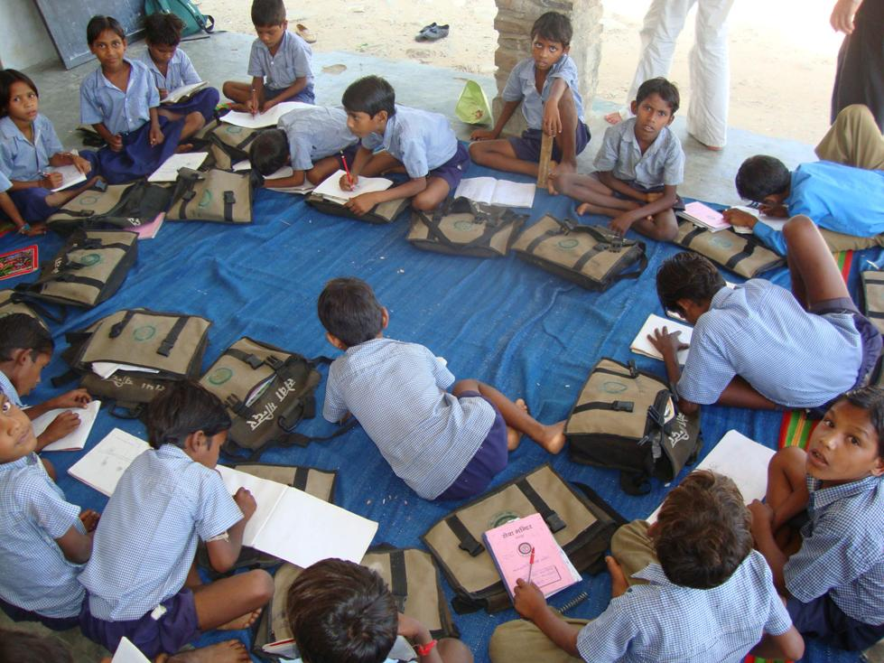

SEVA MANDIR
Udaipur Rajasthan, India
info@sevamandir.org
www.sevamandir.org

Introduction
Seva Mandir helps village communities run Rural Schools or Shiksha Kendras (SKs). The rural schools are single teacher schools that ensure quality education to out of school children (between 6-14 years old) of tribal and marginalized communities. In addition the aim is to also empower local communities to collaborate effectively with the government for ensuring quality education to their children.
In all the areas where Seva Mandir works, children have poor access to quality education. The conditions of schooling in tribal areas is often one of severe neglect, with high rates of teacher absenteeism, use of poor and old pedagogical methods, lack of learning materials, inadequate infrastructure, and above all, an apathetic atmosphere. Parents and communities in general are not able to get the government to address these issues. Their own poverty creates pressures to put every available hand to work. The supply and demand inadequacies compound each other and reduce the likelihood of a child going to or staying in a school. In many places, many children migrate either daily or seasonally for work.
In this context providing a meaningful education is very important not only for its intrinsic value, but also because attendance in school can often prevent the child from migrating at such an early age. The SKs are often single instructor schools offering education to out-of-school children up to class 3.
The instructors (knows as Anudeshak) who teach children in villages in these Shiksha Kendras are from within the villages. They are highly motivated and committed individuals who want to help their villages. The average academic qualification of such a teacher is class 8th. With Seva Mandir’s continuing investment in building their capacities, these local teachers perform very well. The pedagogy followed in these SKs is to enable children to think and reason, question and form concepts on their own. Therefore learning in SKs becomes a joyful experience for these children.
At present, there are 192 rural schools in all the five blocks of Seva Mandir. The total enrollment of children in these schools is 5,665. A Block wise detail of the number of SK’s are shown in Table below. During this reporting a total of 15 centers were closed for various reasons and 7 centers were newly setup. Therefore, a total of 192 centers are running at the moment with 3,339 boys and 2,393 girls.
Block wise details - the number of SK’s in Table 1 below.
Block | No. of Rural Schools/ SKs |  |  |  |  | Enrollment of children
Block | Mar 2010 | Sept 2010 | Teachers | In March 2010  Total Students | September 2010
 |  |  |  |  | Boys |  | Girls | Total
Jhadol | 46 | 47 | 50 | 1334 | 744 |  | 592 | 1336
Kotra | 58 | 56 | 63 | 1972 | 1225 |  | 663 | 1888
Kherwara | 43 | 41 | 42 | 1043 | 552 |  | 478 | 1030
Girwa | 29 | 27 | 31 | 959 | 471 |  | 411 | 882
Badgaon | 24 | 21 | 22 | 582 | 318 |  | 249 | 567
Total | 200 | 192 | 208 | 5,890 | 3,310 |  | 2,393 | 5,703
The schools that were shut down during the last six months report various reasons such as the irregularity of the teacher, very low enrollment of children in the rural school, and in some cases children got enrolled in the Government Schools that were newly set up.

Token Fee (Shiksha Shulk)
Each child attending the rural school has to pay a token fee of Rs. 100 every year. The fee is collected by the village communities. The village spends the collected fee on children’s needs such as uniforms, lunch boxes, flip flops etc. In the period April – September 2010, 48% of the total fee was collected across 192 centers. The amount collected was mainly used for purchasing uniforms for children. In some cases, fee is waived for children who come from vulnerable and poor economic backgrounds. This waiver is done with due discretion of the village development committees in each village.

Results of Children’s Assessment/ Evaluations:

Two times every year the assessments of children’s learning levels are done. It is ensured that the evaluation process is interesting and simple. There are a variety of questions ranging from pictures to identify and name, text for reading and comprehending, mathematical sums, etc. Along with testing language and mathematics skills, children’s knowledge of their surroundings and environment is also evaluated. For example in mathematics, questions range from counting and simple addition to problem sums. Level wise assessment is given below in the table:

Annual Exam April-2010
Block | Level of learning |  |  |  | Total
Block | 0 | 1 | 2 | 3 | Total
Badagaon | 25 | 235 | 83 | 95 | 438
Girwa | 20 | 445 | 166 | 217 | 848
Jhadol | 53 | 539 | 248 | 218 | 1058
Kherwara | 15 | 453 | 173 | 304 | 945
Kotra | 56 | 781 | 337 | 299 | 1473
Total | 169 | 2453 | 1007 | 1133 | 4762

0 level is for beginners and 3 is the highest level of learning. After reaching to level 3 children are ready to go for further schooling.
Certification Course
In the second quarter of the year 2010-2011, 227 instructors were enrolled for the Certification Course. It has been offered to teachers of SKs since 2003. The SK Certification Course is being conducted in collaboration with Vidya Bhawan and continues to be an integral part of the capacity building efforts of the Education Programme for the instructors of SK centers. As mentioned earlier, most of the instructors in the Seva Mandir education program have only studied up to Class 8, and have had no formal training to teach. The certification course helps teachers improve their academic competencies resulting in their confidence of teaching. The course also aimed to set up a mechanism that could enable a continuous dialogue and interaction with the instructors on academic issues, in a manner that the instructors found interesting, challenging, and meaningful for their own learning, and meaningful for the children in their classrooms.
During April-September, a total of 216 teachers participated in the Certification course. At present 208 instructors are working with SKs and 8 teachers selected by village committee, to help the Government school teachers, also participated in Seva Mandir Certification Course. Out of 216 teachers 101 reached to level 1, 61 acquired the level 2 and 54 have reached to the highest level 3 in this course.

Parent-Teacher Meeting
In an effort to further deepen the relationship between the SKs and the parents of the children attending the schools, the Parent-Teacher meetings were organized in all SKs once every two months. The meetings enabled the parents to get acquainted with the progress their children are making and it also allowed the teacher and parents to have a dialogue. A lot of issues were discussed and resolved through such forums. Topics discussed included the token fee, the enrollment and attendance of children, hygiene, teaching pattern, parent’s role etc.

Enrolling in Government Schools
Block | Children
Badgaon | 83
Girwa | 214
Kotra | 68
Jhadol | 333
Kherwara | 330
Total | 1028
A total of 1,028 children got enrolled in Government Schools after graduating from Seva Mandir run Rural schools, during April-September 2010. The following table shows the Block wise children enrolling in Government Schools after finishing SKs

Admission Festival (Praveshotsav)
Pravesh Utsav is a traditional way of celebrating and encouraging the enrollment of out of school children in schools. It is celebrated in July each year, in most of Seva Mandir run Rural Schools (SKs). Students organized rally in their neighborhood encouraging children (out of school) to join them. The new students are welcomed with jaggery, tilak and tying of laccha (a traditional wrist band). In some places students of SKs celebrated the Pravesh Utsav together with the government school.
An experience from field- Chali Bhilwara, Varvaliiya – by Megha
They sang slogans like -
”chalo chalein school chalein” (lets go to school together),
”hum padhne jayenge,bakri nahi charayenge” (we want to go to school not to the pastures for rearing goats),
”Seva Mandir ka hai élan, ladka,ladki hai ek saman”(Seva Mandir is calling boy and girl should be treated equally).
It is inspiring to know, how calling out slogans can lead to enrolling more children in the schools. This is a story of those few children who have been successful in engaging their parents and village members in their struggle to establish their Right to Education.
Pravesh utsav (beginning of new session at school) was celebrated in Chali Bhilwara village on 1st July ’10, to celebrate and strengthen the act “Right to Education’. A rally was organized at 9 am for one hour with 35 children. Of these 35 children 25 were from the rural school.
The rally on this day was organizsed in the neighborhood of Chhali Bhilwara hamlet. Tej singh, the teacher at the rural school of Chhali Village took the lead in organizing the entire event to inspire the out of school children to attend schools. These 35 children set up 12 stalls at varied locations across the village. At each stall 2 or 3 children were conducting various activities to engage with parents and out of school children. The activities at these stalls included –
- registration of the attendees,
- asking the participants to say something they like,
- knowing one’s body weight and height,
- knowing how long one’s foot is,
- counting pebbles in a minute,
- making sentences from the words one would choose,
- using stamp pad to trace one’s thumb prints,
- guessing the object with one’s eyes closed,
- making tattoos on one’s palms with henna and
- putting the coins in the glass in a bucket.
Along with these stalls, children had also acted out a couple of short plays and skits for the community. They conveyed the message of promoting primary education, sending more and more girls to schools and also encouraging parents to enroll their children in schools who have dropped out early.
Everyone in the village participated in the rally and investigated the stalls put up by these enthusiastic children of their village. The event was a big success as within 10 days of the rally 20 children (who had dropped out of schools) got enrolled back into the schools. Another 5 girls (between 14-16 years) who were not going to schools also started attending the rural school (SK) after the rally.
Most importantly the event also helped the community realize the fact that a rural school is not only about education but also about the use of this education in their lives. For example – learning to measure things in Liters or Kilograms or Meters, learning how to weigh and what the use of these concepts etc is.
The village development committees (GVCs) also supported children and Tej Singh in this initiative throughout. Today both the rural school (SK) and the Government schools are witnessing better attendance of students and are feeling enthusiastic about the whole thing.
Tej Singh is also very happy and feels that he is receiving better response in the door-to-door visit to parents. In August during a parent-teacher meeting the collected token-fee was decided to be used for buying sweets for children of the school. The remaining amount was decided to be spent to purchase shirts for the students of the SK.
The success of Chhali village rally also spread to the other surrounding villages. These kinds of events help developing a greater sense of unity in the community and also provide an opportunity to have fun at the same time.

Independence Day (15th August)
It is one of the major national festivals which was celebrated in our Rural Schools. Each year, the days were observed by hoisting the national flag with a cultural program. The villagers also participate in the celebration. Such celebrations provide children a break from their routine and encourage interaction amongst all villagers. The children get an opportunity to participate in creative activities and thereby exhibiting their extracurricular talents.

Volunteers in action
From April to September 2010 a number of volunteers both from within India and abroad worked in the Rural School Program. The volunteers were involved in studies such as Identifying and helping children with learning difficulties; An analysis and evaluation of learning environment of Rural Schools in Badgaon block; A report on promotion of parent teacher meeting at Rural Schools etc.

Conclusion
The Rural Schools (SKs) provide a firm foundation of learning and comprehension to rural children of Udaipur District. This helps these children to perform well in any school they join after graduating from SKs. Every year more than 700 children join government schools from SKs. The learning afforded in the SKs develops their basic literacy and academic skills, enabling them to grasp better and even study on their own. A recent study of Seva Mandir shows that 84 % students who had passed out from Rural School were still found in schools after 3 years of leaving SKs. These kinds of retention rates are certainly far ahead of normal retention rates in the government schools.
The other impact is that the SK is helping change the norms within the rural communities. In many places, the village committees are now questioning if an instructor (at SK) is absent without prior information. The communities have even executed his/her wage deductions accordingly. This is a big transformation. Breaking and resetting the existing social norms is not an easy task.
The program has also created a cadre of very hardworking and motivated teachers (instructors), some of whom have become respected agents of change in their own communities. The other positive impact of SK is the changing role of the instructors, who are not only limiting themselves to teaching at SK but are also becoming "trustees" of change in their communities. A number of instructors do more to get their students enrolled in mainstream schools (Government) after they pass out of SKs. Some of them have constantly consulted their communities about quality education and seeking appropriate solutions.

Story of Hope
In Losing Dhana village the Government School was located 2 kms away. During monsoon it was even more difficult for children to walk to it as the stream in the village divided it into two halves. Considering these hardships the village community proposed to open a rural school in their neighborhood. Therefore, Seva Mandir supported the rural community to set up an SK in 2004. At present there are 22 children enrolled in the centre, including 11 boys’ and 11 girls. The SK is run by a local instructor, Premlata, who has studied till class 8th. She teaches children with lot of care and attention, and makes sure that the environment is child friendly and comfortable.
One of the students at this centre is Meethalal Rawat (12 years old). He came to this centre in 2009. He had passed out of the Government school in Losing Dhana from class 5th, but could hardly read any letter in Hindi nor could count till 20. After 1 ½ years now at this centre he can now count till 100, can do basic mathematic calculations and read and write small sentences in Hindi.
As per the instructor he is friendly to all his classmates and is much disciplined. He loves playing cricket and Kabaddi (Indian sport) too.
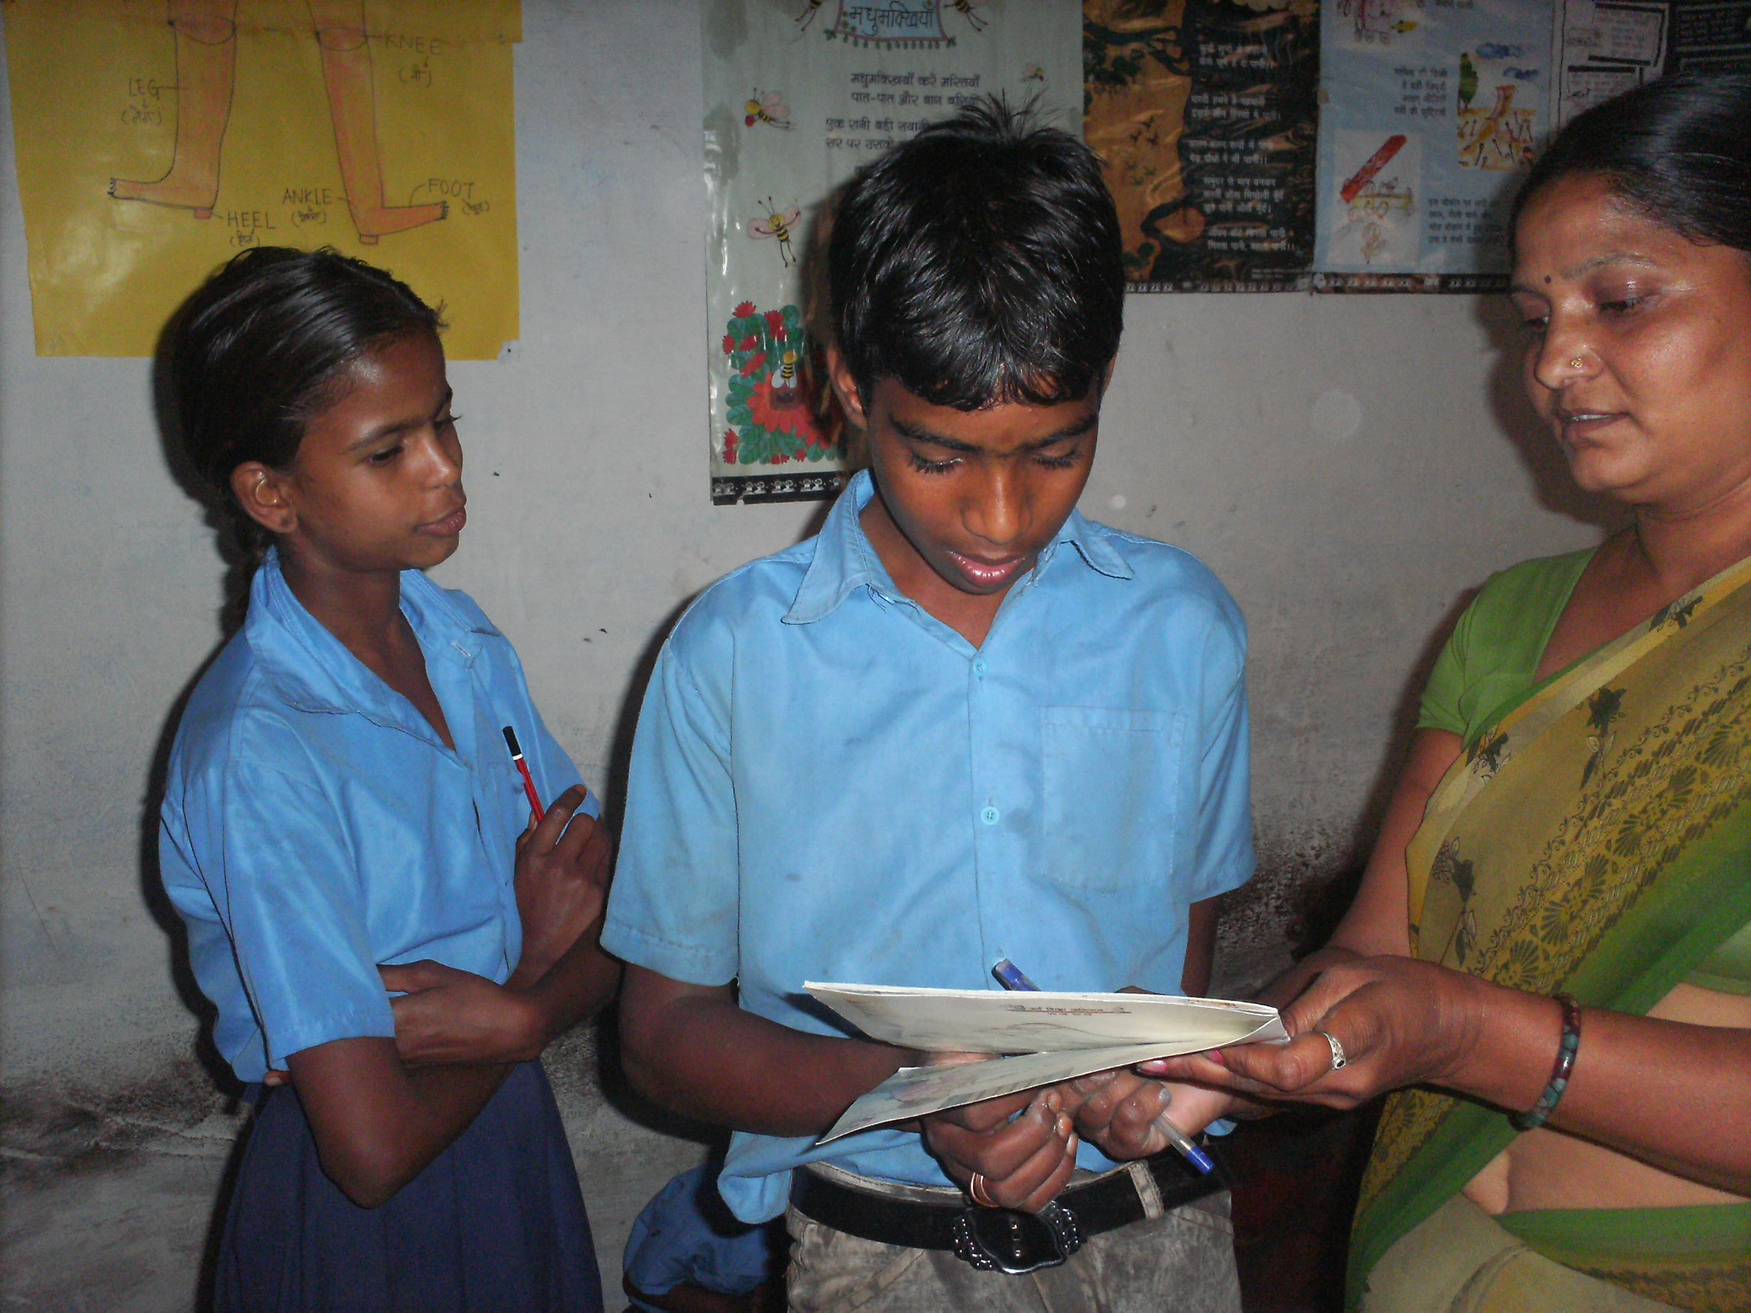
Lakshmi (12 years old) another student at this centre also studied in government school till 4th class. After realizing that she has not learnt much in 4 years, her parents enrolled her with the SK in 2008. Now after spending 2 years her academic performance has improved drastically. She can read and write sentences, count till 100 and can do basic mathematic calculations. She enjoys reciting poems in the class. She works hard and is very bright. She dreams to be a teacher in future.

Vidya Bhawan is a consortium of educational institutions with special expertise in elementary education.

