Annual Report 2010-11
Submitted to
Global Giving

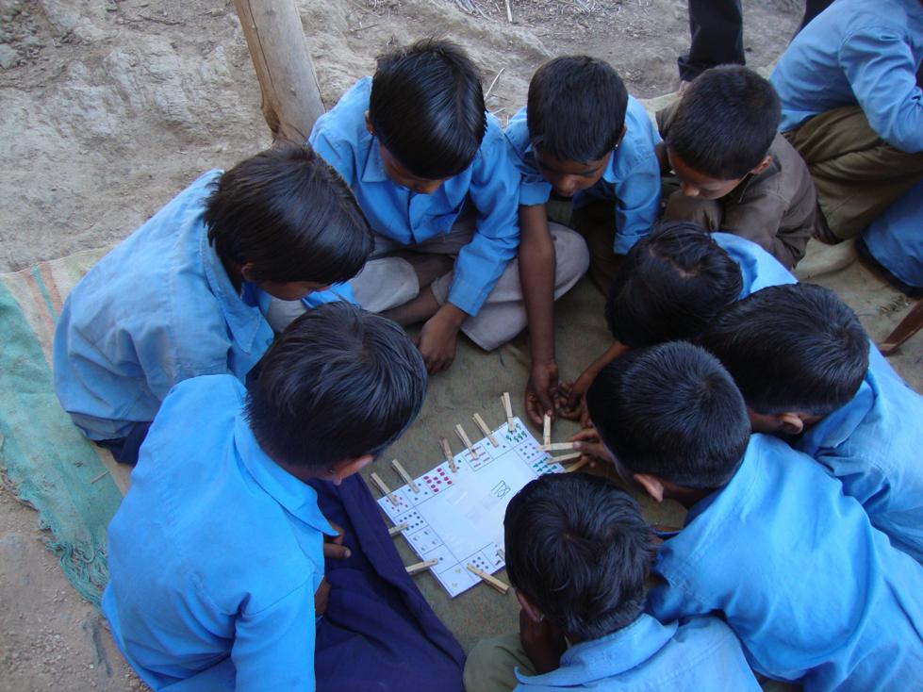

SEVA MANDIR
Udaipur Rajasthan, India
info@sevamandir.org
www.sevamandir.org

Introduction
Seva Mandir works with village communities to establish Shiksha Kendras (SKs), in remote rural hamlets with the aim of providing access to quality education to out of school children between the ages of 6 and 14.
Given the dismal quality of schools, large numbers of children are out of school in remote areas. Those who attend schools often drop-out early due to non-comprehension. In this context, the SK’s not only offer the primary education but also ease the transition and retention of first generation learners to Government schools. The sound education provided at the SK’s help the children become independent learners. In follow ups high retention of children who went from SK’s to Government schools is observed.
The objectives of the SK programme are:
- To ensure quality education to out of school children of marginalized communities, in the age group of 6 to 14 years, who are deprived of education. A focused effort is made to help these children read and write independently with comprehension.
- Provide these children with a strong educational foundation, in order to prepare them for enrolment in regular government schools.
- Provide communities an experience of alternative and meaningful education for their children.
At present, there are 188 rural schools in all the five blocks of Seva Mandir. The total enrollment of children in these schools is 5,694. A Block wise detail of the number of SK’s is shown in Table below. During this reporting a total of 7 centers were closed for various reasons and 3 centers were newly setup. Therefore, a total of 188 centers are running at the moment with 3,288 boys and 2,406 girls.

Block wise details - the number of SK’s in Table 1 below.
Block | No. of Rural Schools/ SKs |  |  |  |  | Enrollment of children
Block | Sept 2010 | March 2011 | Teachers | In Sept 2010  Total Students | March 2011
 |  |  |  |  | Boys |  | Girls | Total
Jhadol | 47 | 47 | 52 | 1336 | 740 |  | 634 | 1374
Kotra | 56 | 54 | 62 | 1888 | 1239 |  | 635 | 1874
Kherwara | 41 | 41 | 43 | 1030 | 552 |  | 478 | 1030
Girwa | 27 | 26 | 30 | 882 | 463 |  | 399 | 862
Badgaon | 21 | 20 | 21 | 567 | 294 |  | 260 | 554
Total | 192 | 188 | 208 | 5,703 | 3,288 |  | 2,406 | 5,694

Some schools were to shut down during the last six months for reasons such as irregularity of the teacher, low enrollment of children in SK or all children got enrolled in the Government Schools that were newly set up.

Token Fee (Shiksha Shulk)
Each child attending the rural school has to pay a token fee of Rs. 100 every year. The fee is collected by the village communities. The village spends the collected fee on children’s needs such as uniforms, lunch boxes, flip flops etc. In the reporting year, estimated fees were Rs. 557,100/- and the actual collection was Rs. 400,035/- which is 72% of the total fee was collected across 188 centers.
The fee collected was mainly spent on purchasing uniforms for children. In some cases, the communities waived the fee for those children who are from very poor economic backgrounds.
Capacity Building of Instructors
- Certificate Course
In the third and fourth quarter of the year 2010-2011, 227 instructors were enrolled for the Certification Course. The SK Certification Course is being conducted in collaboration with Vidya Bhawan. It continues to be an integral part of the capacity building efforts of the Education Programme for the instructors of SK centers. Since most of the instructors have education up to class 8 and they often don’t have any formal training for teaching. The certification course therefore, helps these instructors to improve their academic aptitude for teaching. The course also aims at setting up a mechanism to enable regular dialogue and interaction with the instructors on academic issues, in a manner that the instructors found interesting, challenging, and meaningful for their own learning and for children in classrooms. The current status of enrolled instructors in this course is given in the table below.
Block | Level-1 |  |  | Level-2 |  |  | Level-3 |  |  | Total
Block | enrolled | left | Present  status | enrolled | left | Present  status | enrolled | left | Present  status | Total
Badgaon | 15 (2) | 5 | 10 | 8 | 2 | 6 | 4 | - | 4 | 20
Girwa | 19 (1) | 1 | 18 | 6 | 2 | 4 | 13 | 2 | 11 | 33
Kotra | 37 (10) | 6 | 31 | 19 | 4 | 15 | 9 | 1 | 8 | 54
Kherwara | 16 (2) | 3 | 13 | 12 | 1 | 11 | 18 | 1 | 17 | 41
Jhadol | 17 (2) | 2 | 15 | 19 | 1 | 18 | 15 | 3 | 12 | 45
Total | 104 (17) | 17 | 87 | 64 | 10 | 54 | 59 | 7 | 52 | 193
2. Instructor Training
Competent instructors with a motivation to help village kids are very important. Therefore, capacity building of instructors is pivotal. Every year a one-week long residential training is held for the instructors. These trainings offer a platform to converse theoretical aspects of pedagogy and practical experience among resource persons and instructors.
In the year 2010-2011, a one-week residential annual instructor training was held in March at K.V.K Badgaon in Udaipur. The focus was to discuss and understand various teaching learning methods and also finding ways of making education more joyful and child centered.
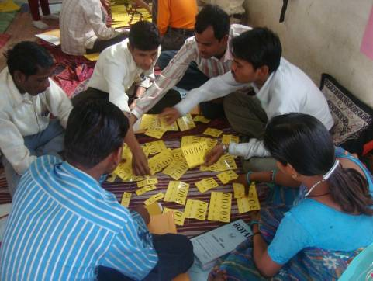
Activity with number cards

The objectives of the training were-
1. Strengthening conceptual understanding of Hindi (language) and Math
2. Sharing and dissemination of the contextual knowledge
For the preparation of training, a training of trainers (TOT) was conducted for four days from 15th to 18th February. During the TOT, discussion was held for the selection of topics and content. Relevant articles were being selected and discussed with the participants. Everyone worked together on various activities and developed a good understanding of these.

Children Fest- Bal Mela
In the month of December 2010 a one-day child fest was organized in the Umariya village of Jhadol Block. It was a successful event with more than 500 children and 200 villagers participation. Children from 16 SK’s, 4 Youth Resource Center (YRC) and Umariya Government school participated in various activities and competitions (Essay writing, drawing, heena tattoo etc).
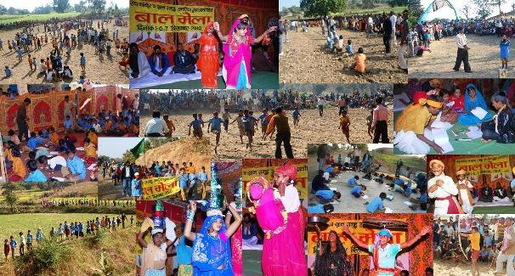
Collage of Activities at fest

The YRC members (the village youth) performed plays to spread awareness about the negative impacts of child marriages, illiteracy and alcoholism. Various cultural activities including folk dance and singing were also undertaken by the youth.

Conclusion
Our experience shows that conversations around education and pedagogy through rural schools (SKs) have been very useful for thousands of children of our region. More and more people in villages are now comparing and questioning the quality of education of government schools. Several communities are now addressing the issues in education with the local governance (village councils). For example, the communities have raised concerns with the Panchayat (village council) for issues such as inadequate teachers in government schools. Some of these communities have even marched demonstrations on national highways in an attempt to claim good education for their children from the government. These are all indicators of the fact that SKs provide quality education which has given confidence to these local communities that their children are also capable of learning.

Story of Hope
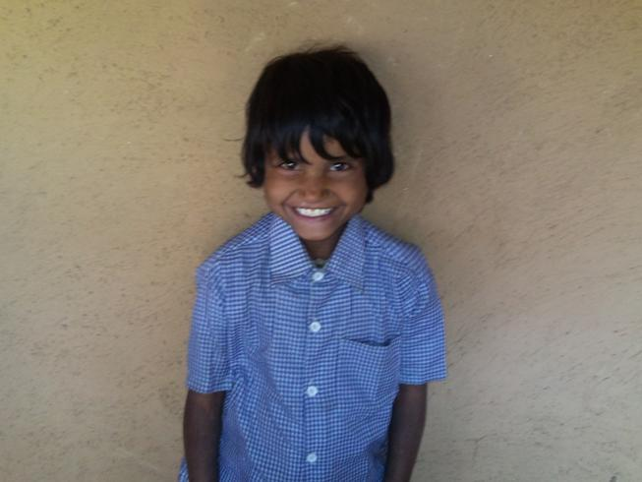
Himanshu Kumari is an 8 years old girl studying at the rural school since 2008. She is a very nice girl with a smile on her face.
Himanshu Kumari
There are 6 members in her family including herself, her mother and 4 siblings. Himanshu’s father purchased a vehicle on loan and was unable to pay the installments in time. Gradually, the repaying the loan became impossible for him due to growing economic constraints. As a result, one day he committed suicide last year. It has some impact on Himanshu and her ability to grasp things easily in the class.
Himanshu’s mother is the only bread winner in the family and also does the daily household chores. After the death of Himanshu’s father, all the other siblings are also having a rough time. One of the sisters went to Udaipur in an orphanage. The youngest brother accompanies Himanshu to her school (SK) even though he is not yet enrolled. The other sister and brother are studying in nearby Government School. Despite of the adverse circumstances, Himanshu’s mother has always encouraged her children to attend schools. She struggles hard in her daily life. Himanshu wants to achieve higher education to support her family for a happy life.

Vidya Bhawan is a consortium of educational institutions with special expertise in elementary education.
‘( )’ are showing the number of instructors who are not enrolled in the course.

