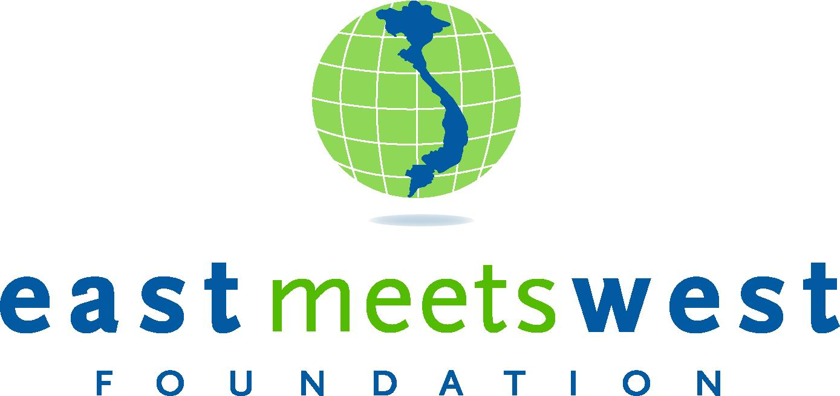

PROPOSAL FOR SAFE WATER SYSTEM CONSTRUCTION FUNDING
SAO PHONG, CAO TRACH & MA THUONG CLEAN WATER SYSTEM

Submitted by : East Meets West Foundation (EMW)
Date : May 29, 2007
Funding Agency/Donor:
Project Code : DO06 – WQB07

Project Name: | SAO PHONG, CAO TRACH & MA THUONG  CLEAN WATER AND SANITATION PROJECT
Scope: | Design and construction of a water system with a water tower, a storage tank with a capacity of 20.5 m³, a river water intake, two pumps, water treatment, 7,282 m of water transmission and distribution pipeline, electrical and control systems, and implementation of a hygiene and sanitation behavioral change program in the community.
Geographic Location: | Sao Phong, Cao Trach and Ma Thuong Hamlets,  Phong Hoa Commune, Tuyen Hoa District, Quang Binh Province, Vietnam
Community Information: | Phong Hoa is a mountain commune located in the northern part of Quang Binh Province, half way between the cities of Da Nang and Ha Noi. There are seven hamlets in the community, with 1,282 households and 5,731 people living in the hills.  The commune is very poor and 90% of the residents subsist on farming and raising livestock. Only 316 out of 5,731 people have university degrees and 61% of the residents live below the GOV poverty line, i.e., earning a monthly per capita income of USD 12 or less.
Current Water & Environmental Sanitation Conditions: | Water for daily use is commonly taken from the Gianh River or from open dug wells for the households located at the foot of the mountain or next to the wet rice fields. The river water is heavily polluted and has high levels of sediments and red mud particles. The well water generally smells bad and is very hard due to the lime rich mountain range; the wells generally run dry from March to September.  For those who can afford it, fresh drinking water is available for purchase in local grocery stores or markets for about 60 cents per 20 liters. The poorer residents however, are limited to using the polluted ground or river water for their daily activities. There is a critical need for access to clean water for the residents in this area.  Few families in the three hamlets Sao Phong, Sao Trach and Ma Thuong have improved sanitary latrines, and hand washing with soap is not regularly done as often as it should be. Water-borne diseases are a problem for the residents, many of whom suffer from related skin, eye, and digestive illnesses.  Water for the clean water system will likely be taken from the Gianh River, which is located 1,000 m from the residential areas.
Needs Assessment: | People in these hamlets do not have convenient access to sufficient quantities of good quality water for domestic purposes. Construction of a new water system directly piped into people’s homes will help address their needs for good quality water in sufficient quantity for drinking, cooking, washing and other domestic uses.  The water system, connected directly to residents’ homes, will save beneficiaries time and energy. Adults can invest the extra time and labor into income-generating activities to improve their living standards as well as pay for their children’s schooling. Children, who are often tasked with the chore of obtaining water, would have more time for their studies and extracurricular activities.  Access to clean water and improved hygiene and sanitation behavior will decrease the incidence of water-borne diseases, such as trachoma, diarrhea, and cholera, and improve overall community and family health, with associated improvement in health-related socioeconomic indicators.
Beneficiaries: | Today 1,380 people live in 276 households in Sao Phong, Cao Trach and Ma Thuong Hamlets. Estimations on a ten year basis, which is the life expectancy of the water system, calculated with a 1.04% population increase per year, indicate 1,515 people will benefit from the potable water supply and environmental sanitation components of the project.  The beneficiaries have accepted to participate in the project and contribute as much as possible to the construction of the system, at least they will provide for free all labour required for digging and backfilling the pipeline trenches. They will also pay the full upfront cost of their house connection (about US$12-18 per household). The willingness to connect to the system will be determined exactly before start of the project to ensure sufficient numbers of customers and a long-term sustainable financial plan. The beneficiaries will pay monthly consumption–based water tariffs to cover operation, maintenance, repair, replacement and potential expansion costs.
Major Project Activities: | - Assessment of local residents’ need for safe water and improved sanitation and hygiene in the project area.  - Assessment of the beneficiaries’ willingness and ability to pay for both initial investments cost for house connections (about US$12-18 per household) and monthly consumption-based water tariffs, and contribution of labor to the construction as digging and backfilling pipeline trenches.  - Identification of the highest capacity, best quality and most reliable supply of clean water in the area (in this case, the source will be the Gianh River, which runs close to the project area).  - Water quality testing of proposed sources, and certification of the selected source as fit for drinking before commencement of design and construction.  - Holding consultation meetings with potential beneficiary groups and the local authorities in order to allow everyone to voice their concerns and opinions about the proposed project, as well as to share local knowledge and experience about hygiene and clean water usage.  - The following standard activities will be carried out: Design and construction of the storage tank(s), water tower, pumps, piping, electrical and control systems, a water treatment system (depending upon the water quality test results), and water transmission and distribution system about 7,282 m. A water production meter will be installed on the outlet to the main distribution line to help monitor production and downstream water losses.  - Training of Water Managers and Project Management Board on technical and management skills to make sure the proper maintenance will be provided to the system when EMW phase out.  - Carry out a hygiene and sanitation behavioral change program, in order to maximize the community health benefits of the new water system. The EMW Hygiene and Sanitation Behavioral Change (HSBC) program will provide awareness raising, training and financial incentives to help families build latrines, and carry out social marketing activities to encourage people to adopt more effective hygiene and sanitation behaviors. The HSBC program is currently under preparation and the details of the program under development.
Estimated Budget Breakdown: | Total value of the project is USD 40,584 which includes following cost components:
  a) Line-item Cost ((1) + (2)): |  |  |  |  |  |  | $28,086 | (a)
   | 1. Water Tower Construction |  |  |  |  | $6,900
   | 2. Other Material and Equipment (i-iv): |  |  |  |  | $21,186
   |  | i) Water treatment (filtration, flocculation, chlorination...): |  |  | $2,875
   |  | ii) Wells and pumps: |  |  | $4,600
   |  | iii) Pipes (7,282m), fittings and other: |  |  | $12,561
   |  | iv) Electrical and control systems: |  |  | $1,150
  b) Implementation Cost ((3)): |  |  |  |  |  |  | $2,809 | (b)
   | 3. Administration (10% of line-item cost): |  |  |  |  | $2,809
   |  |  |  | Base Cost (a+b): |  |  | $30,895
  c) Contingency (5% of Base Cost): |  |  |  |  |  |  | $1,545 | (c)
   |  |  |  | System Cost (a+b+c): |  |  | $32,440
  TOTAL EMW COST (a+b+c): |  |  |  |  |  |  | $32,440
  d) Labor Contribution and House Connection Cost Financed by Beneficiaries (25% of Line-item Cost): |  |  |  |  |  |  | $7,021 | (d)
  e) Value of Land and Construction Rights Provided by Local Government (4% of Line-item Cost): |  |  |  |  |  |  | $1,123 | (e)
  TOTAL PROJECT VALUE (a+b+c+d+e): |  |  |  |  |  |  | $40,584
Requested Donor Funding: | Total funds needed from donor: USD 32,440 which includes:  - Water treatment system, including mechanical filtration, flocculation (if lots of fines), aeration or other treatment (if iron or other contaminants are problematic), and chlorination (to minimize E-Coli and other micro organisms)  - A river intake and pump station  - Pipes and fittings  - Contingency on materials and equipment  - Staffing and administration costs  - Financial cost  The remaining USD 8,144 will be contributed primarily by the beneficiaries, but also local authorities.
Implementation Period: | Six months from approval.
Project Partners: | The local authorities of Tuyen Hoa District, Phong Hoa Commune, residents of Sao Phong, Cao Trach and Ma Thuong hamlets and East Meets West Foundation.
Planning and  Implementation Responsibilities: | The anticipated responsibilities for the various groups planned to be involved in this project are as follows:  I. Responsibility of local authorities of Tuyen Hoa District and Phong Hoa Commune:  A) Before and during the project implementation:  - Be responsible for all necessary formalities to obtain legal permission from local authorities (at the provincial level) to build the system, and to have legal access to the proposed water source.  - Work with EMW to identify suitable water sources as well as a suitable and convenient location for the water tower, wells and storage tanks.  - Provide land for the water system of suitable size and elevation..  - Assist EMW in preparing a detailed map of the proposal transmission and distribution system.  - Identify and assess the experience and capabilities of potential local contractors. Provide necessary information to the contractors for the bidding process to be conducted by EMW.  - Be responsible for setting up a Project Management Board and two local Water Managers to work in conjunction with EMW staff in project management and supervision, and eventually operation, maintenance, repair, replacement, and potentially system expansion, as demand for services grow to accommodate population growth.  - Be responsible for sending a qualified technical supervisor to cooperate with EMW’s supervisors in providing proper monitoring and supervision to the water system’s installation.  - Facilitate the work of EMW staff, builders, and plumbers during implementation and provide security details.  - Meet with community members to discuss various aspects of the project as well as the responsibilities and contributions expected of them.  - Coordinate with EMW staff to direct local residents to dig and backfill the main trenches for pipelines, after the pipe is installed by the EMW plumber(s). .  B) After construction is completed:  - Be responsible for operating, managing, and maintaining the water distribution system when it is handed over to the Community by EMW.  - Regularly (on a monthly basis) collect water fees from each participant households, and inspect the house connections to make sure that the meters are working properly and no water is being pilfered (trickled).  - Prepare quarterly reports (in a format provided by EMW) for submission to on the operation status of the system.  - Get water samples tested every six months to ensure the water is safe for cooking and drinking.  II. Responsibilities of East Meets West Foundation:  - Coordinate with local authorities in the process of identification of a suitable water source(s) as well as locations for the water tower, wells, and storage tanks.  - Carry out water quality tests and production capacity of the proposed water source(s).  - Provide funding for the following tasks:  - Testing the water samples  - Purchasing and installation of all equipment, including pumps, water treatment that will include de-sedimentation, filtration to remove fines, possibly iron removal, and certainly chlorination  - Installing pumps  - Building the water storage tower and related piping and structures  - Installing the electrical power and control systems to run the water system  - Quality control and quality assurance monitoring  - Manage the implementation of the water system and help local authorities in selecting and training qualified water managers to manage and operate the water system.  - Provide technical assistance to the local people in installing the piping system.  - Assist in the maintenance of the system during the first 12 months.  - Provide training to the Water Managers as well as Project Management Board on technical and management skills to make sure that they will provide the proper maintenance to the water system when EMW phase out.  III. Residents of Sao Phong, Cao Trach and Ma Thuong Hamlets will:  Pay for other costs of the project not covered by EMW, including:  - (a) Digging and backfilling all the main pipelines leading from the water tower and through the hamlet.  - ( b) Purchasing and install water meters, pipes, and fittings leading from the main lines to their homes (about 12 – 18$ per household)  - Pay monthly consumption – based tariffs.  Report any system malfunctions, leaks or other potential problems to the Water Manager as soon as possible
Project Photos: | 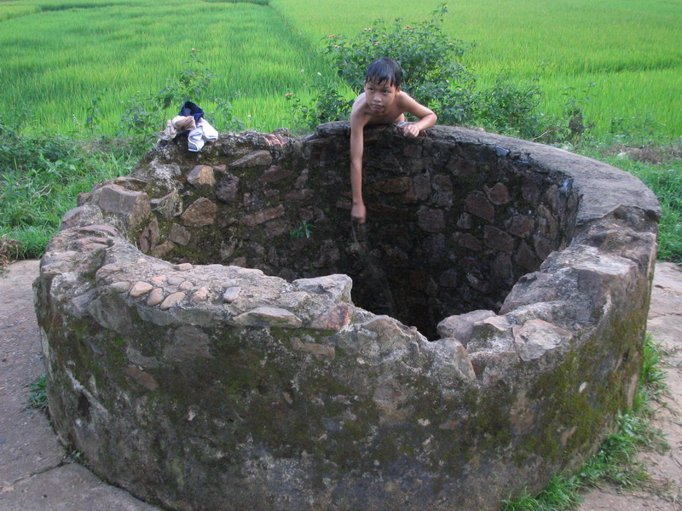  The wells are located close to the rice fields and are often contaminated with fertilizers and pesticides.  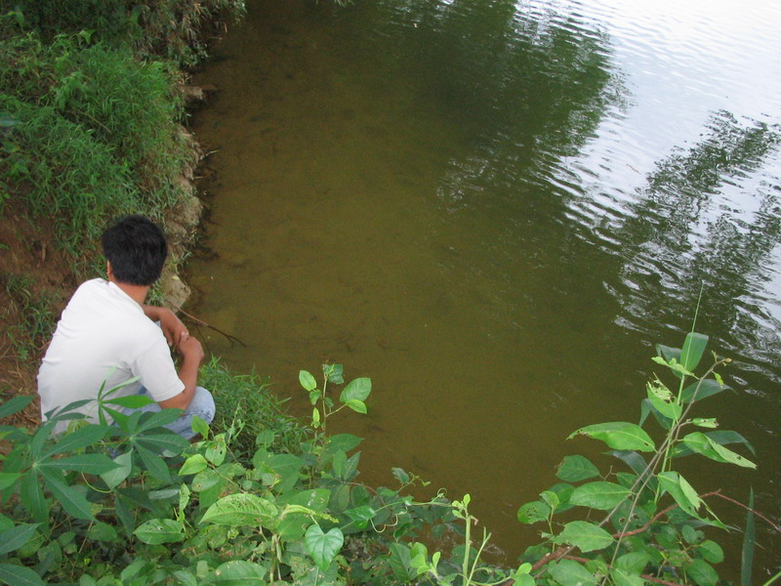  The Gianh River also serves as water source.

In the 1990s GOV defined the national poverty line as the income equivalent needed to buy fifteen, twenty, and twenty-five kilograms of rice per person per month for mountainous, rural and urban areas respectively. In 2005 MOLISA increased the poverty line from VND 150,000 to VND 260,000 per month for urban areas and from VND 100,000 to VND 200,000 (about USD 6.23 – 12.46) for rural areas, which includes mountainous and remote areas.

