Project Evaluation Report
Latest update : November 5, 2011
Project Title : Practice lessons for 7 disabled kids – Project 1788
Reported by : Calincing Love Rainbow Foundation – Indonesia

Summary
We were still continuing the program with disabled children in Cogreg village. Your donations are very important to us to continue our free educational program in Cogreg village. Below is the detail of program that we have been implemented during August – November 2011. Please continue to support us again so we can help disabled children to do learning activities. Thank you very much for your support.

Singing Contest

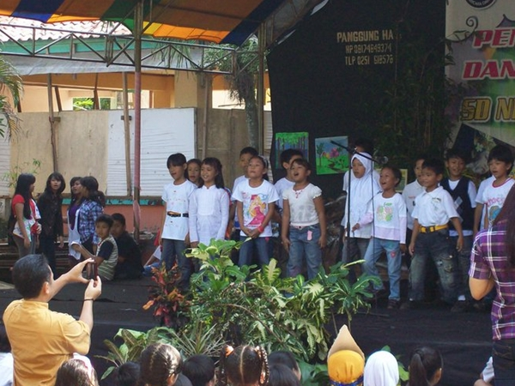
One child with special treatment incorporated in this program, Jeremiah, following the singing contest held in Depok city in September 2011 last month. Jeremiah joined the choir group of children who become the target of Calincing Foundation.

Jeremiah and his friends sing the local song look have fun and enjoy the annual event. A grant received from donor of Global Giving is used to finance training and accommodation for Jeremiah and children in this contest.

Thank you very much for your kind support and donation through Global Giving. Please support us again so we can continue to help our children continue their school and all activities they needed.

Best regards,
Hartoyo Hardjodiwiryo
Team Leader
ypkc_foundation@yahoo.co.id

