Project Evaluation Report
Latest update : April 6, 2011
Project Title : Practice lessons for 7 disabled kids – Project 1788
Reported by : Calincing Love Rainbow Foundation – Indonesia

Summary
We were still continuing the program with disabled children in Cogreg village. Your donations are very important to us to continue our free educational program in Cogreg village. Below is the detail of program that we have been implemented during November 2010 – April 2011. Please continue to support us again so we can help disabled children to do learning activities. Thank you very much for your support.

Competition among students to play ball
The competition was held at the beginning of last February 2011 which was attended by 10 children with disabilities in our school. In this race the children were involved directly and in a pleasant relaxed atmosphere.

The competition aimed to give confidence and cooperation within the group. The children were asked to move a number of tennis balls from the bucket that is available into the rubber on the other hand basket. They ran to move the balls and who is the fastest moving the ball, then he will be the winner.

This race is one of the learning activities for children with autism disabilities.

Thank you very much for your kind support and donation through Global Giving. Please support us again so we can continue to help our children continue their school and all activities they needed.

Best regards,
Hartoyo Hardjodiwiryo
Team Leader
ypkc_foundation@yahoo.co.id
Photo Library
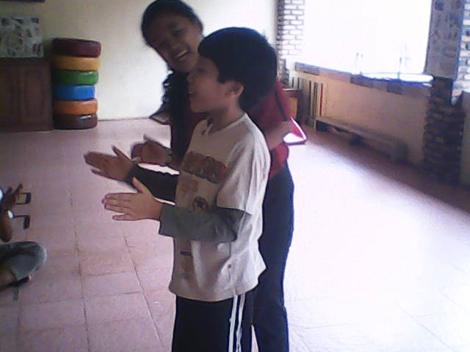

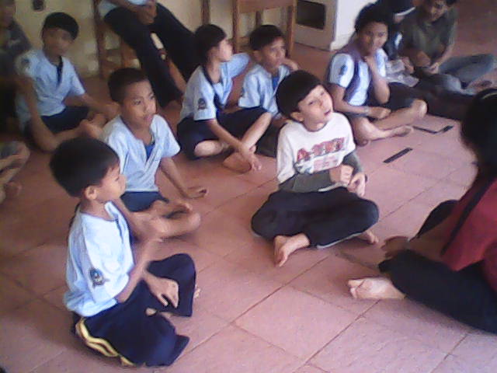

See our video at: http://www.youtube.com/watch?v=b778DLDHrJI

