Our students’ performance
By Tisiya Mahoro-COBURWAS, ambassador in South Africa
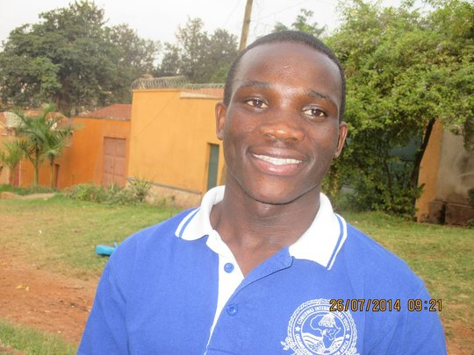
Busisi one of the first students
Arriving From Slovakia, Busisis Jeanbat, CIYOTA Students,
Busisi one of the first students who were enrolled into the CIYOTA High school hostels in 2008, currently a student at the African Leadership Academy arrived on July 26, 2014 from second edition of LEAF Summer Leadership Camp, in Cunovo, Slovakia. As a former head prefect of CIYOTA hostels and refugee youth leader, Busisi shared his leadership experiences, learnt and practiced skills on real-life problems with other 30 other youth leaders from across the globe. He had a chance to discuss the stories of leadership and potentials in all youth.
Busis and,Mahoro also CIYOTA graduate and project leader, founder of Voyager ( for empowering children to develop communities by embracing their culture) after graduating from African Leadership Academy we hosted a COYOTA leadership summer program of 25 high school students to inspire and support participants to come up with feasible social entrepreneurship ideas to address the challenges facing their communities. We are delighted to have some students from the hostel organizing Leadership seminar that is going to take place in January with spirit of sharing the knowledge with those who are not able to access the knowledge. Students are determined to use scarce resources to achieve their dreams of making change in their communities.
About 100 students, boys and girls like Busisi and Mahoro are in school following the footstep of these two students. Our challenge still is the accesses to books to enable them excel and achieve their dreams.
We are all proud of these students and together with our supporters; we are committed to develop every student to become a responsible leader who will solve complex challenges in African communities.

