More than 20 students supported by COBURWAS sat for their secondary school national examination towards the end of 2014. In February the results came, all students excelled; Afia, Emelda and Ndinayo did exceptionally well. The first, second and the third position were taken by young women, the future leaders for Africa. All three of them grew up in the refugee camp and COBURWAS enable them to attend secondary school in Hoima Uganda because like many other thousands of refugee girls do not have access to education because of many factors like early marriages, gender based violence and discrimination. In COBURWAS we believe in every child. We believe that both boys and girls have potential to change their community and from the experience that is supported my wide research around the world, if girls are given the opportunity they can advance change firster and in more sustainable way than boys. Afia, Emelda and Ndinayo are the good examples. With equal opportunity, they have not only been the best students but they have also served as exemplary leaders to the students they live within the COBURWAS students hostels.
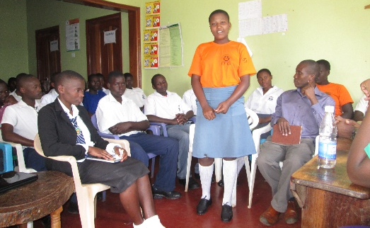
Afia member of COBURWAS Students hostel since 2011. She has been the hostel Head Girl and has successfully completed her Ordinary level of education among the best students in the region. In spite of the challenges she faces at home, in the refugee camp, Afia has worked hard to prepare her bright future. As the head girl she has been an influential lady and a role model to other girls in the hostel and the generation to come.
Emelda has served as the sanitation, secretary and religious prefect and Ndinayo has been the Health Prefect working with Afia to inspire other young women to believe in themselves and to always work hard to achieve their biggest dreams regardless the circumstances around them.
The three girls and 17 other students who have successfully completed secondary school are part of hundreds of students COBURWAS is supporting. With a small number of shared textbooks 20 students who are changing lives have successfully completed another level of education. We send our sincere thank you to all supporters and we ask many others to join our effort to build a library for enabling many more Afia to become the best possible and as they inspire their community through the power of an educated woman

