MERCY & SHARING LEARNING ACADEMY

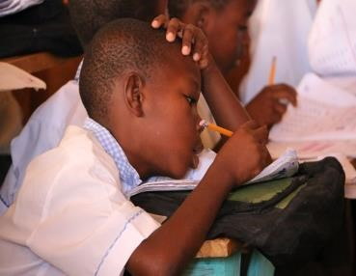
The Mercy & Sharing Learning Academy is a tuition free primary school that educates 258 children including 38 children from M&S’s orphanage and 220 from the nearby village of Williamson. This school provides a high-quality education with a curriculum that includes math, geography, French, grammar, health (hygiene), a creative arts program, a computer lab and one meal per school day
(52,580.00 meals annually). The Learning Academy employs 19 Haitians in the positions of teachers,
administration and meal preparation.

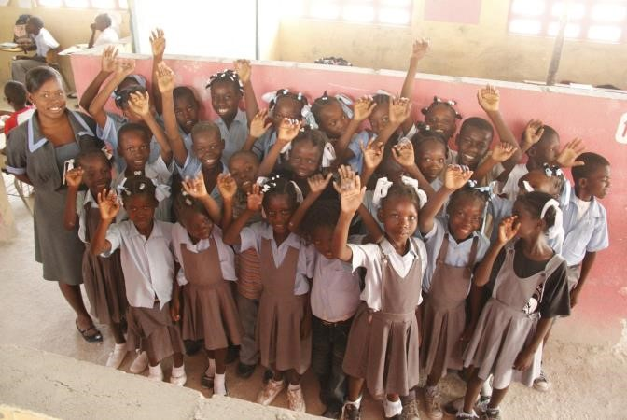
C.I.T.E. SCHOOL
Located in Cite Soleil in the same vicinity where Mercy & Sharing began in 1994, Community Institute of Teaching and Education (C.I.T.E.) School is a lighthouse of the hope and opportunity shining in the slums of Port-au-Prince. Providing education every day to 222 students in grades 16, C.I.T.E. School is preparing children to be productive citizens.

The school recently moved to a new
location to provide more space and a better learning environment. New programs at C.I.T.E. School include evening adult literacy classes and children’s dance and basketball classes.

JOHN BRANCHIZIO SCHOOL
Located in the Cazeau region of Port-au-Prince near the airport, the John Branchizio
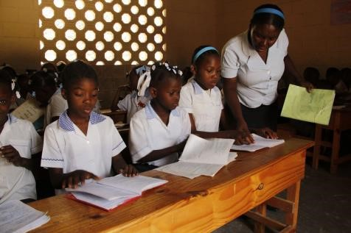
School is consistently rated in the top ten of the 400 surrounding area schools. Over 620 students are enrolled in primary and secondary education which includes a hot meal every day. Science, math, geography, history, languages and life skills form a rigorous curriculum that challenges the students each day. 95% or more of the children at John Branchizio consistently pass the State Exam (compared to the national average of 40%).

