Will You Pledge To Partner Today?
Greetings ……………………..,
Two weeks ago, we invited you to consider making a monthly gift, or a one-time donation to enable us to empower 50 families and transformation their lives forever. It isn't too late to help us reach this year's goal.
Your partnership enables the local church or orphaned children to help meet the needs of the most vulnerable families and restore them to their God-given dignity. This includes touching people like this ones.
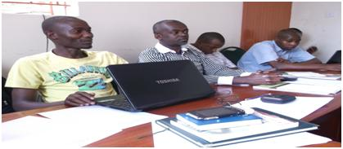
Because of partners like you, OYM was able to equip 25 local churches to serve more than 800 people last year alone.

Will you pledge today to Transform. Together?

A $ 65 monthly pledge enables the local church to serve 4 orphaned families for the year. | A $ 280 one- time gift will help change the lives of one family this year.

http://orcvirtual.wix.com/oneyouthministry Tweeter one youth Ministry Facebook: One youth ministry

Copyright © 2013.One Youth Ministry (OYM,
All rights reserved.
Our mailing address is:
One Youth Ministry, Rd Joseph Kang’ethe Road off Ngong Road
Our giving address is:
PO Box 34765, 00100 Nairobi, Kenya
Unsubscribe from OYM list | update subscription preferences to OYM

