Vidya Poshak’s Employment Readiness Program

Background
Vidya Poshak supports thousands of students to attain their dream of graduation. All the students that VP supports are from a rural background and are financially challenged. Due to their education in rural colleges they lack the skills which will make them employable in service sector. As a step in this direction, we have launched a program to help the graduating students to gain skills that would make them employable.

ERP
Vidya Poshak has launched Employment Readiness Program (ERP) to help the final year graduating students to gain skills that would make them employable. The program was launched with a target of 422 non-professional course students who will complete their graduation in June - 2014.
Refer:
  - Methodology of ERP training
  - Month wise activities
Overall 408 graduates attended the training program during the month of July & Aug 2013. Following are the results after the one to one discussion & individual counseling with the students.
Course Streams | Private Sector Job | Govt. Job | Professional Education | Post-Graduation | Total
Commerce | 172 | 25 | 31 | 15 | 243
Arts | 37 | 26 | 4 | 6 | 73
Science | 56 | 5 | 1 | 30 | 92
Total | 265 | 56 | 36 | 51 | 408

Follow-up Training using Technology
Students who chose Private sector jobs & Government sector Jobs were provided a rigorous follow-up training using mobile & internet technology so that they would be ready to face the competitive world outside their college life. Students were trained in Problem Solving Skills, Interview Skills & Communication skills. Also there was a final round of direct training during the month of March 2014. Some of our material is available in the following blogs.
Between September to April Vidya Poshak team have sent more than 80 online tests using Google forms. In the meanwhile we have created several online resources for students. Blogs that provide Aptitude tests, English language tips, information on jobs etc. are being used by both VP students as well as their friends.
Aptitude online Tests: www.vpcareeroptions.blogspot.in English training materials: http://vpenglishtips.blogspot.in / Aptitude: http://vpaptitude.blogspot.in/
Off Campus Drive
During the month of March & April whenever there was a Campus recruitment drive happening in colleges like JSS College, Oxford College, Adept College, Global business school all the students were invited to attend these campus drives with a special permission from these colleges.
During these drives more than 40 students have been placed in the following companies with an average salary of INR 15,000 per month
- Infosys BPO – 6 students
- IBM India – 2 students
- Wipro WASE & VISTA Program – 2 students
- Tata Consultancy Services – 8 students
- Tech Mahindra – 2 Students
- ICICI Bank – 4 students
- Jindal Steel – 2 students
- First source – 8 students
- AEGIS BPO – 2 students
- Shriram Finance – 2 students
Vidya Poshak Campus Drive
A special Vidya Poshak campus recruitment drive is arranged for the students from 1st June to 10th June. Following are the details. A total of 150 student attended the special campus drive.
Day-1: Arrival of students & updation of their resume
Day-2: Interview Preparation, Mock Aptitude test & Group Discussion
Day-3: Campus recruitment by First American Pvt Ltd, Bangalore. The interview was conducted for a Non-Voice accounts & Mortgage process. 18 students got offer letter with annual CTC of INR 1,50,000 per annum
Day-4: Xchanging Solutions, Shimoga has visited the campus to conduct the recruitment. After different rounds of interview 7 students were selected for a CTC of INR 1,14,000 per annum.
Day-5: HDFC Bank interviews were conducted for 3 processes. The students were selected for Debt Management process, Phone Banking process, Back end operations & Privilege banking process. Overall 24 students got selected with an average salary of INR 14,000 per month.
Day-6: First Source Hubli conducted interviews for the students for their Telecommunication process for their back end operations for Vodaphone & Idea. 19 students got selected for the company which offer INR 8,700 + incentives per month.
Day-7: Chaitanya Micro credits conducted interviews for their positions of Branch Managers, Accounting role, Credit officers & Field officers positions. 5 students were selected for Branch manager Trainee role, 10 students were selected for the credit officer’s position & 6 students were selected for the accounts officer’s positions. The salary is INR 7,000 per month + Accommodation + Travel + Mobile allowance
Day-8: Special drive from Agastya Education foundation was conducted for the science students for the Instructors position. 6 students got selected for the position. The salary package was INR 8500 Per month & Accommodation.
Day-9: First American India Pvt Ltd after seeing the performance of the candidates has come for the second round of interviews to recruit more students for their different process. 22 students got selected with annual CTC of INR 1,50,000.
CA Preparations
The students who were preparing for their CA has been provided orientation during the different residential bridge camps by inviting the practicing auditors. Many students were referred to the CA’s for internship. Following is the updates from them
- 7 students have cleared IPCC Group 1 & 2
- 3 students have completed CS foundation
- 11 students have cleared CPT examinations.
Further plans
Present Status
S.No | Student Option | Total Students
1 | Unique Students Placed for Private sector job | 125
2 | Students clearing CPC / IPCC /CS courses | 21
3 | Students opting for Post-Graduation | 51
Vidya Poshak placement team has already spoken with companies like Accenture, Hewlett & Packard, JP Morgan Chase, Hinduja Global solutions for conducting further rounds of walk-in interviews as soon as the final semester results are announced by end of June. We expect to place another 100 students through these placement drives. For the remaining student who could not get placed we would be arranging for a separate GFS training.
For the 56 students who have decided to work in government sector Vidya Poshak has created a SMS Group & Google Group to keep them posted on the several government job opportunities available for them. Recently they were updated about the openings in SBI Bank Clerical Grade, Post Office openings, LIC Openings etc.
For the students who have opted for the Higher education and aspiring to become teachers or research fellows and Professional education like CA & CS will be guided and referred to avail Education loan through Canara Bank so that without financial difficulties they would be able to complete their Post-graduation.
Sample videos of placed students & Testimony
VP Student Mahalaxmi placed in Infosys sharing her experience: http://youtu.be/7LYM_zBekdw (Video Link)
VP Student Kavita placed in Infosys sharing her experience: http://youtu.be/Kud6YqzNxXc (Video Link)
Student placed in TCS & IBM talk about their achievement & support provided by Vidya Poshak team to Prof R.N.Tikot: http://youtu.be/0lD253rbuT4 (Video)

Challenges
- Accessing the online contents on a regular basis was not possible for the students. Vidya Poshak has also made arrangements to send the soft copy of the materials.
- Regular doubt solving sessions through SKYPE or Google Hangouts were planned but not many students were able to utilize the service.
- About 10% of the students were unable to improve their skills even after regular interventions, for these students Vidya Poshak has offered training on a reduced fee through its Graduate Finishing School program.
Sample images from the Recruitment Program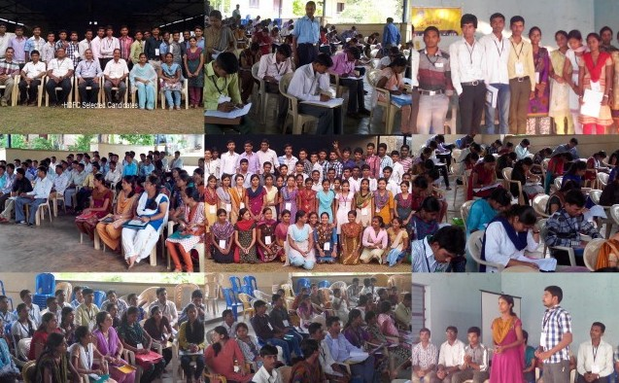

Annexture1: Methodology
We planned to provide the employability skills in phased manner. The first phase was to meet with the students and understand their dream and aspirations. The next part of the same phase was to help create a path to achieve their dream. It started with an introduction to the students on skills like Resume writing, English speaking and comprehension, interview skills and aptitude skills. This training was done in 7 day residential camps. The second phase is to continue the training remotely by means of online tests and reading material. Once the students completed their graduation, we plan to get them into another residential camp and provide the finishing touches to their training in employment skills.
Day | Activity
One | Arrival of students from various areas to the camp.  Counselors addressed the students and explained the survey form. / Students completed the survey form providing their family details and aspirations.
Two | Individual counseling based on the various aspirations described in the survey forms.  The other students awaiting counseling learn about Resume Writing. A Resume Template is provided to students.
Three & Four | Training on Aptitude skills. / Solve question papers collated to offer various numerical aptitude skills.
Five and Six | Training in English Comprehension. / Provide questionnaire that exposes the students to the real life questions in tests.
Seven | A test that includes Aptitude and English comprehension conducted. This test gives a quantification of the students learning during the camp and gives a heads up to the students about their study path. Students leave for their home by the end of day.

Some images from the ERP Camps
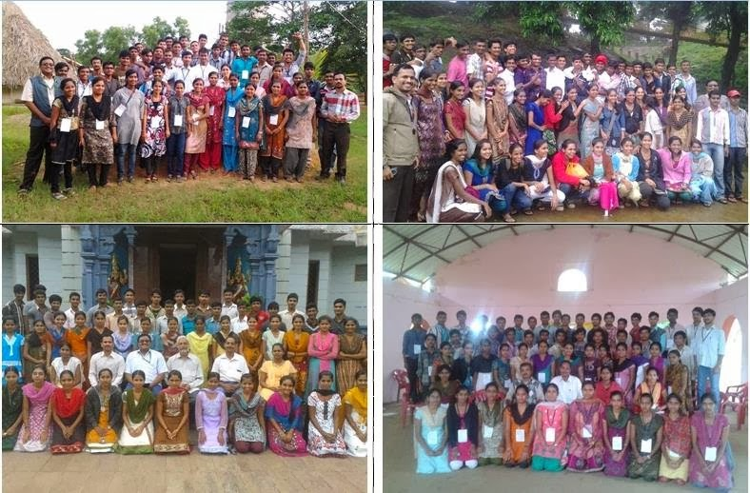

Annexture2: Month-wise Activities.
Our activities for the ERP were planned month-wise and the table below shows the plans in detail.
Sl.No. | Planned time / Month | Activity | Status
1 | June 2013 | Plans drawn for Employment Readiness Program. Lists of students drawn based on their streams and locations. | Completed.
2 | July 2013 | Pilot phase of counselling completed for students from Dharwad. Counselling on this sample leads to revision of the survey form. | Completed.
3 | Aug 2013 - September | Conduct ERP Camps. | Completed
4 | Aug – Dec | Online follow-up training using our Blog & Mobile Internet technology | Completed
5 | Jan 2014 – Feb 2014 | Follow-up workshop & assessment / Participation in Joint campus recruitment in colleges | Completed
6 | Mar 2014 – May | Finalize resumes of all students & Start to approach the companies. | Completed
7 | April 2014 | Conduct a 2 day Final workshop | Completed
8 | June 2014 | Schedule campus recruitments for the students who have completed their last semester exams. | Completed
9 | Jul – Dec 2014 | Continue training the students offline and invite companies for placements.

