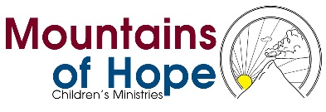
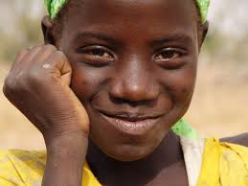It's been a while- how have you been?

You are receiving the first of many monthly e-newsletters because of your previous support and interest in Mountains of Hope. We want our success to be your success, so we hope to keep you updated with the newest happenings and updates!
------------------------------------------------------------
We are sincerely thankful for all you do for the children at Mountains of Hope. We know how much you believe in them, and please remember that none of what we do is possible without your tireless support.

Below you will find a few of our recent updates! We'd love to hear your feedback, so let us know what else you'd like to see in this e-newsletter in the future.

On behalf of Mountains of Hope, I hope to hear from you soon.

Kindest Regards,
James Malinga

** Mission: Raise the Roof
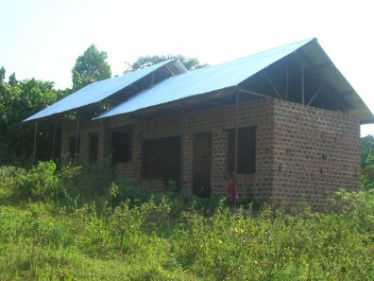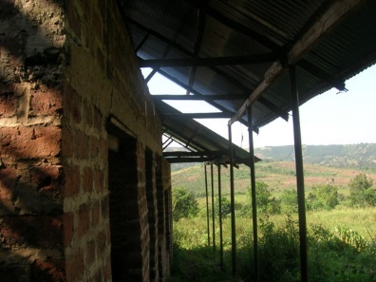
We are halfway to finishing construction on the completely new children’s home! We hope that after completion, it will be ready to house about 50 orphaned Ugandan children and provide school fees, clean drinking water, and a healthy lifestyle. Right now, the children are being graciously housed by relatives and well-wishers. We know that they are just as excited as we are to get back to the Mountains of Hope family!

And the good news is….WE ARE HALFWAY THERE! The home has just been roofed, and our goal is to complete the house in December 2014. Help us complete the building! Only $25 dollars will buy enough doors and windows to finish the entire house. Every penny counts…and every donation does too.

** Sarah’s Story- a reminder of why we do what we do:
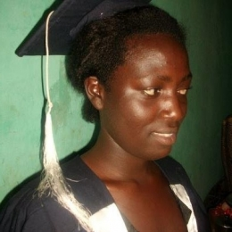
Sarah always dreamed of being a teacher, but when her father died she thought there was no hope for her. Two years ago, Sarah moved into the children’s home and we immediately enrolled her in school to pursue a diploma in education. She completed her course in just two years, and now she is teaching in one of the best schools in Kampala city. Since then, she has been able to help her siblings as well as sponsor herself for further studies in education.
Sarah is just one example of what is possible when children are able to follow their dreams. Sometimes, all a child needs is a place to call home, or someone to help them through school. With your support, you can help more children become like Sarah, and reach places that they never thought were possible.

