THINK YOUTH DEVELOPMENT INITIATIVE UGANDA (TYDI-Uganda)
Improving youth livelihoods through knowledge sharing, self-help project startups and environmental conservation.
Tel. +256782035777 / 256702965421
Located at Kakindu/kawuku Email:thinkinnitiative@gmail.com
Along Entebbe Road Website: www.thinkyouthdevinnitiative.wordpress.com

Date………………….

Name of organization: Think Youth Development Initiative Uganda (TYDI-
Uganda)
Mission: Improving youth livelihoods through engaging them in knowledge sharing,
vocational training, self-help project startups and environmental conservation.

Date of Formation: 09/2010
Date of Registration: 23rd /10/ 2013
Registration No: WCBO/1186/13

Location: Kakindu, Kisubi parish, Katabi Sub County in Wakiso district.
Contact person: Kirabo Ronald
Position: Chairperson
Tel: +256705035777, +256782035777
Email: kibronie2004@gmail.com
WHAT WE DO
- Vocational training to youths in metal works and fabrication, carpentry, wood work, art, painting and printing.
- Integrated fish farming.
- Bio gas construction and training.
- Lobbying and advocacy role on behalf of the TYDI-Uganda beneficiaries geared towards increased community awareness on the rights based approach.
- Community outreach e.g. organizing medical camps, Promotion and distribution of safe and clean water project.
- Environmental conservation including tree planting and manufacturing of improved cook stoves.
- Incorporating and addressing gender concerns in project activities.
- Collaborating with government and the civil society in improving youth livelihoods.
- Promoting knowledge sharing and information management using ICTs.
- Orphan education, empowerment of women and people living with HIV and AIDS.
- Water harvest projects with the objective of facilitating access to safe water, improve hygiene, reduce disease burden, and improve economic well-being among vulnerable populations
ON GOING PROJECTS

Below are the pictures of poultry and biogas promoted by TYDI-Uganda under farmer forums as means of providing food and employment as well as protecting the environment by use of biogas from cow dung to provide energy for home use especially cooking and lights
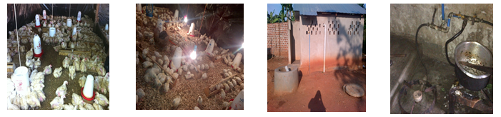

Below are farmer forum members learning from one another as well as exchanging ideas on different approaches to specific environmental and
development aspects of life

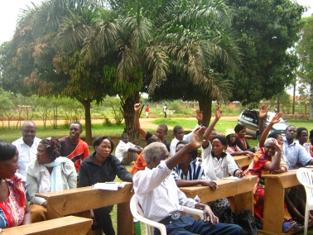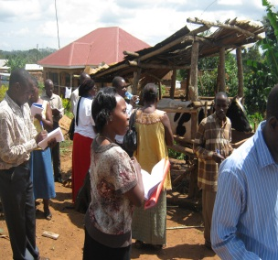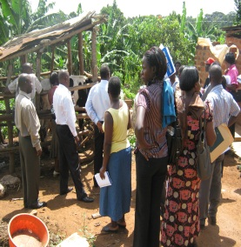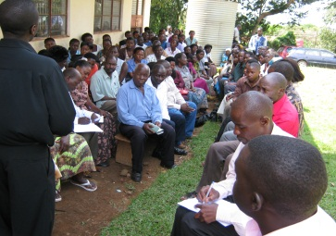

Fish farming practices for youth empowerment.

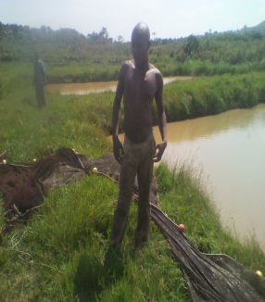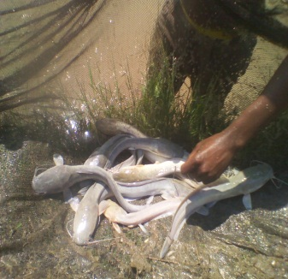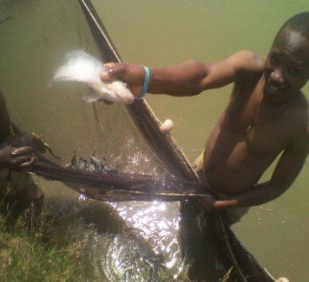

Below are the pictures of tanks constructed with a partnership of Rotary club of Entebbe of capacity 10,000litres each in different areas like Entebbe hospital GRADE B and SOS children’s home in Entebbe. This has improved access to water in the hospital making it very easy for the patients to access and for medical use.
It has also improved hygiene, reduce disease burden, and improved economic well-being among vulnerable populations.

