Project Evaluation Report
Latest update: August 6, 2011
Project Title : Learning Centre for Cogreg Village Children – Project 1703
Reported by : Calincing Love Rainbow Foundation – Indonesia

Summary
We were still continuing this program with the children in Cogreg village. The donations from Global Giving Donors are very important for us to continue our free educational program in Cogreg village. Below is the detail of program that we have been implemented during April – July 2011. Please continue to support us so we can help more than 40 children and young people to do learning activities. Thank you very much for your support.

Back to school
Activities undertaken by children who are members of the Village Learning Center Cogreg during April – July 2011, many filled with learning activities together. After implemented the annual examinations held nationwide in last May, they got holiday.

After carrying out national year-end exams in last May, the children also holidays with their families until the end of June. Currently the children have returned to their respective schools and some have graduated and entered the higher ranks, from primary to junior and from junior high to high school.

In the Learning Center program that we are implementing, the children in addition learning in formal school, they also have the addition of general knowledge and playing with teaching aids and fit better with age and education.

Many children feel happy to join in this program because they get to know more friends to study together and play together with a new game that does not exist at home. Here they can also ask the supervisor about the lessons they receive in school.

Thank you Global Giving for your support.

Best regards,
Hartoyo Hardjodiwiryo
Team Leader
ypkc_foundation@yahoo.co.id

Photo Library

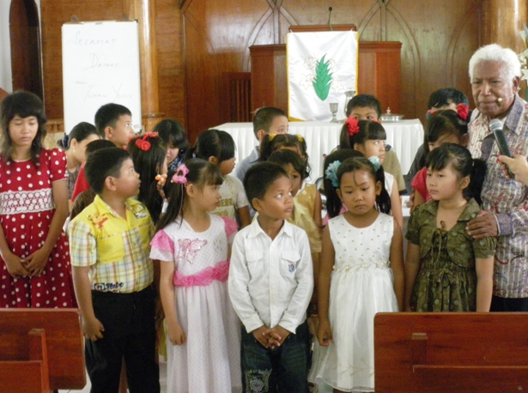
Children are singing together at local Church

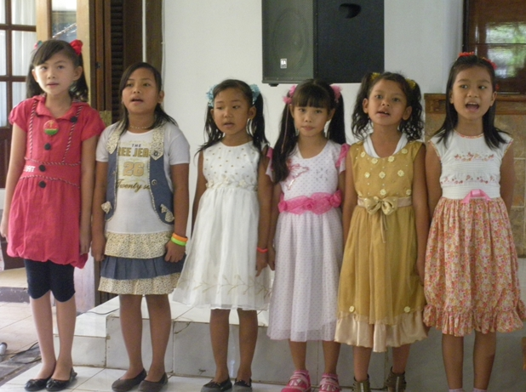
Every Sunday we meet and learn to sing together

