CENTRE FOR WOMEN’S DEVELOPMENT AND RESEARCH
Education to Empower 500 Women and Adolescent Girls
Update – December 2010
We have been continuing our education and income generation programme for women and life skill and sexuality education for adolescent girls. During this period the focus was on making handmade soaps and 16 days activism from 25th November that is International day to eliminate violence against women to 10th December that is International Human Rights Day. These 16 days were spent on campaigning activities to eliminate violence against women. Adolescent girls and women were preparing themselves by developing scripts for street plays, training themselves in street play techniques and also preparing campaigning materials.
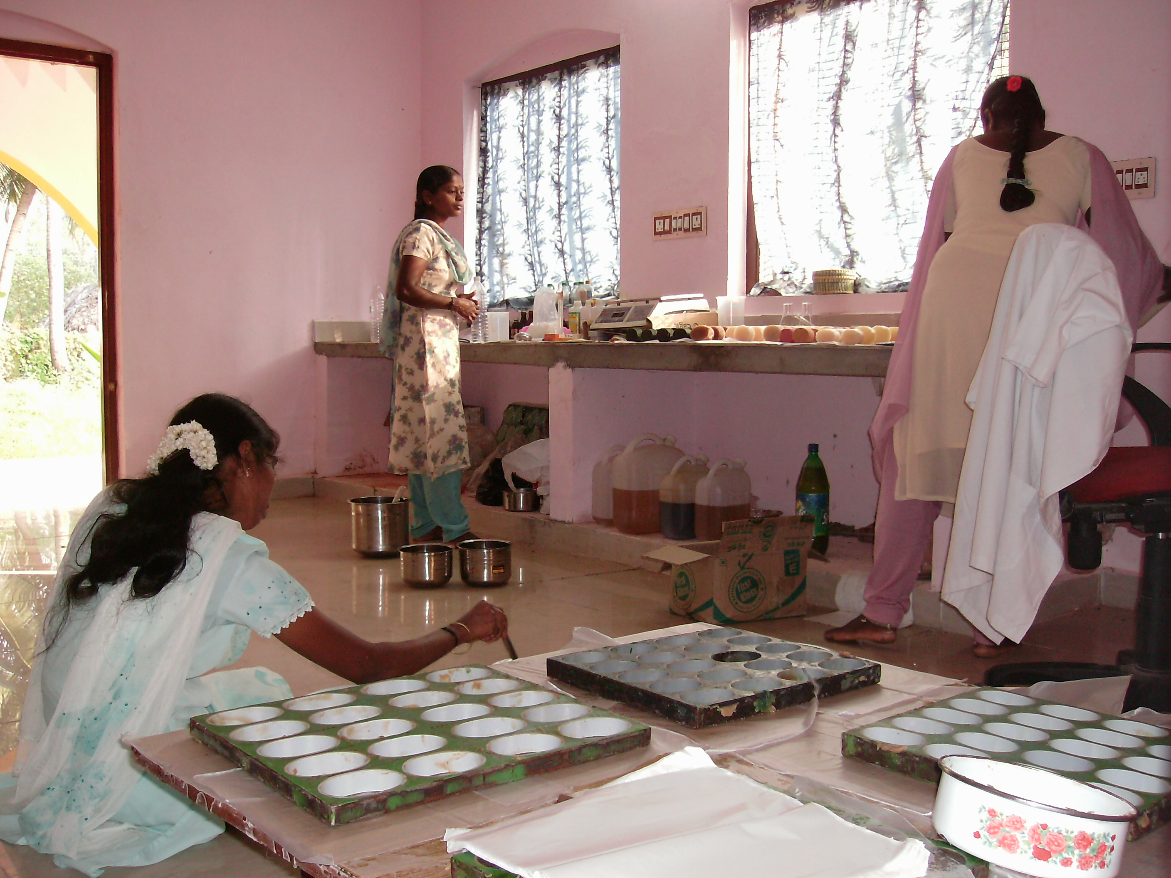
Handmade Soap Making Training
Life Skill and Sexuality Education Workshops for adolescents: We have been regularly organizing weekend lifeskill and sexuality education workshops for girls and also for boys. During this period nearly 125 girls and 24 boys benefitted from these programmes. During this period we had planned to conduct combined workshops for boys and girls but we did not organize combined workshops, because of some objections from parents particularly parents of adolescent girls. From our experience we have learned it would take some more time the community people are also not supporting this. We have also organized lifeskill and sexuality education workshops in schools in our working area. Nearly 250 high school students benefited from this programme.
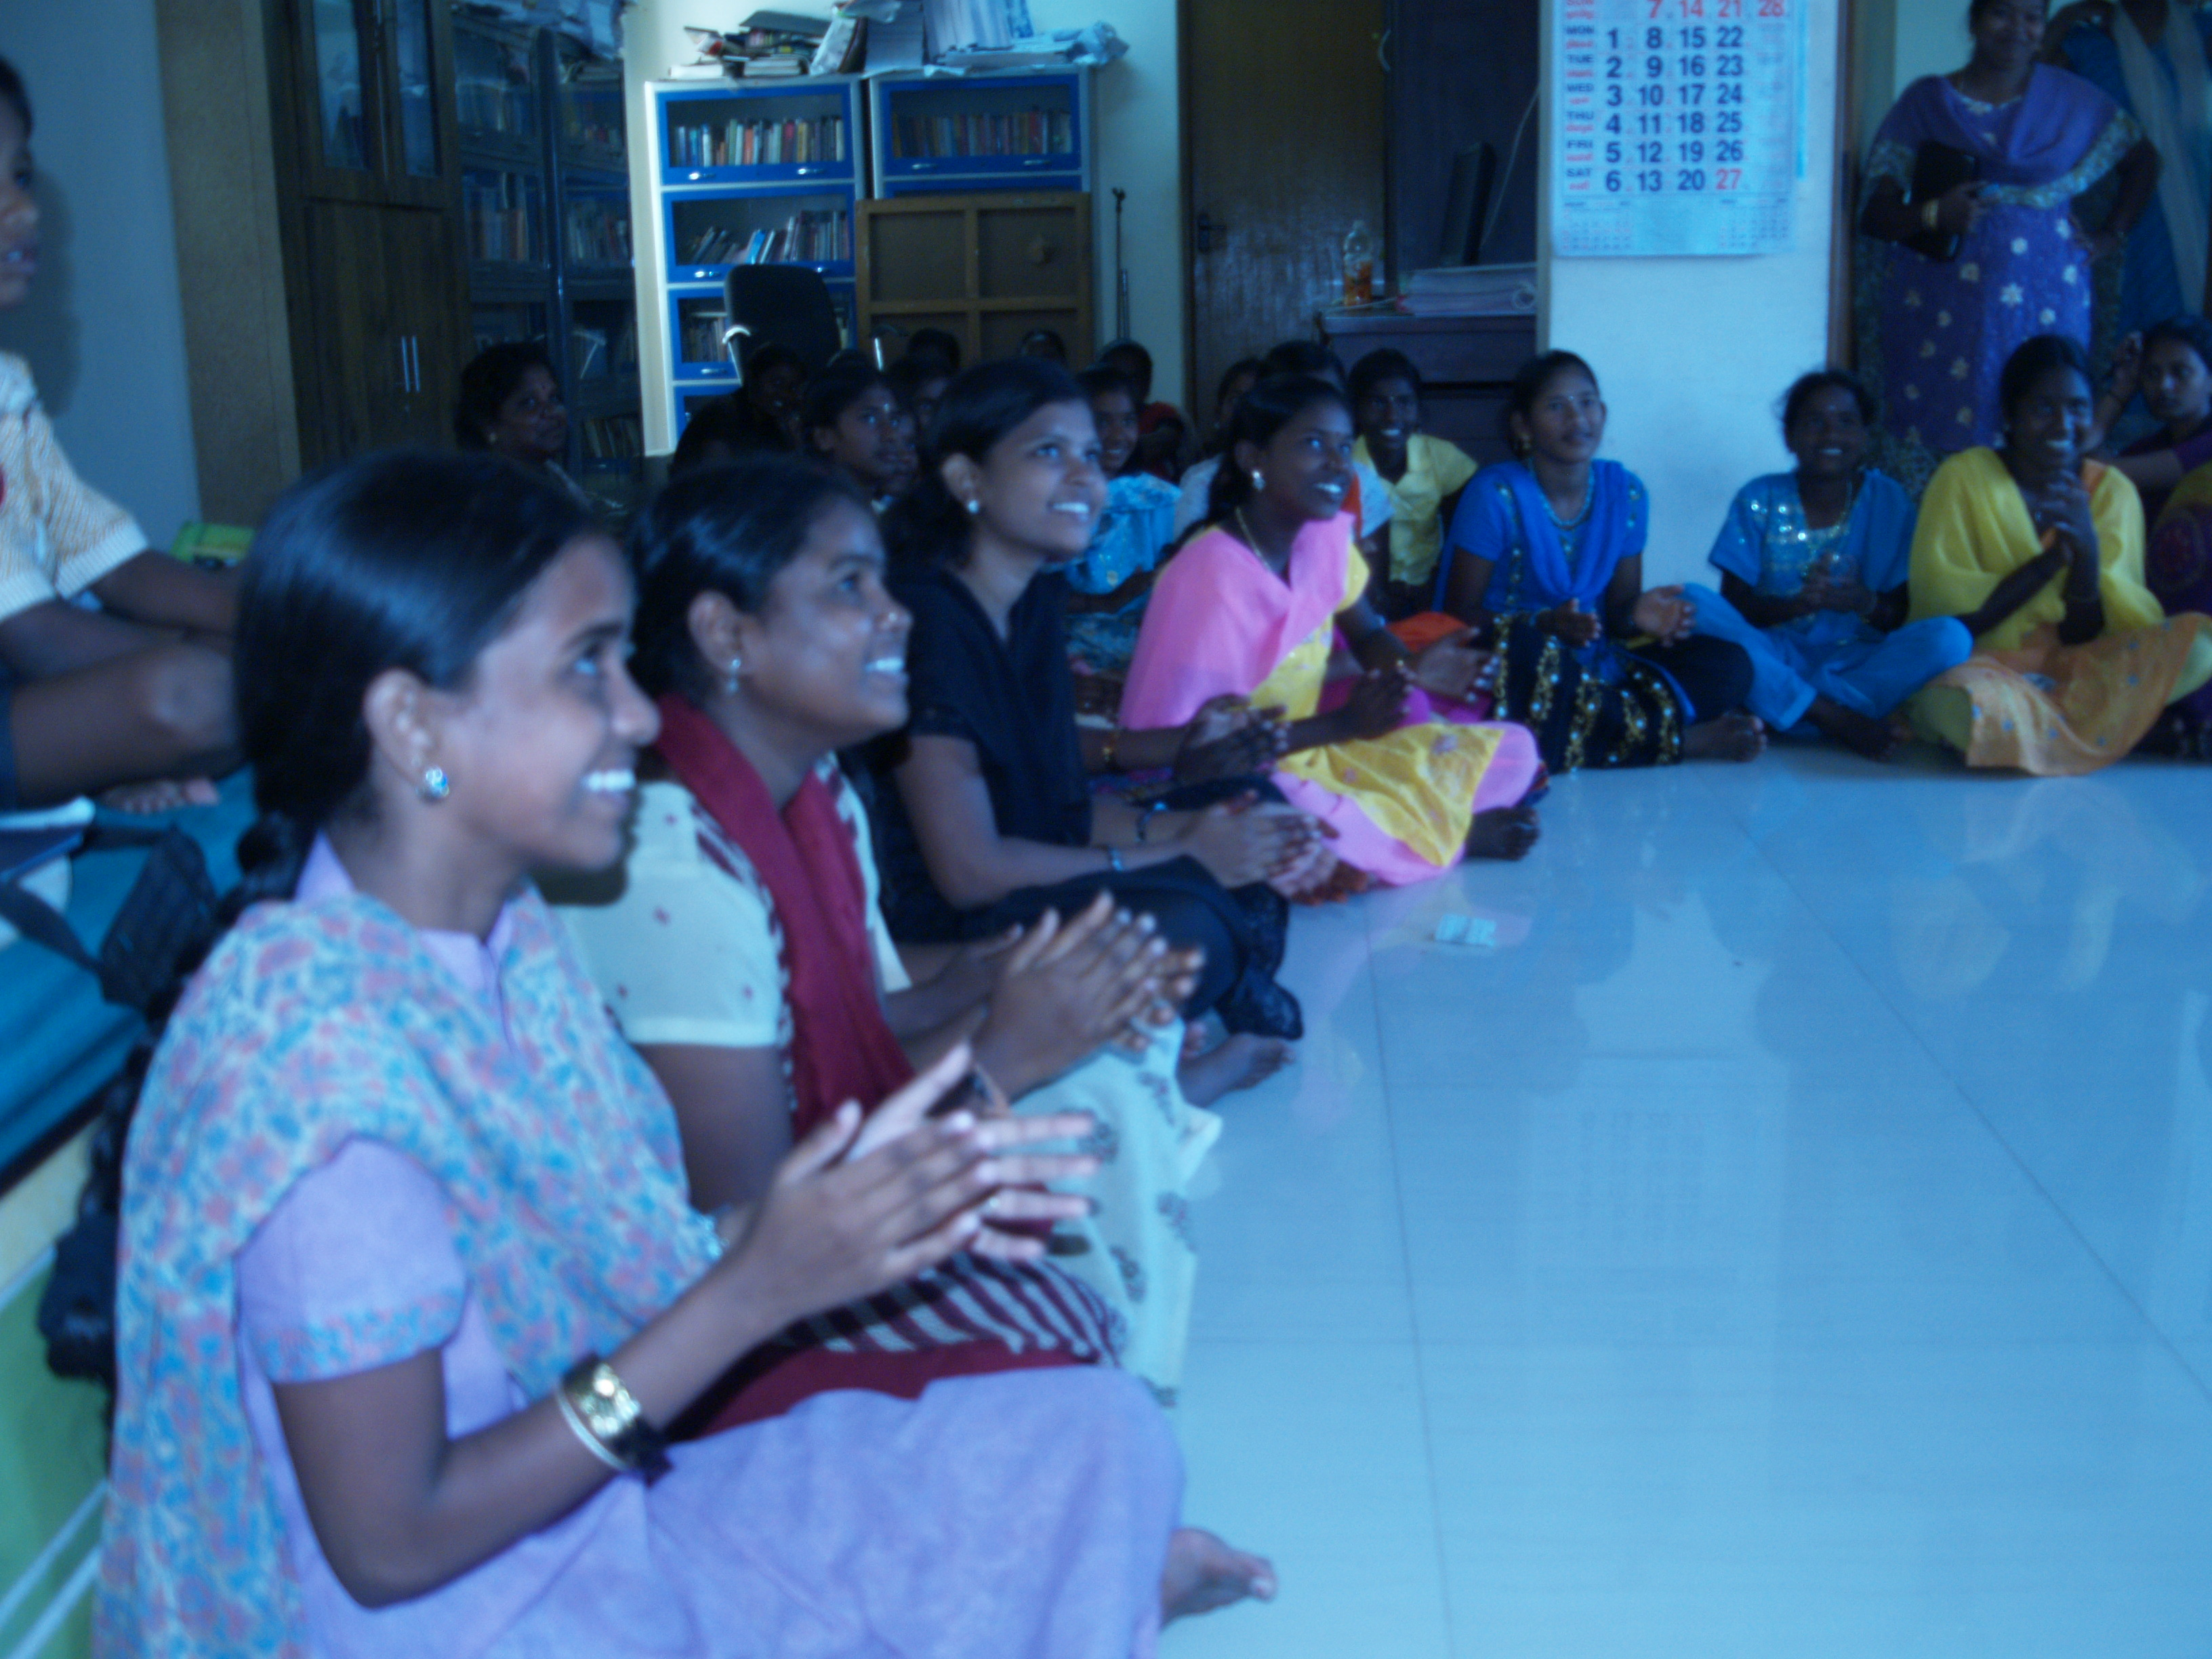
Lifeskill and Sexuality education workshop
In addition to that we are also providing computer skill training for adolescent girls. 40 girls were trained in basic computer skills. During this period we have also received 8 refurbished computers from Infosys company. This would help us to train more girls.
Art, Music, Dance and Drama workshops for girls: During this period we have also organized workshops on drawing and painting. In addition to that to prepare for the 16 days activism to eliminate violence against women we have organized music, dance and drama workshop for 25 girls. After the training these girls and our staff members performed street plays in different places to educate the public about the importance of eliminating violence against women. During 16 days they have performed in 30 places and more than 10,000 people watched these plays and exhibitions and also participated in the discussions.
We have also organized soap making, embroidery and jewels making training for adolescent girls. 35 girls benefitted from these programmes.

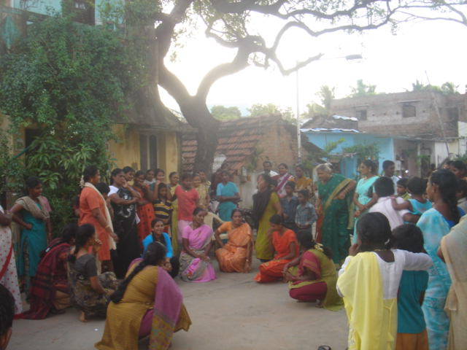
16 days activism Street Play
Education and Income Generation programme for Women:
We have been organizing regular leadership skill training for local level women’s organizations. We have also organized hand made soap making training and Tailoring training for women. More than 80 women benefitted from these trainings. As part of soap making and using it we have also organized health education programmes for local level women’s group members. In all these programmes single women were given preferences. In our 12 fishing villages we have initiated 12 single women’s SHGs_Self Help Groups. There are more than 250 single women members in these groups. They were given entrepreneur skill training and loans to start their own small business activities. 50 women were given loans during this period.
Future Plan: We have to build new building to expand out computer skill trainings in Panaiyur village. We are also thinking of initiating a rural BPO centre to provide employment for girls trained in our computer training centre. We are looking for help to build this centre also looking for volunteers to help us to initiate a rural BPO.

Women’s Rights are Human Rights
Let’s Together Make it a Reallity

