MARY MOTHER OF PEACE-MEDJUGORJE CHARITY, Inc.
8617 Irvington Avenue, Bethesda, MD20817-3603, USA; Tel 1 301 530 5416
Fax 1 301 530 3422; E-mail: mmpcharity@rcn.com ; Web: www.mmpcharity.org
 EIN # 52-2248969; CFC # 7825 

Contacts: Claudine Dussert, Ph.D., President and Bernard Dussert, Treasurer
Working in Partnership for Implementation with the Local Faith-based NGO:

JEEVANA SAMRIDHI (Life in Abundance) the Charity arm of
INDIA
6F Thadikaran Centre, Palavirattom, Kochi - 682025 Kerala, India; Tel 91 484 309 5859/ 233 8685; Fax 91 484 255 5354; E-mail: manojsunny@jesusyouth.org ; jyglobal@jesusyouth.org
Contacts: Manoj Sunny, International Coordinator, Berly Earnest, Coordinator Relief Activities, Mathew Sebastian, Field Operations Supervisor, and Rev. Fr. Jose Narithookil, Chairman and signing authority.

BICYCLES FOR POOR STUDENTS, SOUTHERN INDIA

Providing 300 bicycles and shoes to 300 students --150 boys and 150 girls—
to help them go to school in poor coastal areas of Kerala, India

March 03, 2007

INDIA

THE PROJECT “BICYCLES FOR POOR STUDENTS” IN KERALA

- 1) Title of the Project:

“BICYCLES FOR POOR STUDENTS”

- 2) Beneficiaries:

The students of the poor coastal areas of Azheekal need go to school at St George High School in the village of Thankey, in Alleppy district, the only nearby school available to them. The area is steeped in poverty and at the mercy of repeated sea erosion including last tsunami disaster. School is too far from Azheekal to walk each day barefoot with heavy bags of books, making school attendance difficult to the point of jeopardizing students’ future. Bicycles will have a strong impact by helping poor children go to school regularly. The 300 beneficiary students (150 boys and 150 girls) will own their bike after completing school. The possibility of including beneficiaries from other poor coastal areas such as Poomkavu also in Alleppy district or Challanam in Ernakulam district can be considered later in a second phase of the project.
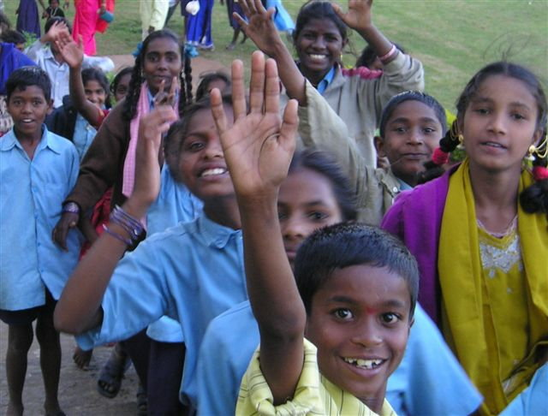
“Please gi’me a bike to go school !”

- 3) Official Local Support:

The General Manager of the Corporate Educational Agency of the Kochi region of Kerala which is running the local school is Rev.Thomas Parathara who is a pastor and an educator. He is the project initiator and facilitator. Project is approved by the school authorities, the Diocese of Kochi (Cochin) and local government. The school system in Kerala is traditionally run very cooperatively between the religious leaders and secular government authorities. Teachers and staff are paid by the government, including in the private schools, which are often the only schools available for students especially in poor remote areas. St George High School is a Catholic school open to all castes and creed.

- 4) Location of the Project:
Thankey is a coastal village located about 16 Kilometres (12 miles) north of Alleppy district in Kerala. The area is steeped in poverty and is at the mercy of repeated sea erosion including the last tsunami disaster.
St Mary’s Parish in Thankey is a remote village in itself. The first small church was built here in 1768, near the ancient St. Mary’s Syrian Church at Muttam, Cherthala which belongs to the St Thomas Christians of the Apostolic Origin. A considerable section of these Christians were Latinised by the Portuguese Jesuit Missionaries and brought under the Diocese of Cochin and became parishioners of this Thankey Church.
In this historical context, St George School was started to cater to the educational requirements of the local village people. Over time, since the local parish was not able to administer the school for various reasons (financing, staffing, and extreme poverty) it was handed over to the Corporate Educational Agency of the Kochi region.

- 5) People and their back ground:
The people of the locality are the descendants of the poverty-stricken coastal community converted by St. Francis Xavier in the 16th Century and they are noted for their zeal and faith amid their poverty and penury.
St Mary’s is a large parish, consisting of 1,900 catholic families thus numbering around 10,000 people. The parish church with its meager resources finds it difficult to run on its own. Majority of the people here are Catholics who are living together with Hindus peacefully for centuries.
The main occupation is fishing in the sea and the back waters. Some are daily coolly workers. Most of the women, in spite of the facts of exploitation by the big merchants and business people, go to the nearby villages for peeling (prawns) work to fetch an income to support the family. The recent tsunami disaster affected the area badly and has seriously affected different sections of workers in a number of ways. The geographic isolation of the village, coupled with poverty, has perpetuated the backwardness of the people. Education, health, housing and the availability of drinking water are some of the major issues to be dealt with.
The essential part of the community, the children, suffers most, since there is no facility to help them grow in all levels, educational, social, spiritual, etc. Bringing the whole village community to the main stream of social life is a task ahead, for the overall development of the village. The children are to be taken care of first.

- 6) Present Involvement of the People:

The School has done a lot for the improvement of this community. The policy and implementation of the programs are done with the participation of the representatives of the local Community, which work in small Groups of Basic Christian Communities and other Self Help Groups.
.
- 7) The Need of the Project:

The educational standard of the people as well as the income of the families has to be raised. There should be better health services and improvement of hygienic condition. The availability of safe drinking water has to be assured. Malnourished children and pregnant mothers have to be taken care of.
With an intention of giving High School Education to all the students of the Locality, the present management of the school, Corporate Educational Agency, has chalked out a plan to help the students, who have to walk more than one mile (about 2 km) of distance from the school with their heavy bags of books. It is therefore proposed to provide a bicycle to each student. Each student family will give a contribution of Rs. 500/- (about US$12 equivalent) to get the bicycle. The ownership of the bicycle will be transferred to the student as he/she completes the school.
The programme for the students, irrespective of caste and creed will help the integrated development of the village, which will ensure a qualitative change in the life of the people.

- 8) Objectives of the Project:

The key objective of the project is to provide basic education to the poor students in the vast coastal territory of Azheekal where St George High School is located in the village of Thankey. Although private, the School is funded by local authorities. (Salaries of the teaching and non-teaching Staff are paid by the Government of Kerala). The students from this predominantly fishermen community want to drop from school and make their own living now rather than go to school, which is about 2 kilometres away from their houses. Easing access to school with bicycles is a better bet for their future.

- 9) Project and the Budget:

We propose to buy 300 bicycles (and shoes).

Net purchase cost without transport and distribution cost is as follows:
(with US$1 = about 42 Rs):

150 Herald Thriller bicycles for boys @ Rs. 2500/- Rs. 375,000/- Equivalent to US$ 8,930/-
150 Lady Bird bicycles for girls @ Rs. 2600/- Rs. 390,000/- Equivalent to US$ 9,290/-
Sub-Total - Rs. 765,000/- Equivalent to US$18,220/-

Contribution from the 300 Students @ Rs 500/- (Rs.150,000/-) Equivalent to (US$ 3,570/-)

300 shoes for the boys and girls @ Rs.210/. Rs. 63,000/. Equivalent to US$ 1,500/.
Transport and distribution cost estimated @ Rs. 41,800 Equivalent to US$ 990/.

Net Grant Needed from Donor Rs. 719,800/- Equivalent to US$ 17,140/-

Total Project Cost: Rs. 869,800 Equivalent to US$ 20,710/.

Not counting donor possible fund raising fees and donor project supervision management cost including local volunteers travel (tbd)

- 10) Mode of implementation:

Under the supervision of Jeevana Samridhi Charity in Kochi and its field operations supervisor Mathew Sebastian [JS/JY/MMP-MC], the Corporate Educational Agency with the participation of the pastoral council and the Basic Christian Communities in the village, will guide the selection of the student beneficiaries and supervise the preservation and use of the bicycles.

- 11) Accounts and Report:

Exact recording of accounts of payments and receipts is ensured by the Corporate Educational Agency, and the Diocese of Kochi. Audited accounts of project will be sent to Jeevana Samridhi Charity and all concerned, once the project is completed.

- 12) Conclusion:

The Corporate Educational Agency, the beneficiary high school, the concerned authorities in Diocese of Kochi, and other local community leaders –and the direct student beneficiaries and their families-- hope that the Project “BICYCLES FOR POOR STUDENTS” will help this ancient Christian Community in the territory of Azheekal/Thankey/St Mary and all those of other Faiths who live peacefully with them.

Project will be instrumental in making progress towards the envisaged sustainable development of these poor coastal areas in a few years as their children get well equipped educationally. No doubt this will become a strong means to deepen the community hope for a better life and it will also be a boost to the unity among the people of different socio-cultural background in this village.

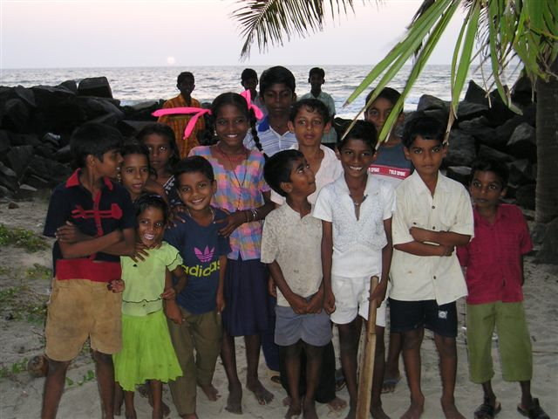
Many of these joyful children of all faiths in the Azheekal coastal area are candidates for the “Bicycles for Poor Students” project.

We, therefore, look upon to your generosity with great expectation. We pray and wish that your endeavour in serving the Lord and People be blessed by God.
Assuring you and your apostolic work, the prayers of pious but poor people of this coastal area of Kerala and wishing you all the best, we remain. With kind regards and love,

Prepared in February 2007 by:
Fr. Thomas Parathara, General Manager, Corporate Educational Agency, Cochin, Kerala, India
In cooperation with St George High School and local authorities in the district of Alleppy and the coastal areas of Azheekal/Thankey/StMary

Submitted on February 21, 2007 to Mary Mother of Peace-Medjugorje Charity, Bethesda, MD, USA through:
Dr. Edward Edezhath, Trustee member of Jeevana Samridhi and Co-Founder of Jesus Youth
English Professor at St. Albert’s College, Ernakulam, Kerala, India

With the Recommendation of:
Most Rev. Dr John Thattumkal
Bishop of Cochin, Bishop’s House, Kochi 682 001

Reviewed and reformatted (+ pictures) on March 03, 2007 by Bernard Dussert, Treasurer, and approved by:
Dr. Claudine Dussert, President, Mary Mother of Peace-Medjugorje Charity, USA

The humanitarian assistance NGO MMP-MC, Inc is a mission and faith-based 501 (c) 3 tax-exempt non-profit emergency relief organization helping orphans, homeless children, poor families and refugees of all faiths rebuild their life and improve their living and educational conditions, and regain dignity. MMP-MC financial performance ratio of admin + fund raising cost to total donations received is less than 5%.
Claudine (a former university professor) and Bernard (a World Bank official, ret. and consultant to WB and UN development agencies) live in the Washington DC area. They are the project supervisors, in coordination with Manoj Sunny, Berly Earnest and Mathew Sebastian , and in cooperation with project benefactors and beneficiaries.
JY is an international Catholic youth movement born and based in Southern India, and also registered in America. Its special focus is on a God-centered life, prayer, fellowship and actions of charity including humanitarian assistance and emergency relief through their Charity Trust Jeevana Samridhi. JY/JS International Coordinator Manoj Sunny has been invited to a prayer breakfast meeting at the White House in February 2005 and again in 2006.

