HERF Schooling
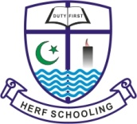

ANNUAL REPORT 2013.

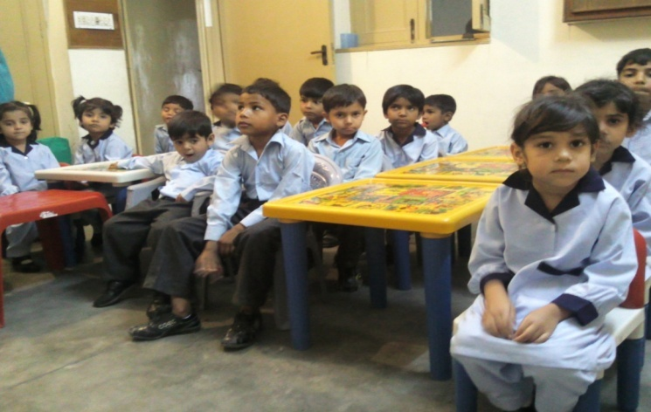

House #331/A, Near Islam Park,
Batala Colony, Faisalabad Pakistan
^^^^^^^^^^^^^^^^^^^^^^^^^^^^^^^^^^^^^^^^^^^^^^^^^^^^^^^^^^^^^^^^^^^^^^^

Preface:
HERF (Human Education Resource Foundation) HERF foundation is a Non-Government, Not for Profit, but Professional and dedicatedOrganization serving in the field of Education & Economic Development. HERF Schooling is an educational wing of this foundation. After serving the prestigious Christian educational institutions as a teacher, hostel warden, Master Teacher Trainer, Principal of schools and college for twenty four years, I resigned from the service of prestigious institutionsand commenced community mobilizationin August 2010, with a few likeminded dedicated and professional people in two Abadi’s(slum areas) of Faisalabad Waryam Singh Wala&Ashrafabad) & two of Lahore which are(& (Nishat colony &Youhanabad) respectively.On the basis of this community development work we requested few partners to join us to fulfill this great Mission for the service of the people through education, but only BKF accepted our invitation.
Waryam Singh Wala is a small urban settlement consisting of poor and disadvantaged groups of people. The majority of the people are laborers. They do not have permanent jobs, and they work on daily wages. Their families are large in number; the average family consists of 8 to 9 members. They hardly earn 2 Euros a day. With this income they have to see their health, education of the children and day to day expenditures. With this income they cannot meet the needs of their kids, and this brings a lot of suffering and un-happiness and frustration in the family. HERF Schooling has informal contact with these families since last year but this year 2013, we started getting the group organized. We had meetings and discussions in community meetings and following problems came up as key issues:
1- Illiteracy
2- Lack of awareness on health & Hygiene
3- Lack of awareness on local and existing sources
4- Gender Discrimination
5- Limited Exposure
6- Unemployment
7- Poor family planning
The Basics for Kids Foundation joined hands with HERF Schooling for the promotion of Education of the poor Christians in January 2013. With the financial support from BKF the first HERF Schooling progressed and made a very good impression in the community for the quality education of the poor Christian students of this area. HERF foundation brought many new changes in the lives of poor, orphan and children at risk by establishing its first ever HERFSchooling in January 2013 at Faisalabad.
We strongly believe that education is a powerful tool for the development of the poor; therefore we employed all our sincere efforts to provide education to these poor children without any discrimination of the cast, creed & religion. Due to our holistic & quality education based on the human values we have received a great response, even the Muslim parents have a wish to get their children admitted to HERF schooling. We look forward with a great hope that one day these poor children will become the responsible members and resource persons of the Christian community in particular & the nationalcommunity at the large. To share the mission, vision, objectives &activities of HERF Schooling a website is being launched in October 2013.

Our Vision:
To Improve the quality of life of vulnerable communities by providing assistance to minimize poverty through education (formal & non-formal), economic development, peace building & by establishing healthy environment in the society.
Our Mission:
To transform lives of marginalized communities through joint efforts by utilizing all the available resources for poverty reduction.

Our Values:

The Philosophy of HERF Schooling is based on Christian values,
Equality
Love
Tolerance

Compassion
Integrity
Responsibility

We envision inculcating these Human Values in the lives of our students, so we can provide “Value-based Education”

Our Working strategy:
Working with vulnerable communities and then mobilizing them to identify their needs & then meeting those needs through collaboration of people & with the partnerships of public/private/international/cluster NGO’s and Government collaborations.

