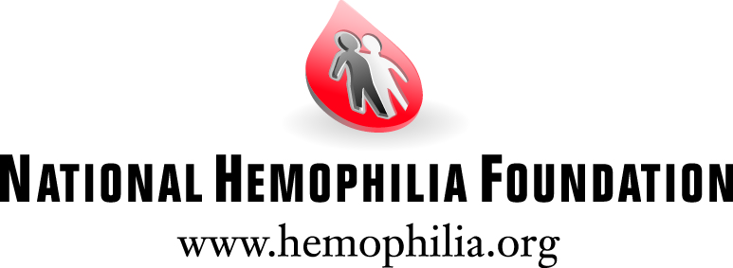

About Our Organization
The National Hemophilia Foundation (NHF) is dedicated to finding better treatments and cures for inheritable bleeding disorders and to preventing the complications of these disorders through education, advocacy and research. Established in 1948, the National Hemophilia Foundation has chapters throughout the country. Its programs and initiatives are made possible through the generosity of individuals, corporations and foundations as well as through a cooperative agreement with the Centers for Disease Control and Prevention (CDC).

About Bleeding Disorders
Living with a bleeding disorder -- an early and sometimes shocking diagnosis, with frequent and demanding treatment, and the likelihood of complications -- can alter the experience of childhood and adulthood. Bleeding disordres, such as hemophilia and von Willebrand disease, are genetic and prevent the blood from clotting normally. The primary symptom is uncontrolled, often spontaneous bleeding in different areas of the body. The amount of bleeding depends on the severity of disease. Internal bleeding, which commonly occurs in the spaces around joints, frequently results in pain and swelling. If left untreated, it can cause permanent damage.

National Youth Leadership Institute
Program Goal
The goal of the National Youth Leadership Institute (NYLI) at the National Hemophilia Foundation is to provide youth in bleeding disorders community with leadership opportunities to effect change and positively influence others.

Program Overview
The National Hemophilia Foundation has designed the National Youth Leadership Institute to assist young people from the bleeding disorders community to become well trained, recognized leaders. NHF works closely with young adults through training and support; NYLI members provide educational presentations and programs to the bleeding disorders community. NYLI provides an amazing opportunity for youth to learn and share experiences of living with a bleeding disorder.

Applications are released each May. Youth may remain in the program for three years total, but are requested to renew their membership annually.

Program Objectives
1. Increase Leadership Opportunities for NYLI Members
2. Increase Education for the Bleeding Disorders Community
3. Increase Visibility and Reach of NHF Messaging

NYLI members will meet these objectives through trainings, educational programming and internships. Below is a list of the activities members will be expect to take part in. Each year will include Annual Meeting and Spring Leadership trainings, but responsibilities within each year will differ slightly allowing for growth and unique opportunities.

Victory for Women
Victory for Women (V4W) is NHF's health initiative to address the critical issues faced by women with bleeding disorders. V4W has two main goals:
- to increase awareness of women's bleeding disorders so that girls and women receive early, accurate diagnoses, leading to better health outcomes and
- to provide women affected by bleeding disorders with the education, support, skills and resources they need to advocate for their healthcare, financial and social support needs.
Project Details
The art workshop is entitled ‘Your creative past, present, and future!’ This 90 minute art workshop will help young women deal with the everyday challenges of living with a bleeding disorder. The workshop will be led by trained NYLI members to help girls 12-17 years old develop coping skills and increase social support to successfully manage the medical, emotional, and social challenges they face. NYLI members will be trained by a licensed art therapist to facilitate the art workshops for 100 girls across the country.

