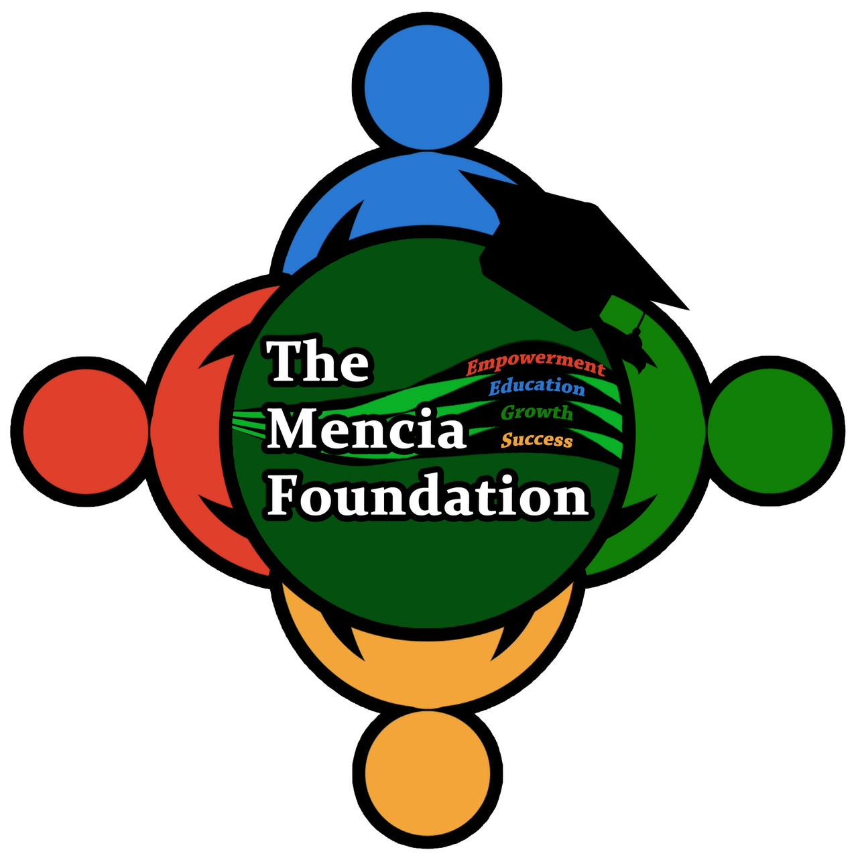

The Mencia Foundation
January 23, 2014
Proposal for
Supporting 25 Abandoned children in the Dominican Republic

Introduction

The Mencia Foundation is a 501c3 nonprofit organization that helps underprivileged children in the Dominican Republic and other Latin American countries.

The Foundation was created to continue the efforts of Miguel and Argentina Mencia in supporting and encouraging education by providing essential resources to those in need. Miguel and Argentina Mencia was a very well-known and cherished couple in Salcedo, Dominican Republic. They did not hesitate in helping their neighbors and their community. One of the Mencia's charitable donations included a piece of land in the community of El Jobo in Salcedo for building the first and currently only elementary School in that area. This was a big advancement for El Jobo, given that many of the adults and children of Salcedo are still illiterate. This is the school that motivated us to create the Mencia Foundation. After Miguel and Argentina’s passing, we decided to continue their efforts in helping their community by helping children in the area go to school. We started helping just one school in el Jobo, and up until today, we have been able to add 5 more schools and one orphanage.

Currently, we support children by providing the basic resources needed to attend school (i.e. notebooks, backpacks, pens/pencils). We also provide additional needed items such as shoes, socks, and undergarments. Additionally, we support a small orphanage in the Salcedo region by providing everyday necessities such as nonperishable foods, clothes, toiletries, as well as school supplies.

Needs/Problems

The Dominican Republic is statistically known as one of the poorest countries in the Americas. According to the Central Intelligence Agency’s (CIA) “World Fact Book,” The ‘below poverty line’ for the Dominican Republic is at 34%. Additionally, UNICEF reports that a total of 10.2 million orphan children are currently living in Latin American countries, a 5% of the total child population. Worldwide, the number of abandoned children continues to grow at a very rapid rate. This may be due to a number of causes including high unemployment rates, teenage pregnancy, death of their parents, among many others. With very limited funding, the government in the Dominican Republic is not able to provide assistance to such underprivileged communities. Because of this, volunteers at these organizations (orphanages, shelters) must solicit help to other members of the community. This alone represents a huge challenge since the population itself is of low income and cannot help as much as they would like.

Goals/Objectives

- To purchase enough quantities of nonperishable foods for 6 months to a year
- To purchase shoes and clothing for 25 abandoned children
- To purchase health and oral care needs for 25 abandoned children
- To deliver the above items by August 2014
- To raise a total of $5000

Procedures/Scope of Work

Task | Scope of Work
Fundraising | Manage fundraising page on GlobalGiving  Soliciting item donations from local businesses  Promoting project on social media
Project Management | Ensure project activities and deliverables are met on time and on budget.
Purchasing | Purchasing donation items
Packing/Shipping | Packing and shipping of items to the Dominican Republic
Event Coordinating | Coordinate activities in order to deliver items to orphanage

Timetable

 | Description of Work | Start and End Dates
Phase One | Project Planning | 1/1/2014 to 1/31/2014
Phase Two | Fundraising | 2/1/2014 to 5/31/2014
Phase Three | Purchasing | 6/1/2014 to 7/13/2014
Phase Four | Packing and Shipping | 7/13/2014 to 7/15/2014
Phase Five | Charity Event | August 19th 2014

Budget

 | Description of Work | Anticipated Costs
Phase One | Project Planning | $0
Phase Two | Fundraising | $300
Phase Three | Purchasing | $4000
Phase Four | Packing and Shipping | $500
Phase Five | Miscellaneous | $1000
 | Total | $5,800.00

Key Personnel

Argentina Rosado
(Project Manager)
Angela Gutierrez
(Project Assistant)
Olga Mencia
(Purchasing and Shipping)
Olga Rosado
Technical Assistant

Evaluation

The project will be evaluated periodically to discuss project deliverables, due dates, and budget. This will be done at bi-weekly team meetings.

