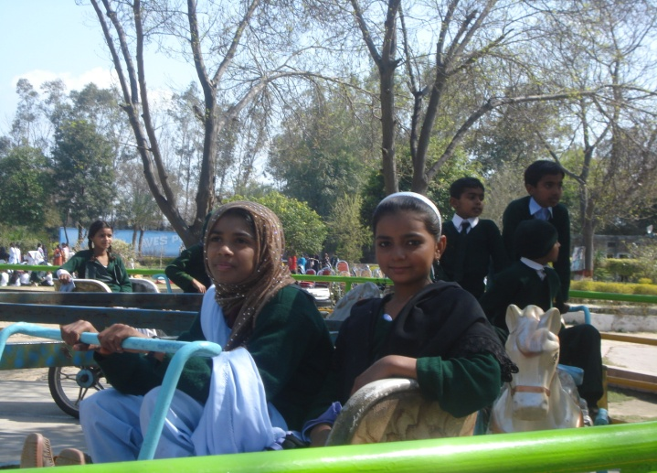
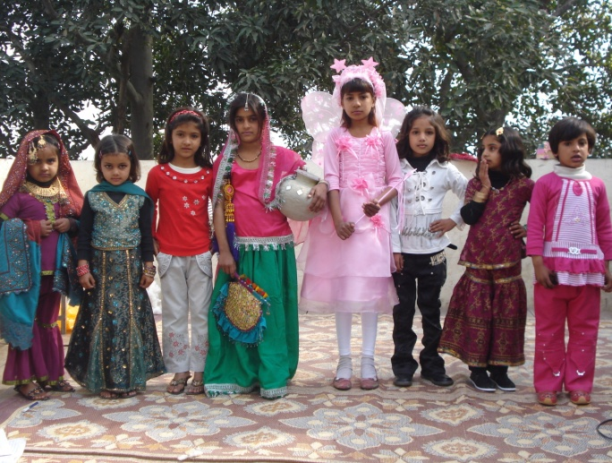

Performers at the funfair arranged for Malikpur and Lakhodair students

Excited girls on a ride: Recreational Trip to Sky Land

