Non-formal Primary Education for Vulnerable Children (Age 7-14) with an accelerated curriculum in Swat-Kohistan, NWFP, Pakistan

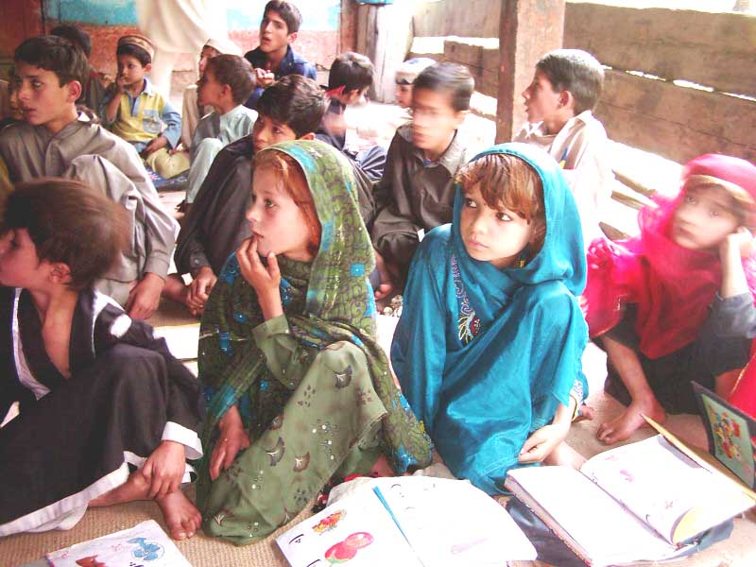

- Executive Summary;

Pakistan Village Development Program (PVDP) is presenting this project proposal on education titled “Non-Formal Education for Vulnerable Children”. PVDP seeks to address the problem that vulnerable children do not have access to quality education. This proposal focuses on marginalized children that have been dropped out of school or never attended school.
PVDP will launch its non-formal education program in 2006, through community based schools in underserved areas, focusing on access and quality for girls and boys. PVDP will address the issues affecting access and quality of education in vulnerable areas by supporting community-based non-formal schools. This would not be a parallel structure to formal education but a bridge to fill the gap and limitations of formal education. The vital thrust of this program is active participation of targeted communities. That is dynamic and regular involvement in daily school matters and supervisory role through PTAs/CBOs.

PVDP believes that access to education cannot make a marked impact on communities and society at large; unless quality imparted through schools is an agreed value for all partners. The capacity building component will mainly focus on teacher training, to provide quality services; demonstrate innovative methodologies and approaches, improving children’s learning and ensuring primary school retention in target areas. The capacity building component would include school administrators, PTAs and field staff to strengthen outreach program.
The proposed project implementation is based on establishment of 15 non-formal schools with 2400 students. Under capacity building 60 teachers (15 CBS & 45 Government) will be trained in participatory teaching methodologies. Teachers Capacity Building will have the following basic components; participatory teaching methodology, schools and classroom management, lesson planning, production of low cost teaching aids, community participation, subject knowledge. A PTA will be organized for each school and trained on its roles and responsibilities.
PVDP will act as the lead organization and will work closely with the implementing partner (DoE) to ensure program quality. PVDP is well equipped to understand and provide quality education services to vulnerable communities through its professional staff and pool of consultants. PVDP has 7 years of experience in education and has implemented several non-formal education initiatives for boys, girls, adolescents and adults.
PVDP will involve all major education stockholders in the community, to ensure the sustainability and quality of community schools. Sustainability will be ensured through quality education. That is the standard of education and environment which will attract more and more families to send their children to schools.
A careful monitoring plan will form part of the project implementation. This will be accompanied by intensive presence of the project staff in field. PVDP will organize an evaluation for official review at the end of the project.
The budget for this intervention is 12,229 USD. Project per student cost is USD 48 for one year. The funding for the first year has been requested by GlobalGiving as yet. PVDP looks forward to working with communities to provide access to quality education for vulnerable children.

- Location;
The said project will be implemented in the following villages of District Swat;

S.N | Village | Union Council | District
1 | Ashoka | Mankyal | SWAT
2 | Bar Kali Ayeen | Mankyal | SWAT
3 | Satal Chum | Bahrain | SWAT
4 | Paklai Shagram | Madyan | SWAT
5 | Shagai Shagram | Madyan | SWAT
6 | Jopeen | Madyan | SWAT
7 | Kuz Kali Madyan | Madyan | SWAT
8 | Tangar | Madyan | SWAT
9 | Tat Kali | Mankyal | SWAT
10 | Palam | Madyan | SWAT
11 | Damlai | Tearat | SWAT
12 | Qilla Damana | Tearat | SWAT
13 | Madina Colony Darushkhela | Darushkhela | SWAT
14 | Qilla Khwazakhela | Khwazakhela | SWAT
15 | Kalagai | Madyan | SWAT

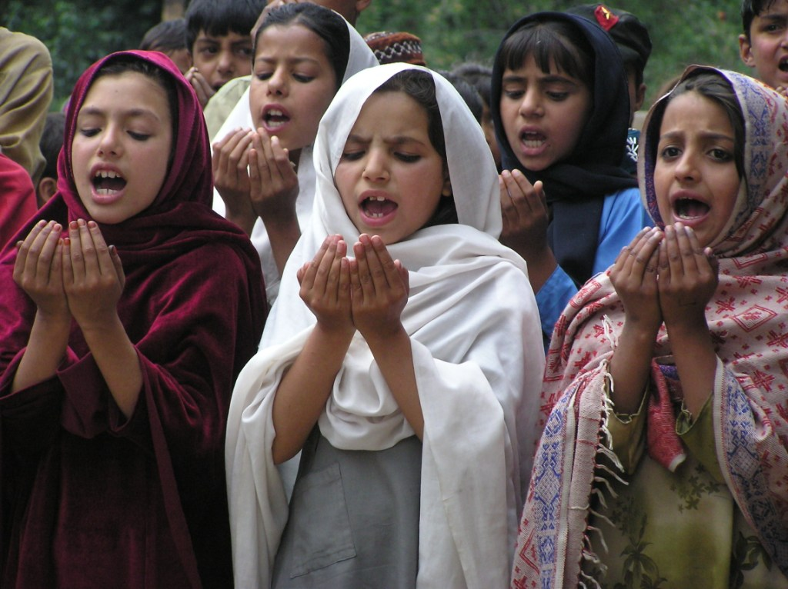
- Overall description of the project;

Project Title: Educating 2400 vulnerable girls (7-12) in Swat, NWFP

Project Summary:

The project will educate 2400 girls (drop out/out of school) with basic level of education in sustainable Community Based Schools to be established in 15 remote villages of Swat-Kohistan.

Project Need and Beneficiaries:
The project will be implemented in 15 villages of Swat-Kohistan and will benefit 2400 vulnerable school age girls, their parents and local community members by addressing the following issues:

- Inaccessibility of quality education to vulnerable girl children;
- Parents’ preference for child labor than education;
- Scarcity of trained female teachers in remote areas;
- Gender insensitivity

The project will have greater impact on the social fabric of these villages as community schools will continue to function as educational and advocacy institutions to address vulnerabilities of girl child in these remote villages.

Project Activities:

- Stakeholders meetings & surveys to ensure coordination & collect data
- Village meetings to organize parent & motivate community
- Establish schools to educate 2400 girls
- Technical support to train local teachers;
- Advocacy events for Girls education

Donation Options
D O# Amount (USD) Description

1 $ 488 will educate 10 vulnerable Girls
2 $ 3909 will create 80 jobs for female on sustainable basis
3 $ 400 will facilitate the functioning of 1 community schools

Potential Long-Term Impact

- 2400 vulnerable girls, 4800 parents, 80 teachers, 160 Parent groups will directly benefit
- Access to quality education on sustainable basis for girls
- Reduced gender discrimination
- Improved income for 20 local female teachers
- Increase literacy

- Overview, Background & Rationale;
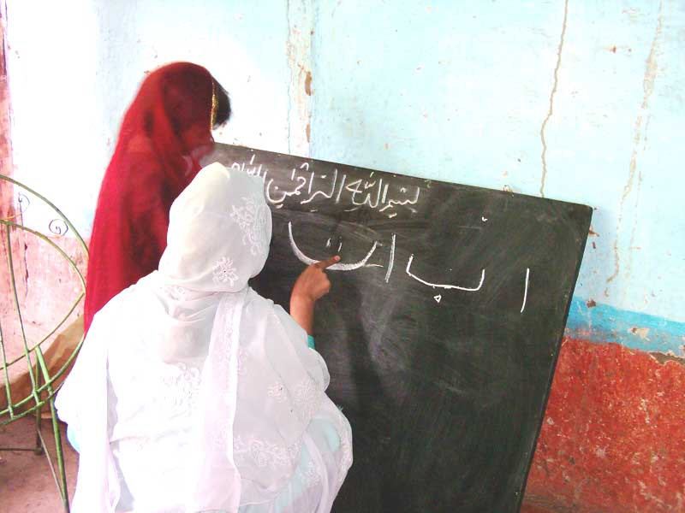
The problem analysis below presents the causes of the central problem. There are numerous issues and causes of education problems for vulnerable children, which fall mainly in two categories: access and quality. These two issues are interlinked because access is a prerequisite for quality. Likewise, quality of education enhances parents’ trust in education and can motivate them to send their children to school.
Problems of Access to Education
Access is the first of two main issues with regard to primary education. Inaccessibility of primary education is a result of distance, child labor, male preference, scarcity of teachers, local leaders’ fear of loosing power and frequent policy changes. The problem of access applies to both girls and boys; however it is more serious for girls.
Distance: Many children have to travel miles to reach school which is not possible for them, especially for the girl child because culturally they are supposed to stay close to home. Of the total number of primary schools in Pakistan, girls’ schools represent only 39 percent with boys’ schools representing 55 percent according to UNESCO study in 2000. The reason that schools are far away is that resources allocated by government for primary education are insufficient to meet the needs and are often politicized. Many families cannot afford traveling expenses for their children. Those who can afford transport it is often not available. Additionally, t eachers that do not belong to the same community are sometimes unable to attend school daily because of above-mentioned problems.
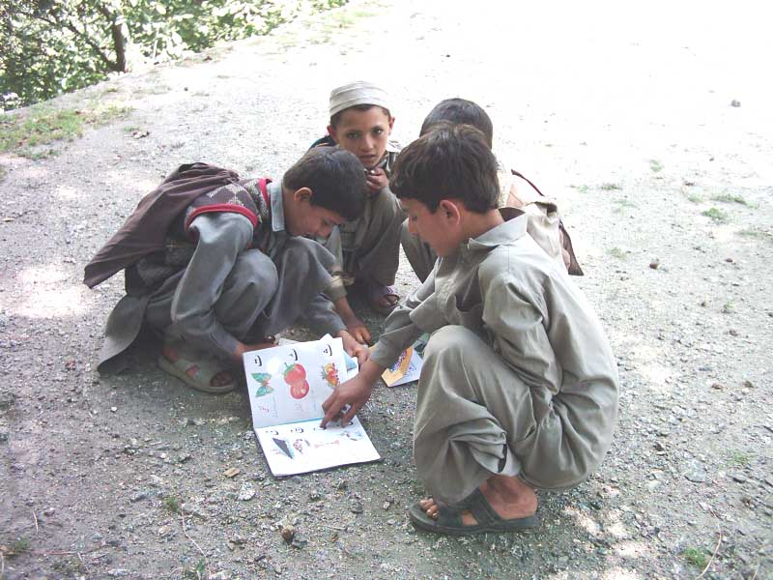
Child labor: Children often do not attend school because they are working to support their families for their survival. According to UNICEF, 17.6 % of Pakistani children are working and supporting their families, 8 million children under the age of 14 are laborers at brick kiln factories, the carpet weaving industry, agriculture, small industries and domestic services across Pakistan. Therefore child labor is not an isolated problem. It is an outcome of social, economi c and traditional factors.

Male preference: Parents often favor the education of their sons over their daughters. Whenever there is a trade off between boys and girls for sending school; parents prefer to expend on boys education as they are they future earning hands of their families. Typically, education of a boy is desirable even for the most disadvantaged people and those who live beyond the designated settled areas. However, education of a girl is not necessarily desirable because any investment made would not bear fruit for their family since girls leave to live with the family of their husband.
Scarcity of teachers: There is a critical need to increase the number of teachers in Pakistan, especially female teachers. The need for more female teachers in this regard cannot be underestimated. The presence of women teachers boosts parents’ confidence in the safety of their daughters, encouraging them to send their daughters to school, esp ecially in conservative areas. The scarcity of female teachers is due to distance from training institution and lack of residential facilities. Secondly, females are not allowed to stay in residential institutions because of cultural norms.
Fear of loosing power: Local leaders oppose girls’ education out of fear of loosing power. For example, some of the government and non-government organizations have tried to open formal and non-formal schools in these areas, but the landlords, oppose such measures, apparently out of fear that people who become literate will cease to follow them with blind faith.
Frequent changes in education policies: Frequent changes in the Pakistan government have meant frequent changes in educational policies, plans and schemes. In 57 years, Pakistan has come up with 23 different plans to achieve its educational objectives. Unfortunately, no administration has fully implemented their educational plans. Additionally, the Ministry of Education faces insufficient allocation of financial and human resources.

Problems of Quality Education
The second main problem with regard to primary education is that of quality. Quality education means creative learning, a conducive learning environment, and an education applicable to day to day life. Article 42 of the Dakar Framework of Action defines quality education as one that satisfies the basic learning needs and enriches the lives of learners and their over all experience of living. In the Pakistani context parents usually consider quality as academic excellence and child certification of primary schooling.
Enrollment does not guarantee learning or completion of primary education. Quality education demands quality inputs. Quality inputs include skilled motivated teachers, adequate school structures, essential teaching/learning material, the provision of text books, students and proactive communities. Poor quality education in Pakistan has various causes, includi ng unskilled teachers, inadequate facilities, classroom discipline, and lack of coordination and communication.

Unskilled teachers: Teachers are not fully familiar with what they teach due to changing syllabi. Teachers’ training syllabus and curriculum is 57 years old and does not relate to the current students’ curriculum. Teachers are not familiar with the new changes in textbooks and are unable to fulfill the demands of new curriculum and often have little understanding of what they teach. They practice traditional teaching methods and lack the concept of interactive and co-operative learning. Ultimately, the children’s progress is slow and negligible.
Inadequate Facilities: Existing schools lack basic facilities like adequate structures, safe drinking water, sanitation facilities, furniture and basic teaching learning material. Most of the primary schools also lack recreational material and play grounds. The school environment is unable to attract children to school. Almost all classes have more students than can be properly seated. For example, in many of the schools of Punjab Province, children bring rags from their homes to sit on the ground. This is because of the burgeoning demand for education and slower expansion of facilities as compared to the population growth. In Pakistan, 70 percent of primary schools lack basic equipment and space according to the Ministry of Education itself.
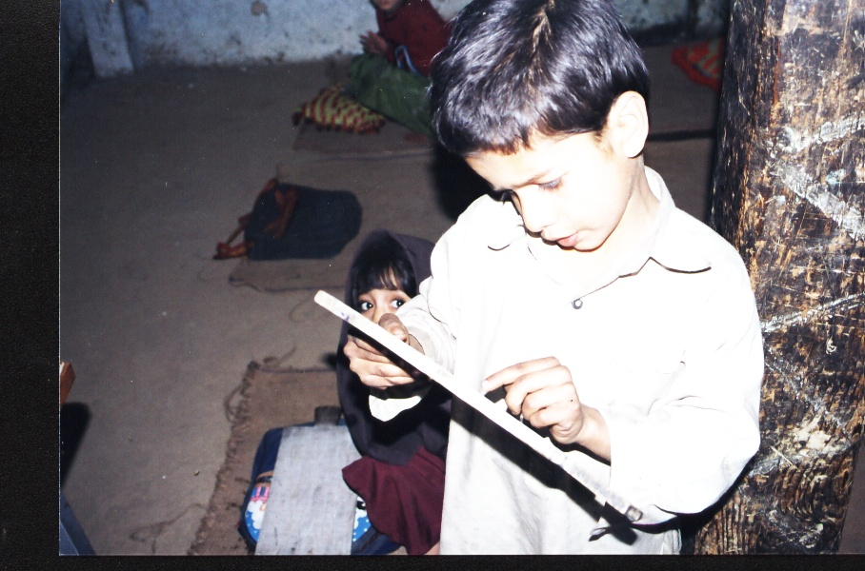
Classroom Discipline: Physical punishment is by and large a common phenomenon in schools. There is evidence of parents themselves allowing teachers to iron out the rough edges of the child’s behavior by punishing them physically. “The flesh belongs to the teacher and bones to the parents”, is a proverbial phase cited by the parents when they admit their children to school in the rural Punjab. This creates an environment of fear in the classroom which is not conducive to learning.
Lack of Coordination & Communication: The lack of coordination between parents, teachers, community and religious leaders, Community Citizen Boards (CCBs), and local government officials is big hurdle to access and quality. What is learned by children in schools is not reinforced at home by parents. The coordination is not only important for parents, but other stakeholders as well to advocate for quality education, and hold school teachers accountable. Unfortunately, communities are often not motivated or mobilized to participate in school activities.

PVDP proposes to improve access to quality for vulnerable children in underserved areas. The project is three years period with priority efforts provided to areas where out of school children ratio is quite high and female literacy rates are lowest. PVDP has selected localities that are non-seasonal and schools may remain open throughout the year to help complete primary education within 3 years. Initially 15 schools in two sub-tehsils of district Swat will be established to impart accelerated education to vulnerable children. In subsequent months and years, activities may extend to other district in the same provinces or other provinces depending upon the success and funding availability. Education strategy will be guided by a vision to work in partnership to promote and support the Government of Pakistan’s national plan of action, entitled “Education For All,” as well as the National Education Policy. The strategy focuses on access, quality and partnership;

Proposed intervention:

Project Goal:

“Vulnerable children have improved access to quality education in targeted areas.”
The proposed project would adopt a two-pronged approach expanding the number of non formal schools along with enhancing the quality of the teaching offered in the schools. Quality of education is viewed as the learning outcome of students which is primary concern of all stakeholders. Quality learning cannot be expected without quality inputs. Quality inputs would include adequate place/space, trained teachers, teaching kit, refresher courses for teachers, supplementary reading material for teachers and students, community support and local government involvement.

Strategic Objectives

SO.1: Children have an opportunity to complete primary education in target areas
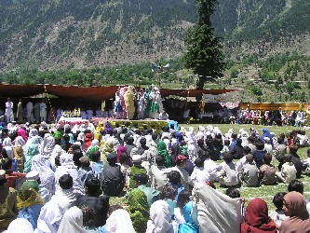
The project is designed to provide primary education, through community based schools, to all children in targeted areas who have never enrolled, or have dropped out of primary school. The program will follow a planned yet flexible approach in responding to students needs. Students can be mainstreamed with formal school at any stage according to their age and performance. It is important because condensed education is only f or over age students to compensate their lost time. It is expected that more and more out of school children would be enrolled in community based schools. Other partners supported NFE schools will work with these vulnerable children for two to three years and then help them to mainstream into formal schools. The idea behind this non-formal education intervention is to bring schools closer to communities in order to reduce distances to primary school for girls. This is particularly to improve community participation in day to day school activities as well. Female enrolment will also be encouraged by recruiting more female teachers who will act as role models in the proposed non formal schools and possibly local recruitment of female teachers to facilitate the sense of community ownership for schools. The partner will use provincially authorized primary syllabus and cover it over the period of three years to speed up the process. Non-formal students will appear in exams with formal students in formal primary schools present in the area.

S. O. 2: Vulnerable children have improved quality of education in target areas.
- Quality education is identified as a priority by various stakeholders. All participants are in agreement that there is an urgency to seek remedies for substandard education which causes high dropout ratio. To achieve the desired quality the input and process should also have quality in terms of efficiency, effectiveness, and excellence. The quality of education output can be achieved only if quality is ensured at each level of the educational process from standard setting, learning environment and monitoring.

Sustainability:
The project once implemented will be regularly monitored and documented by PVDP team in the form of periodical progress report with quantities and qualitative achievement analysis for sharing with concerned project stakeholders and beneficiaries. Major achievements would also be published in PVDP newsletter and website.

PVDP has been implementing Swat-Kohistan Education Project since 2001 with the financial support of various partner organizations and have established more than 75 Community Based Schools with more than 7000 girls students in age group 5-14 years. 90% of have been made sustainable where communities and their representative organizations (CBOs, CCBs and PTAs) as owners and custodians. The proposed project initiatives would also be implemented based on the principles of sustainability.

A brief outline of a 3 years project sustainability Plan is given below:

Sr. No. | Project Period | PVDP Focus
1. | Year-1 | - Project initiation  - Project Implementation  - Financial and Technical support to communities  - Building Capacities of stakeholder
2. | Year-2 | - Technical and partial Financial Support for consolidation continue;  - Building Capacities and promotion of linkages;  - Hand over custodianship and management
3. | Year-3 | - Building Capacities and promote linkages for communities;  - Technical support;  - Phasing Out

- Beneficiaries;

Targeted beneficiaries of the proposed project would be children out of school due to various reasons mentioned above in problem identification section. The total number of students to be reached is 2400 Girls & their parents (age 9-14 years) in 15 CBSs. The total number of teachers to be trained is 15 non-formal school teachers. Each school will have one PTA consisting of 8-10 members. This unit will make up the executive body. All the parents will be part of the general body.

Indirect beneficiaries would not include only the immediate families of the students but government education department, non-governmental organizations, Union Councils and bilateral projects will benefit to learn from the project achievements and replicate similar community based sustainable models in their own partner communities.

Beneficiary Group | PVDP Target | Total number individuals
Number of Girls | 60% | 600
Number of Boys | 30% | 150
Number of schools | 15 | 15
Number of PTAs | 15 | 15 X 8= 120
Number of Teachers | 15 | 15
Total number of direct beneficiaries | - | 1650

- Program Impact (Outcomes);

Outcome for SO 1:

OC-1: Targeted children have increased attendance in schools
PVDP has seen through experience that when community members contribute resources to school, they are more likely to ensure that their children are enrolled in schools and attend regularly. The CBS will be owned and managed by the communities. These schools will be opened in premises identified by the communities. It is expected that establishment of CBS will overcome the distance, therefore, children especially girls will be attracted to attend school regularly and presence of female community teacher will be an added incentive for regular attendance. Shorter distances to schools will provide security both for teachers and students. Communities specifically parents will be trained to provide stimulating environment for newly enrolled children to attend school regularly.

Output for SO1:

OP-1: Out of school children enrolled in schools
Education is essential for development and particularly what we call today integral and sustainable development. Establishment of CBS will provide an opportunity for missed outs, dropouts and vulnerable girls to have access to primary education. Enrollment will be ensured trough PTAs.

Outcome for SO 2

OC-1: Teachers apply participatory teaching methodologies
The basic purpose of the teachers’ training is to develop certain competencies among students. A teaching –learning model facilities the understanding of the process through which these competencies are developed. The school environment is result of the interaction of teachers, students, management and activities undertaken for achieving its objectives. Similarly each teacher has a distinct intellectual and emotional make-up. The learning outcome is the result of a dynamic and complex interaction of a wide variety of factors. The adoption of participatory teaching methodologies will require ongoing encouragement and reinforcement. Such support may include peer coaching, working with a mentor teacher, peer support groups. In participatory methodology teachers will move beyond rote learning and will use variety of interactive approaches. It is expected that trained teachers will use self directed and experiential learning methods as listed: group work, discussion, brainstorming, role play, educational games, story telling, audio visual aid, art/drawing, easy writing dealing with objective, questioning, observing and cultural activities. Participatory techniques will take into account the various needs of learner and provide an opportunity for learner and facilitator to share their experience.

OC-2: Community participation in management of non-formal education
It would be the responsibility of the community to identify preferably female teacher who is a permanent resident of the community, and who therefore does not have problems commuting to and from the school. Communities will be responsible for the provision of teacher, enrollment of out of school children, and for their regular attendance. Communities will identify of space to establish non formal school which will be incontrovertible and accessible for all. Community will include PTA and SSG and together will ensure the well being of every child. They will be actively involved in awareness raising program to ensure parents recognize the value o f education and support the cause of non-formal schools. The experts agree that when parents get involved in education, children try harder and achieve more at school. Parents who help and encourage their children to learn at home and who develop positive attitudes toward school, contribute to the personal growth and academic success of their children. Communities (PTAs) will also ensure teachers attendance, performance, behavior in the classroom, and regular school time.

Output for So 2

OP-1: Teachers have increased knowledge of participatory methodologies
The importance of teacher as a key figure is recognized in education process has always been recognized. It is expected that teachers will increase knowledge about physical and cognitive development of the students, which will definitely vary within and across the classroom.

OP-2: PTAs /CBOs, trained in basic organizational structures and strategies
In order to obtain concrete results of PTAs/CBOs , it is necessary to conduct formal trainings for the PTAs in the areas of capacity and skills. A series of training would be conducted by implementing NGO as we have master trainers in the relevant field. PTA Training modules may be borrowed from the local government as well. Besides this all the trainings acquired by NGO staff would be replicated with PTAs if deemed necessary.
Cross cutting for both SOs

Institutional strengthening an d capacity building of partner organizations
Organization will be supported for the development of staffing, systems and structures to achieve the goal of the project. The aim of these trainings would be planning, monitoring, effective management, sustainable organization, report writing, and management of effective information system. Trained staff will replicate necessary and need trainings with the PTAs to enhance their capacities in manage non-formal education on sustainable footing.

- Time Line;

S.# | Program Activities: | Nov | Dec | Jan | Feb |  | Mar |  | Apr | May |  | Jun |  | Jul |  | Aug | Sep | Oct
1 | Community identification
2 | Selection of schools premises
3 | Selection of teachers
 | Teachers training
4 | Establishment of schools
5 | Enrollment of the children
66 | Distribution of books to students
5 | Formation of PTAs
6 | Orientation of PTA
7 | Monitoring and follow up of teachers performance
8 | Quarterly report
9
10 | Financial request for second quarter
11 | Evaluation of first grade
12 | Purchasing and distribution of books for second grade
13 | Re-orientation session for teachers for second grade
14 | Quarterly report for second quarter
15
16 | Financial request for third quarter
17 | Proposal development for next quarter
18 | Exchange visit to another non-formal education partner
19 | Evaluation of 3 quarters by PVDP
20 | Submission of next years proposal and budget
21 | Sign of MOU of 2nd year

- Performance Indicators; (Inputs, Outputs and Outcomes indicators)

Project Personnel;

Project Personnel #1

Name: Nosheen Malik Title: Program Officer Education & Health

Bio: Ms. Nosheen is having a master degree & has been working with PVDP for the last 5 years as project officer and now as a program officer education and health. She has good planning, coordination and analytical skills and has contributed significantly to improvement of girl’s education and adolescent reproductive health care in PVDP project areas & has gained a name for herself at the national level.

Credentials, awards, degrees (250): Nosheen has Master degree in Urdu. She participated in courses related to education & health. She is also the author of PVDP AAGAHI and ROSHNI Newsletters & was awarded women of the year award by Pakistan National AIDS Consortium.

Project Personnel #2

Name: Nishat Perveen Title: Senior Female Education Resource Person

Bio: Ms. Nishat has been working with PVDP since 1999 on its education program. She is from Swat and has gained significant field level experience in the field of girls’ education in remote areas. Her additional qualities include effective coordination & communication skills with all stakeholders and bringing reality to the theoretical concepts.

Credentials, awards, degrees
Ms. Nishat Perveen has a bachelor degree with special courses on Primary Teachers Training. She also works as a Health Workers to facilitate relief to the underprivileged women. She has received appreciation letters from departments for her work.

PVDP Project Budget
Non-Formal Education for Vulnerable Girls Children in Swat, NWFP Pakistan
Budget Categories | Unit rate | Units |  |  |  | Total Annual Budget in PRS
Budget Categories | Unit rate | Units | Year-1 | Year-2 | Year-3 | Total Annual Budget in PRS
Project Support Cost
Staff Salaries
Direct
Project Manager | 0 |  | - | - | - | -
Female Education Resource Person | 10000 | 12 | 120,000 | - | - | 120,000
Male Education Resource Person | 0 | 0 | - | - | - | -
HID/PM&E Officer | 0 | 0 | - | - | - | -
Admin. Finance Officer Regional Office | 0 | 0 | - | - | - | -
Driver | 0 | 0 | - | - | - | -
Watch Man and Office Assistant | 4000 | 12 | 48,000 | - | - | 48,000
Sub total Direct |  |  | 168,000 | - | - | 168,000
Indirect
Executive Director (partial) |  |  | - | - | - | -
Admin. Finance (Partial) |  |  | - | - | - | -
Office Assistant (Partial) |  |  | - | - | - | -
Sub total Indirect |  |  | - | - | - | -
Sub Total |  |  | 168,000 | - | - | 168,000
Staff Benefits
Direct |  |  |  |  |  | -
Project Manager |  |  | - | - | - | -
Female Education Resource Person |  |  | - | - | - | -
Male Education Resource Person |  |  | - | - | - | -
HID/PM&E Officer |  |  | - | - | - | -
Admin. Finance Assistant Regional Office |  |  | - | - | - | -
Driver |  |  | - | - | - | -
Watch Man and Office Assistant |  |  | - | - | - | -
Indirect |  |  | - |  |  | -
Executive Director (partial) |  |  | - | - | - | -
Admin. Finance (Partial) |  |  | - | - | - | -
Office Assistant (Partial) |  |  | - | - | - | -
Sub Total |  |  | - | - | - | -
Professional Fees
Audit Fee (Partial) |  |  | - | - | - | -
Sub Total |  |  | - | - | - | -
Office Expenses(Main Office)
Rent |  |  | - | - | - | -
Utilities |  |  | - | - | - | -
Communication |  |  | - | - | - | -
Printing/Stationary |  |  | - | - | - | -
Office Supplies |  |  | - | - | - | -
Bank Charges/Miscellaneous Expenses |  |  | - | - | - | -
Sub Total |  |  | - | - | - | -
Office Expenses(Regional Office )
Rent |  |  | - | - | - | -
Utilities |  |  | - | - | - | -
Communication | 2000 | 12 | 24,000 | - | - | 24,000
Office Supplies |  |  | - | - | - | -
Stationery |  |  | - | - | - | -
Sub Total |  |  | 24,000 | - | - | 24,000
Insurance
 |  |  |  |  |  | -
Sub Total |  |  |  |  |  | -
Maintenance & Repair
Equipment Maintenance |  |  | - | - | - | -
Project Vehicle Maintenance Field Office Swat |  |  | - | - | - | -
Vehicle Maintenance/Staff Mobility | 6000 | 12 | 72,000 | - | - | 72,000
Sub Total |  |  | 72,000 | - | - | 72,000
Travel (Excluding Monitoring)
 |  |  |  |  |  | -
Sub Total |  |  |  |  |  | -
Vehicle Running Expenses
Vehicle Regional Office (Swat) |  |  | - | - | - | -
Vehicle Fuel Main Office for M&E |  |  | - | - | - | -
 |  |  |  |  |  | -
Sub Total |  |  | - | - | - | -
Furniture & Equipment Purchases
Laptop Computer |  |  | - | - | - | -
Printer |  |  | - | - | - | -
Digital Camera | 25000 | 1 | 25,000 | - | - | 25,000
Cost of Vehicle |  |  | - | - | - | -
Office Table |  |  | - | - | - | -
Office Chairs |  |  | - | - | - | -
File Rack |  |  | - | - | - | -
Photo copier Studio-200 |  |  | - | - | - | -
Sub Total |  |  | 25,000 | - | - | 25,000
Sub-total A |  |  | 289,000 | - | - | 289,000
Direct Project Cost
Support to 10 CBSs
Furniture & Fixture @ 6000 per CBS | 6000 | 10 | 60,000 | - | - | 60,000
Books for Students @ 110 for 400 students | 400 | 110 | 44,000 | - | - | 44,000
Teacher's Salary @ 2000 | 12000 | 10 | 120,000 | - | - | 120,000
Teaching Aid Material for 10 CBSs | 2500 | 10 | 25,000 | - | - | 25,000
Inter-School & Students Compitions (1) @ 20000 | 20000 | 1 | 20,000 | - | - | 20,000
Celeberation of National day 1 @ 3000 |  |  | - | - | - | -
Rent & Utilities of CBS @ 1000/month (Community Contribution) |  |  | - | - | - | -
Sub Total |  |  | 269,000 | - | - | 269,000
Teachers Trainings (20 CBSs+50 Govt. Teachers)
5-days Teaching Skills & Methodologies | 20000 | 1 | 20,000 | - | - | 20,000
3 Days CBS Management and Record keeping |  |  | - | - | - | -
Supplementary Courses |  |  | - | - | - | -
5 Days Child Rights Convention | 20000 | 1 | 20,000 | - | - | 20,000
Exposure Visits for teachers |  |  | - | - | - | -
PTA Members (50) |  |  |  |  |  | -
3-days Social Mobilization, Linkages & Networking Training |  |  | - | - | - | -
3-days Gender & Development 40 persons | 15000 | 1 | 15,000 | - | - | 15,000
SKEP Staff: |  |  |  |  |  | -
Staff Training and Development |  |  | - | - | - | -
Sub Total |  |  | 55,000 | - | - | 55,000
Monitoring & Evaluation
Project Director M&E Section Visits |  |  | - | - | - | -
Mid Term Review+ Final Review |  |  | - |  |  | -
Sub Total |  |  | - | - | - | -
Other Project Related Expenses
Publication of quarterly ROSHNI News Letter | 4 | 12000 | 48,000 | - | - | 48,000
Strengthening of DESG |  |  | - | - | - | -
IEC Material |  |  | - | - | - | -
Sub Total |  |  | 48,000 | - | - | 48,000
Sub-total B |  |  | 372,000 | - | - | 372,000
Sub Total C = A + B |  |  | 661,000 | - | - | 661,000
Total A +B |  |  | 661,000 | - | - | 661,000
In US$ |  |  | 11017 | 0 | 0 | 11017
11% Transaction fee |  |  | 1211.87
Grand Total |  |  | 12,229 |  |  | 12,229

